

NR (64 Channel NVR)
User Manual

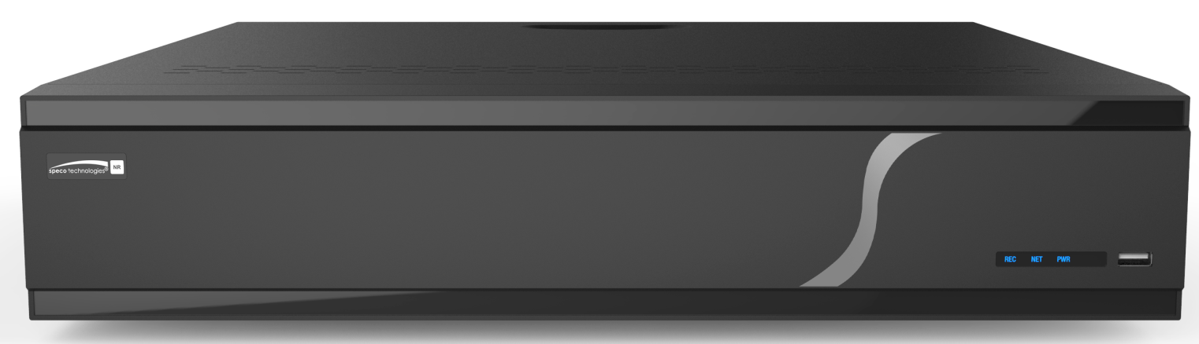

N64NR

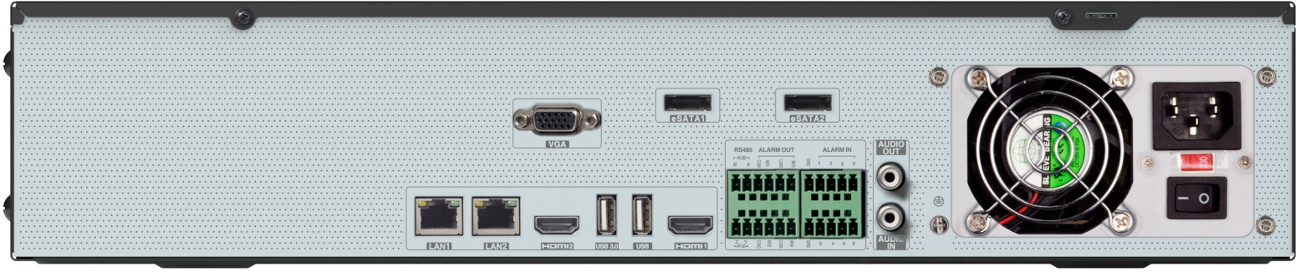

Version 1.0
Features and specifications are subject to change, please check www.specotech.com for firmware updates.

Notes

- Please read this user manual carefully to ensure that you can use the device correctly and safely.
- The contents of this manual are subject to change without notice.
- Do not install this device near any heat sources such as radiators, heat registers, stoves or other devices that produce heat.
- Do not install this device near water. Clean only with a dry cloth.
- Do not block any ventilation openings and ensure proper ventilation around the machine.
- Do not power off the device at normal recording condition.
- This machine is for indoor use only. Do not expose the machine in rain or moist environment. In case any solid or liquid get inside the machine’s case, please turn off the device immediately and get it checked by a qualified technician.
- Do not try to repair the device by yourself without technical aid or approval.

Contents
1 Introduction 1
1.1 Welcome 1
1.2 Features 1
1.3 Front Panel Descriptions 4
1.4 Rear Panel Descriptions 4
1.5 Connections 4
2 Basic Operation Guide 5
2.1 Startup & Shutdown 5
2.1.1 Startup 5
2.1.2 Shutdown 5
2.2 Remote Control 5
2.3 Mouse Control 6
2.4 Text-input Instruction 6
2.5 Common Button Operation 7
3 EZ Setup & Main Interface 8
3.1 EZ Setup 8
3.2 Main Interface 12
3.2.1 Main Interface Introduction 12
3.2.2 Setup Panel 14
3.2.3 Main Functions 16
4 Camera Management 17
4.1 Add/Edit Camera 17
4.1.1 Add Camera 17
4.1.2 Edit Camera 19
4.2 Add/Edit Camera Group 20
4.2.1 Add Camera Group 20
4.2.2 Edit Camera Group 20
4.2.3 IP Planning 21
5 Live View Introduction 22
5.1 Live View Interface Introduction 22
5.2 View Mode 23
5.2.1 Display Mode 23
5.2.2 Quick Sequence View 24
5.2.3 Camera Group View In Sequence 25
5.2.4 Scheme View In Sequence 25
5.3 Image Configuration 26
5.3.1 OSD Settings 26
5.3.2 Image Settings 27
5.3.3 Mask Settings 27
5.3.4 Fisheye Settings 28
5.3.5 Image Adjustment 28
6 PTZ 31
6.1 PTZ Control Interface Introduction 31
6.2 Preset Setting 34
6.3 Cruise Setting 34
7 Record& Disk Management 36
7.1 Record Configuration 36
7.1.1 Mode Configuration 36
7.1.2 Advanced Configuration 37
7.2 Encode Parameters Setting 38
7.3 Schedule Setting 38
7.3.1 Add Schedule 38
7.3.2 Record Schedule Configuration 40
7.4 Record Mode 41
7.4.1 Manual Recording 41
7.4.2 Timing Recording 41
7.4.3 Motion Based Recording 41
7.4.4 Sensor Based Recording 41
7.4.5 Analytics Recording 41
7.5 Disk 42
7.5.1 Disk Management 42
7.5.2 Storage Mode Configuration 44
7.5.3 View Disk and S.M.A.R.T. Information 45
8 Playback& Backup 46
8.1 Instant Playback 46
8.2 Playback Interface Introduction 46
8.3 Smart Playback 49
8.4 Record Search, Playback &Export 50
8.4.1 EZ Search 50
8.4.2 Time Search 52
8.4.3 Event Search 53
8.4.4 Bookmark Search 54
8.4.5 Snapshots 54
8.4.6 View Export Status 55
8.4.7 Behavior Search 55
9 Alarm Management 56
9.1 Sensor Alarm 56
9.2 Motion Alarm 57
9.2.1 Motion Configuration 57
9.2.2 Motion Alarm Handling Configuration 57
9.3 Combination Alarm 58
9.4 Smart Event 58
9.4.1 Face Detection 58
9.4.2 Crowd Density Detection 60
9.4.3 People Intrusion Detection 61
9.4.4 People Counting 61
9.4.5 Object Detection 63
9.4.6 Tampering 64
9.4.7 Tripwire 64
9.4.8 Intrusion Detection 65
9.5 Exception Alarm 66
9.5.1 IPC Offline Settings 66
9.5.2 Warning Handling Settings 67
9.6 Alarm Event Notification 67
9.6.1 Alarm-out 67
9.6.2 E-mail 68
9.6.3 Display 68
9.6.4 Buzzer 68
9.6.5 Push Message 69
9.6.6 Alarm Server 69
9.7 Manual Alarm 69
9.8 View Alarm Status 70
10 Account & Permission Management 71
10.1 Account Management 71
10.1.1 Add User 71
10.1.2 Edit User 72
10.2 User Login & Logout 73
10.3 Permission Management 74
10.3.1 Add Permission Group 74
10.3.2 Edit Permission Group 74
10.4 Block and Allow List 74
10.5 Preview On Logout 75
10.6 Network Security 75
10.7 Password Security 76
10.8 View Online User 76
11 Device Management 77
11.1 Network Configuration 77
11.1.1 TCP/IP Configuration 77
11.1.2 Port Configuration 78
11.1.3 PPPoE Configuration 80
11.1.4 DDNS Configuration 80
11.1.5 E-mail Configuration 81
11.1.6 UPnP Configuration 82
11.1.7 802.1X 82
11.1.8 NAT Configuration 83
11.1.9 View Network Status 83
11.2 Basic Configuration 83
11.2.1 General Configuration 83
11.2.2 Date and Time Configuration 84
11.2.3 Recorder OSD Settings 85
11.3 Factory Default 85
11.4 Device Software Upgrade 85
11.5 Backup and Restore 86
11.6 Restart Automatically 87
11.7 View Log 87
11.8 View System Information 87
12 Remote Surveillance 88
12.1 Mobile Client Surveillance 88
12.2 Web LAN Access 88
12.3 Web WAN Access 89
12.4 Web Remote Control 89
12.4.1 Remote Preview 90
12.4.2 Remote Playback 93
12.4.3 Remote Export 94
12.4.4 Intelligent Analysis 94
12.4.5 Remote Configuration 94
Appendix A FAQ 95
Appendix B Calculate Recording Capacity 100
Appendix C Specifications 101

Introduction

Welcome
Thank you for purchasing this NVR.
If technical assistance is needed, please contact Speco Technologies Technical Support.

Phone: 1-800-645-5516 option 3
Email: techsupport@specotech.com

Features
- Basic Functions
- Supports network device access including IP camera/dome and the Onvif IP cameras
- The NVR supports the H.265 and H.264 IP cameras
- Supports standard ONVIF protocol
- Supports dual stream recording of each camera
- Supports IP cameras to be added quickly or manually
- Supports collective or individual configuration of the cameras’ OSD, video parameters, mask, motion and so on
- Supports a maximum of 8 user permission groups including Administrator, Advanced and Common which are the default permission groups of the system
- Supports a maximum of 16 users to be created, multiple web client login by using one username at the same time and the user’s permission control to be enabled or disabled
- Supports multiple web client logins at the same time
- Live View
- Supports 4K×2K/1920×1080/1280×1024 HDMI and 1920×1080/1280×1024 VGA high definition synchronous display
- Supports multi-screen modes such as 1/4/6/8/16/32/64
- Supports auto adjustment of the camera’s image display proportion
- Supports audio monitoring of the camera to be enabled or disabled
- Supports manual snapshot of the camera
- Supports the sequence of the cameras to be adjusted
- Supports display mode to be added and saved and the saved modes can be called directly
- Supports quick tool bar operation of the preview window
- Supports camera group view and scheme view in sequence, quick sequence view and dwell time setting
- Supports motion detection and video mask
- Supports multiple popular P.T.Z. control protocol and setup of the preset and cruise
- Supports direct mouse control of the IP dome including rotating, zoom, focusing and so on
- Supports single camera image to be zoomed by sliding the scroll wheel of the mouse
- Supports any area of the image to be zoomed in to a maximum of 16 times of the current size
- Supports image and lens adjustment (only available for some cameras)
- Supports quick camera adding in the camera window of the live view interface
- The live camera sequence of the web client will keep consistent with that of the NVR after adjusting the live camera sequence of the NVR, but the live camera sequence of the NVR will not be changed if that of the web client is changed
- Disk Management
- A maximum of 8 SATA HDDs
- Supports 2 e-SATA HDDs
- Each SATA interface of the NVR supports the HDDs with max 14TB storage capacity
- Supports disk group configuration and management and each camera can be added into different disk groups with different storage capacity
- Supports disk information and disk working status viewing
- Supports formatting disks in batch
- Record Configuration
- Supports main stream and sub stream recording at the same time and collective or individual configuration of the record stream
- Supports manual and auto record modes
- Supports schedule recording, sensor alarm recording and motion detection recording, etc
- Supports schedule recording and event recording setting with different record streams
- Supports record schedule setting and recycle recording
- Supports pre recording and delay recording configuration of the event recording
- Record Playback
- Supports time scale operation in quick playback and the playback date and time can be set randomly by scrolling the mouse; the time interval of the time scale can be zoomed
- Supports record searching by time slice/time/event/tag
- Supports time view and camera view in searching by EZ mode
- Supports EZ search by month, by day, by hour and by minute and time slice to be displayed with camera thumbnail
- Supports a maximum of 16 cameras to be searched by time
- Supports event search by manual/motion/sensor/intelligent events
- Supports bookmark search by the manual added bookmarks
- Supports instant playback of the selected camera in the live view interface
- Supports a maximum of 16 synchronous playback cameras
- Supports acceleration (maximum 32 times of the normal speed), deceleration (minimum 1/32 times of the normal speed) and 30s’ addition or reduction to current playing time
- Record Export
- Supports record to be exported through USB (U disk, mobile HDD).
- Supports record to be exported by time/event/image search
- Supports record cutting for exporting when playing back
- Supports a maximum of 10 export tasks in background and export status viewing
- Alarm Management
- Supports alarm schedule setting
- Supports enabling or disabling of the motion detection, external sensor alarm input, intelligence alarm and exception alarms including IP address conflict alarm, disk IO error alarm, disk full alarm, no disk alarm, illegal access alarm, network disconnection alarm, IPC offline alarm and so on, alarm trigger configuration supportable
- Supports IPC offline alarm trigger configuration of PTZ, snapshot, pop-up video, etc.
- Supports event notification modes of alarm-out, pop-up video, pop-up message box, buzzer, e-mail and so on
- The captured images can be attached into the e-mail when alarm linkage is triggered
- Supports alarm status view of alarm-in, alarm-out, motion detection and exception alarm
- Supports alarm to be triggered and cleared manually
- Supports system auto reboot when exception happens
- Network Functions
- Supports TCP/IP and PPPoE, DHCP, DNS, DDNS, UPnP, NTP, SMTP protocol and so on
- Supports allow and block list function and the allow and block IP address/IP segment address can be set
- Supports multiple browsers including IE8/9/10/11, Firefox, Opera, Chrome (available only for the versions lower than 45) and Safari in MAC system
- Supports remote achievement, configuration, import and export of the NVR parameters and other system maintenance operations including remote upgrading and system restart
- Supports remote camera configuration of the NVR including video parameters, image quality and so on
- Supports remote search, playback and export of the NVR
- Supports manual alarm to be triggered and cleared remotely
- The motorized zoom camera can be adjusted through web client (Supports zoom in/out, but one key focus is not currently supported)
- Supports NAT function and QRCode scanning by mobile phone and Tablet
- Supports mobile surveillance by phones or Tablets with iOS or Android OS
- If one camera recording is enabled or disabled manually through web client, it will be simultaneously enabled or disabled in the NVR
- Other Functions
- The NVR can be controlled and operated by the buttons on the front panel, the remote controller and the mouse
- Setting interfaces can be switched to one another conveniently by clicking the main menus on the top of the setting interfaces
- Supports NVR information viewing including basic, camera status, alarm status, record status, network status, disk and export status
- Supports factory restoring, import and export of the system configuration, log view and export and local upgrading by USB mobile device
- Supports auto recognition of the displayer’s resolution
- You can click the right mouse button at any interface to go back to the upper interface
- You can click the mouse wheel at any interface to go to the live view interface
- The display language and video format of the NVR will not be changed and the system logs will be reserved if you reset the NVR to factory default
- Press and hold the right mouse button for 5 seconds in any interface to switch the output to VGA and the NVR will display the video at the lowest resolution which the NVR supports

Front Panel Descriptions
The following descriptions are for reference only.

Name | Descriptions
REC | When recording, the light is blue
Net | When access to network , the light is blue
Power | Power indicator, when connection, the light is blue

Rear Panel Descriptions
To quickly get started, connect the following to your recorder in the following order, please refer to the following figure (N32NRE shown for reference).

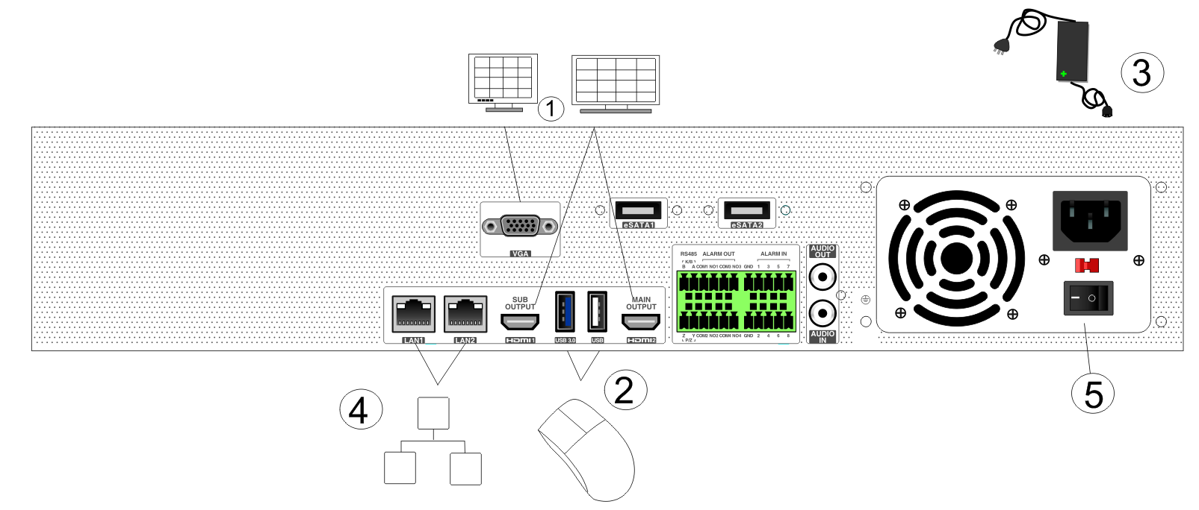

- Connect a monitor to the recorder via VGA or HDMI cable (not included).
- Connect the included optical mouse into any USB port of the recorder.
- Connect the power adapter to the recorder and plug power cord into a 120VAC 50/60Hz outlet.
- Connect recorder to network (optional)
- Turn on power switch and allow recorder to boot up.

Connections
- Video Connections
Video Output: Supports VGA/HDMI video output. You can connect to monitor through these video output interfaces simultaneously or independently.

- Audio Connections
Audio Input: Connect to microphone, pickup, etc.
Audio Output: Connect to headphone, sound box or other audio output devices.

Basic Operation Guide

Startup & Shutdown
Please make sure all the connections are done properly before you power on the unit. Proper startup and shutdown are crucial to extending the life of your device.

Startup
- Connect the output display device to the VGA/HDMI interface of the NVR.
- Connect with the mouse and power. The device will boot and the power LED would turn blue.
- EZ setup window will pop up (you should select the display language the first time you use the NVR). Refer to 3.1 EZ Setup for details.

Shutdown
You can power off the device by using remote control or mouse.
By remote control:
- Press Power button. This will take you to a shutdown window. The unit will power off after a while by clicking “OK” button.
- Disconnect the power.
By mouse:
- Click StartShutdown to pop up the Shutdown window. Select “Shutdown” in the window. The unit will power off after a while by clicking “OK” button.
- Disconnect the power.

Remote Control

- It uses two AAA size batteries.
- Open the battery cover of the remote control.
- When adding batteries check for the polarity (+ and -).
- Replace the battery cover.

Key points to check in case the remote doesn’t work.
1. Check batteries polarity.
2. Check the remaining charge in the batteries.
3. Check IR controller sensor for any masking.

If it still doesn’t work, please contact your distributor or tech support. You can just turn the IR sensor of the remote control towards the IR receiver of the NVR to control it when you are controlling multiple devices by remote control.
The interface of remote controller is shown as below.

Button | Function
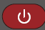 Power Button | Switch off—to stop the device
Record Button | To start recording
-/-- /0-9 | Input number or choose camera
Fn1 Button | Unavailable temporarily
Multi Button | To choose multi screen display mode
Next Button | To switch the live image
SEQ | To go to sequence view mode
Audio | To enable audio output in live mode
Switch | No function temporarily
Direction button | To move cursor in setup or pan/title PTZ
Enter Button | To confirm the choice or setup
Menu Button | To go to menu
Exit Button | To exit the current interface
Focus/IRIS/Zoom/PTZ | To control PTZ camera
Preset Button | To enter into preset setting in PTZ mode
Cruise Button | To go to cruise setting in PTZ mode
Track Button | No track function temporarily
Wiper Button | No function temporarily
Light Button | No function temporarily
Clear Button | No function temporarily
Fn2 Button | No function temporarily
Info Button | Get information about the device
 | To control playback. Play (Pause)/Stop/Previous Frame/Next Frame/Speed Down/Speed Up
Snap Button | To take snapshots manually
Search Button | To go to search mode
Cut Button | No function temporarily
Backup Button | To go to backup mode
Zoom Button | To zoom in the images
PIP Button | Not active
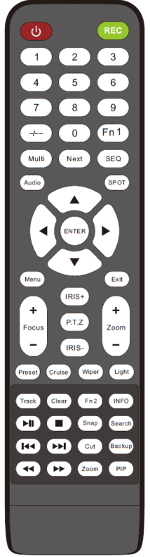

Mouse Control
- Mouse control in Live Display & Playback interface
In the live display & playback interface, double click on any camera window to show the window in single screen mode; double click the window again to restore it to the previous size.
In the live display & playback interface, if the interfaces display is in full screen, move the mouse to the bottom of the interface to pop up a tool bar. The tool bar will disappear automatically after you move the mouse away from it for some time; move the mouse to the right side of the interface to pop up a panel and the panel will disappear automatically after you move the mouse away from it.
- Mouse control in text-input
Move the mouse to the text-input box and then click the box. The input keyboard will pop up automatically.
Note: Mouse is the default tool for all operations unless an exception as indicated.

Text-input Instruction

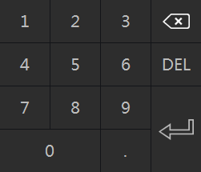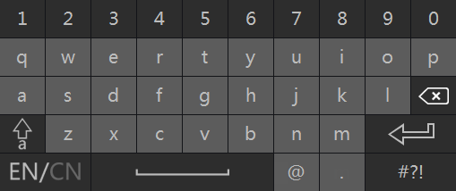

The system includes two input boxes. Refer to the above pictures. The left box is the number input box and the right box is the input box which provides inputs of numbers, letters and punctuation characters. The introductions of keys on the input boxes are shown below.

Button | Meaning | Button | Meaning
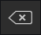 | Backspace key | 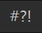 | Switch key of punctuation character
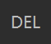 | Delete Key | 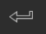 | Enter key
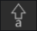 | Switch key between upper and lower letter | 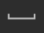 | Space key
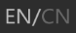 | Switch key of language

Common Button Operation

Button | Meaning
 | Click it to show the menu list.
 | Click it to change the sequence of the list.
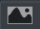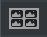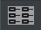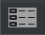 | Click it to change the camera displaying mode.
 | Click it to close the current interface.
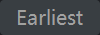 | Click it to go to the earliest date of camera recording.
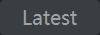 | Click it to go to the latest date of camera recording.

EZ Setup & Main Interface

EZ Setup
The disk icons will be shown on the top of the startup interface. You can view the number and status of each disk quickly and conveniently through these icons (: no disk; : unavailable disk; : RW available disk).
You must configure the wizard if you start the NVR for the first time (or click “Skip” to cancel the EZ Setup next time).
The first time you start up your NVR, you shall read the privacy statement. Then choose the language and locality as needed. After that, you shall configure date and time.
System Time: Set the time and date format of the system
DST: Toggle Daylight Saving Time On or Off
Time format: Choose between 24-hour mode and 12-hour mode.
NTP: Specify an NTP server to synchronize the time (optional).

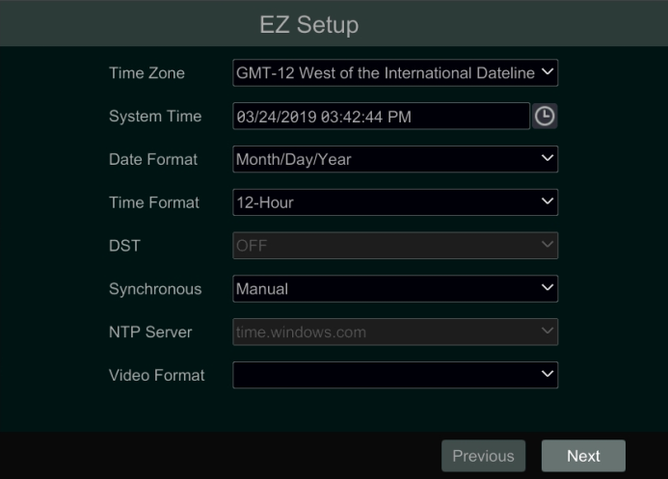

Click “Next” to continue.

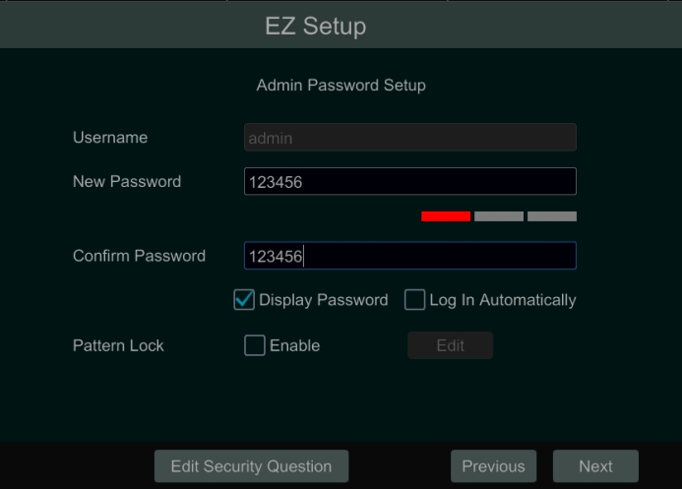

System Login. Set your own password when you use the wizard for the first time; select the login username and enter the corresponding password next time.
Enable pattern lock and click “Edit” to set the pattern lock.

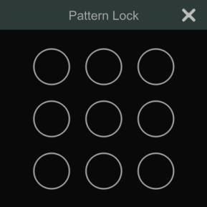

Click “Edit Security Question” to set questions and answers for password security of admin. If you forget the password, please refer to Q4 in Appendix A FAQ for details.
Click “Next” to continue.

After you log in, you will see an EZ setup interface as shown below.

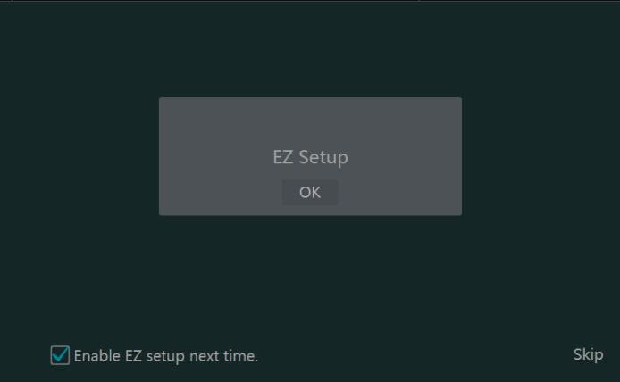

Click “OK” to start wizard. The EZ Setup steps are as follows.
- System Login. Set your own password when you use the wizard for the first time (the default username of the system is admin); select the login username and enter the password you set by yourself.

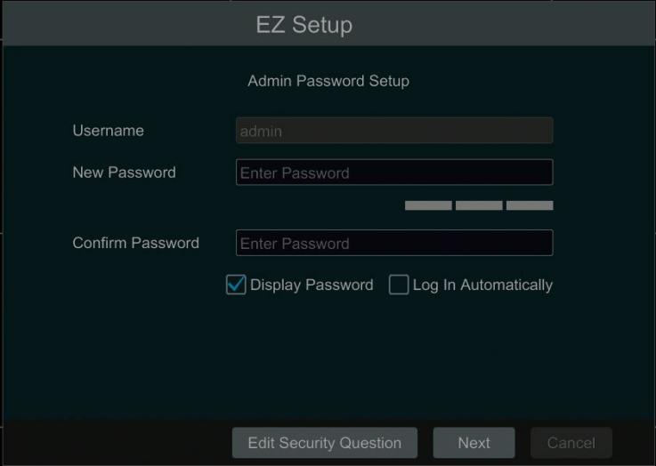

Click “Next” to continue or click “Cancel” to exit the wizard.

- Network Settings. Select the network work pattern as required. Check “Obtain an IP address automatically” and “Obtain DNS automatically” to get the IP address and DNS automatically (the DHCP function of the router in the same LAN should also be enabled), or manually enter them. Enter the HTTP port, RTSP port and Server port (please see 12.1.2 Port Configuration for details). Click “Next” to continue.

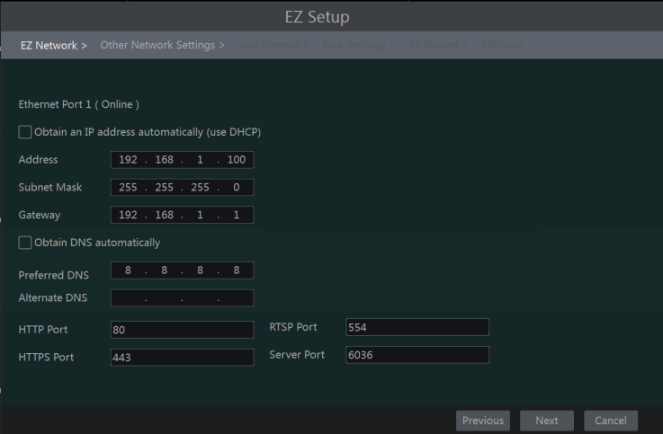

- Other Network Settings.
- UPnP settings: Check “Enable” in the interface and enter the port of external and then click “Test”. If the UPnP status were “Invalid UPnP”, the port number may be wrong. Click  to modify the port until the UPnP status turns to “Valid UPnP”. Refer to the following picture. You can view the external IP address of the NVR. Enter the external IP address plus port in the address bar of your browser to access the NVR. (Please see 12.1.6 UPnP Configuration for details).
- DDNS Settings: Check “Enable” and then select the DDNS type. Enter the server address, domain name, username and password according to the selected DDNS type. And then click “Register” or “Test” to test the effectiveness of the domain name. If it is effective, you can enter the domain name in the address bar of your browser to access the NVR. (Please see 12.1.4 DDNS Configuration for details).

Note: Make sure the router supports UPnP function and the UPnP is enabled in the router. Set the NVR’s IP address, subnet mask and gateway and so on corresponding to the router.

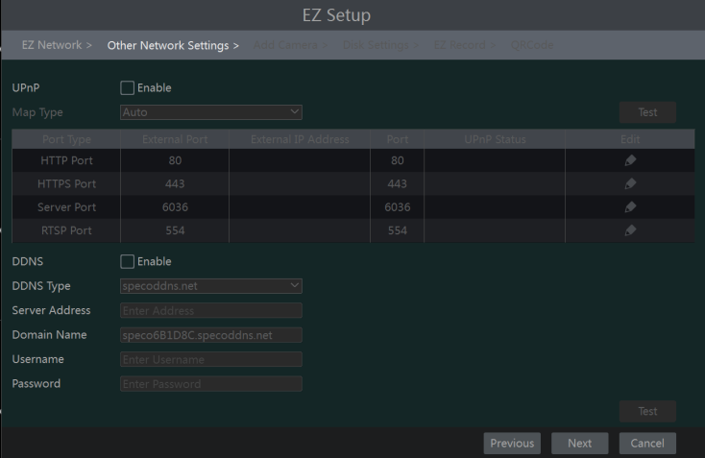

- Add Camera. Add cameras via PoE first before adding any cameras from the LAN. Speco cameras added via the PoE ports will automatically be added to the corresponding channel. To add cameras from the LAN, make sure all cameras are set to DHCP. Click “Refresh” to refresh the list of online IP cameras which are in the same local network with NVR and then click to add the searched camera. Click “Add All” to add all the cameras in the list. Click 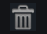 to delete the added camera. Click “Delete All” to delete all the added cameras.

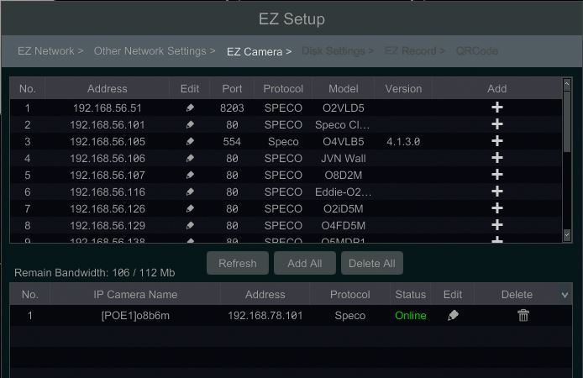

Click to edit the searched IP camera as shown on the below left. Enter the new IP address, subnet mask, gateway, username and the password of the camera. You can check “Sync to IPC” to modify the IP address of the IPC via different network segments for being in the same network segment with the NVR. Click “OK” to save the settings.

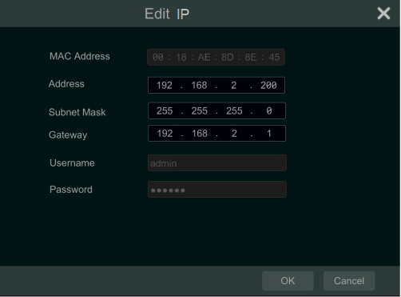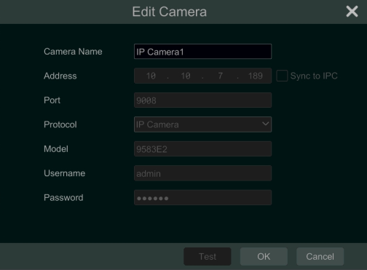

Click to edit the added camera as shown on the above right. Enter the new camera name, IP address, port, username and the password of the camera. You can click “Test” to test the effectiveness of the input information. Click “OK” to save the settings. You can change the IP camera name only when the added camera is online. Click “Next” to continue.

- Disk Settings. You can view the disk number, disk capacity of the NVR and serial number, R&W status of the disk. Click “Formatting” to format the disk. Click “Next” to continue.
- Record Settings. Two record modes are available: auto and manual.
Auto: Select one auto mode in the interface as shown below and then click “Next” button to save the settings. Click “Advanced” to self-define record mode. See 7.1.1 Mode Configuration for details.

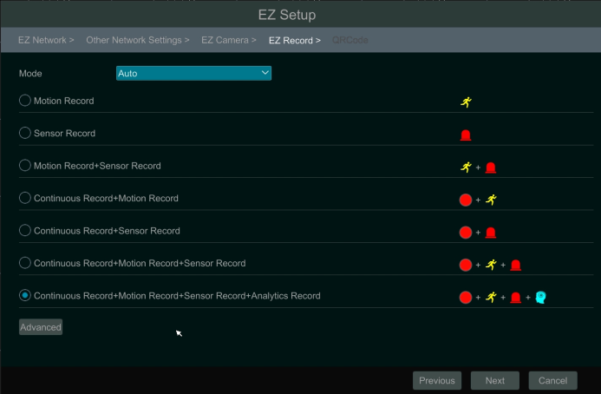

Manual: Set the “Sensor Record”, “Motion Record” and “Schedule Record” of each camera. Click “OK” to save. See 7.1.1 Mode Configuration for details.
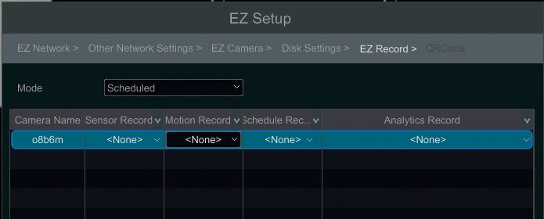

- QRCode. Enable the NAT function in the interface or set it in the network configuration after exiting the wizard (please refer to 12.1.8 NAT Configuration for details). You can scan the QRCode through the Speco Blue App available for iOS and Android to easily and securely view your cameras. Please refer to 13.1 Mobile Client Surveillance for details. Click “OK” to save the settings.

Main Interface

Main Interface Introduction

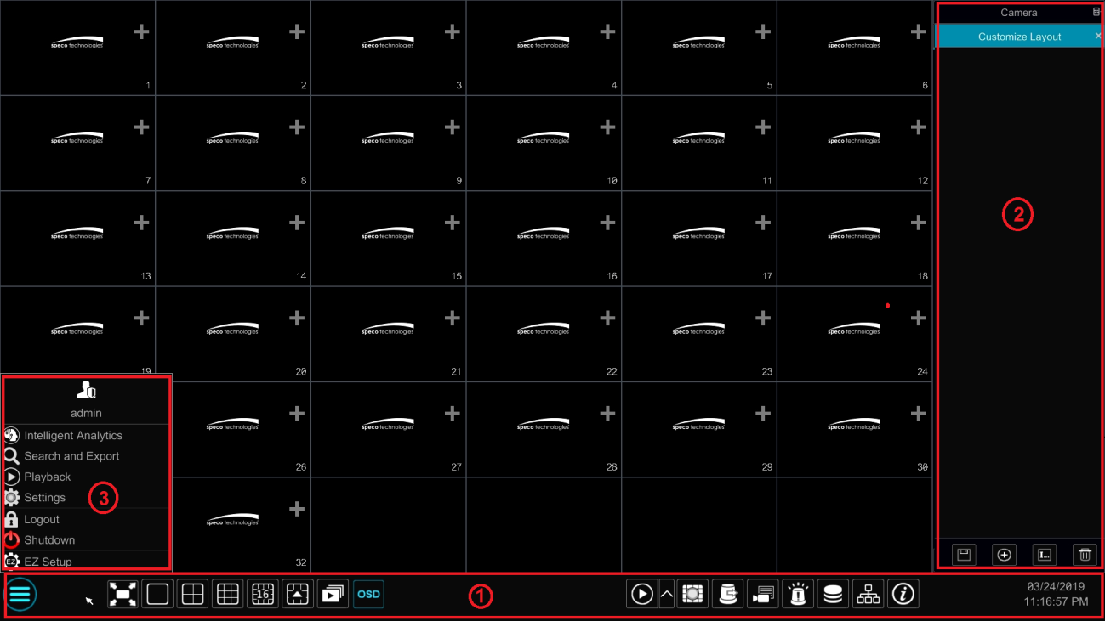

The buttons in area ① are introduced in the table below.

Button | Meaning
 | Start button. Click it to pop up area ③.
 | Full screen button. Click it to show full screen; click it again to exit the full screen.
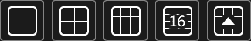 | Screen mode button.
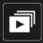 | Dwell button (see 5.2.2 Quick Sequence View and 5.2.4 Scheme View in Sequence for details).
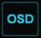 | Click it to enable OSD; click again to disable OSD.
 | Click to set the default playback time before starting instant playback (8.1 Instant Playback) or going to the playback interface for playback operations (8.2 Playback Interface Introduction); click to go to the playback interface. For instance, if you choose “5 minutes ago” as the default playback time, you can playback the record from the past five minutes.
 | Manual record button. Click it to enable/disable record.
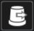 | Manual alarm button. Click it to trigger or clear the alarm-out manually in the popup window.
 | Record status button. Click it to view the record status.
 | Alarm status button. Click it to view the alarm status.
 | Disk status button. Click it to view the disk status
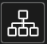 | Network status button. Click it to view the network status.
 | Information button. Click it to view system information.

Introduction of area ②:
Click “Camera” to view all the added cameras in the camera list. Select one camera window on the left side of the interface and then double click one camera in the list to preview the camera image in the selected window.
Click “Single Channel Sequences” to view all the added groups in the group list; click one group in the list to view all the added cameras in the group (refer to 4.2 Add/Edit Camera Group for detail configuration of the camera group). Select one camera window on the left side of the interface and then double click one group in the group list to preview the cameras’ images one by one in the selected window.
Click “Customize Layout” to view all the display modes in the display mode list (refer to 5.2.1 Display Mode for detail configuration of the display mode). Double click one display mode in the list to switch to the display mode for previewing.

Introduction of area ③:

Icon / Button | Meaning
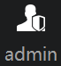 | It shows the current login user.
 | Click to go to the intelligent analytics interface.
 | Click to go to record search and export interface, see 8.4 Record Search, Playback & Export for details.
 | Click to go to playback interface (click on the tool bar at the bottom of the live view interface to set the default playback time), see Introduction for details.
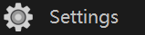 | Click to pop up the setup panel, see 3.2.2 Setup Panel for details.
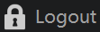 | Click to log out the system.
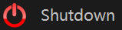 | Click and then select “Logout”, “Reboot” or “Shutdown” in the popup window.
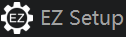 | Click to go to the EZ setup.

Setup Panel
Click StartSettings to bring up the setup panel as shown below.

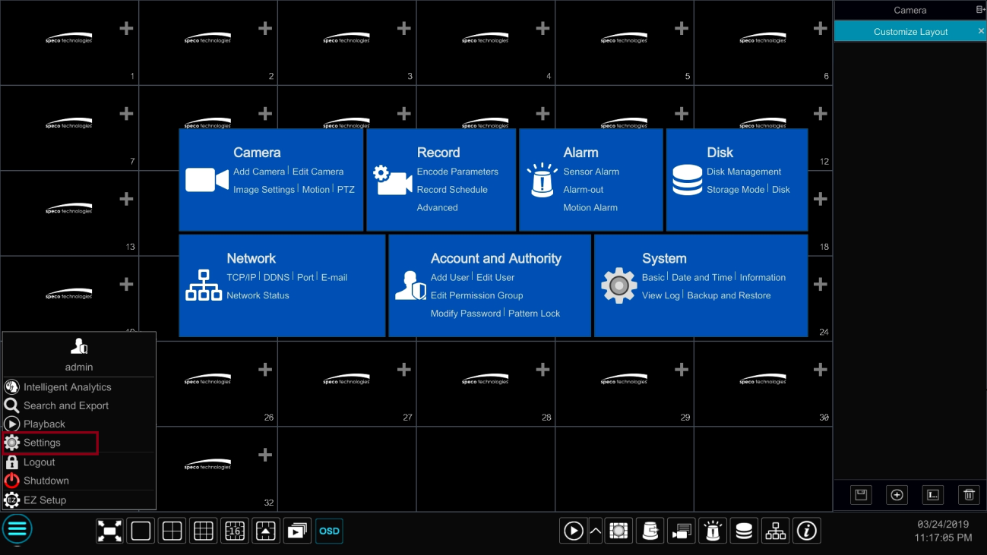

The setup panel includes seven modules. Each module provides some function entries with links for convenient operation.
Here we take Camera module as an example. The Camera module provides convenient links such as “Add Camera”, “Edit Camera”, “Image Settings”, “Motion”, “Intelligence Analysis” and “PTZ”. Click Camera to go to the camera management interface as shown below.

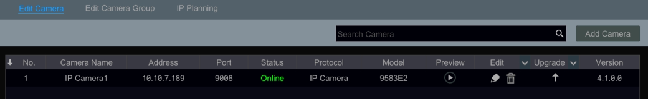

There are some function items on the left side of the camera management interface. Click each item to go to corresponding interface or window. For instance, click “Add Camera” to pop up the window as shown below.

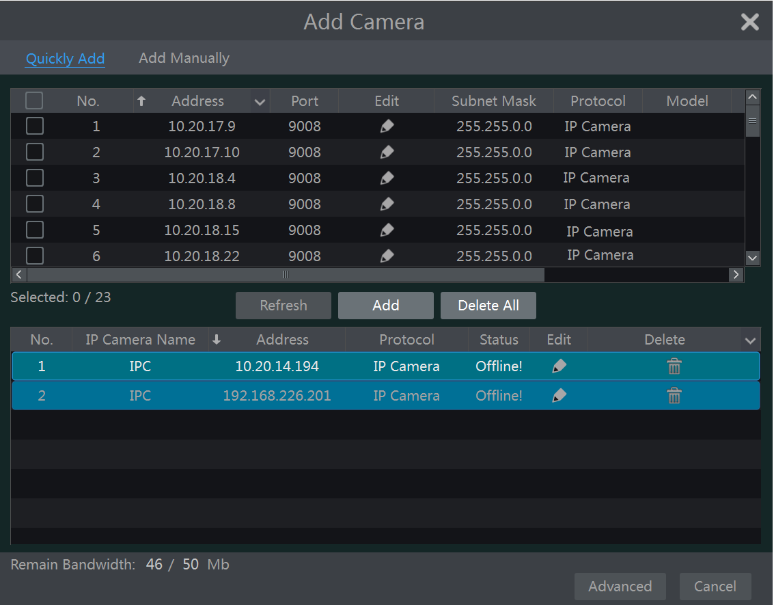
Click the main menus on the top of the camera management interface to go to corresponding interfaces. Refer to the picture below. For instance, you can go to the system setup interface by clicking “System” tag.

Main Functions
- Camera
The module covers the functions such as Camera Management (see Chapter 4 Camera Management for details), Image Settings (see 5.4 Image Configuration for details), Motion (see 9.2.1 Motion Configuration for details), and PTZ (see Chapter 6 PTZ for details) and so on.

- Record
The module covers the functions such as Encode Parameters and Record Schedule and so on. Please see Chapter 7 Record & Disk Management for details.

- Alarm
The module covers the functions such as Sensor and Motion Alarm Handling and Alarm Out Settings. Please see Chapter 9 Alarm Management for details.

- Disk
The module covers the functions such as Disk Management, Storage Mode and Disk Information and so on. Please see Chapter 7 Record & Disk Management for details.

- Network
The module covers the functions such as TCP/IP, DDNS, Port, E-mail and Network Status and so on. Please see 11.1 Network Configuration for details.
- Account and Authority
The module covers the functions such as Account Management (see 10.1 Account Management for details) and Permission Management (see 10.3 Permission Management for details) and so on.

- System
The module covers the functions such as Basic Configuration (see 11.2 Basic Configuration for details), Device Information (see 11.8 View System Information for details), Log Information (see 11.7 View Log for details) and Configuration File Import & Export (see 11.5 Backup and Restore for details) and so on.

Camera Management

Add/Edit Camera

Add Camera
The network of the NVR should be set before adding IP camera (see 11.1.1 TCP/IP Configuration for details).
Refer to the pictures below. Click Add Camera in the setup panel or in the top right corner of the preview window to pop up the “Add Camera” window as shown below. You can quickly add or add the IP camera manually.

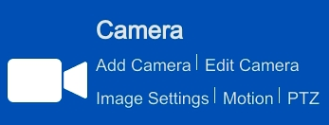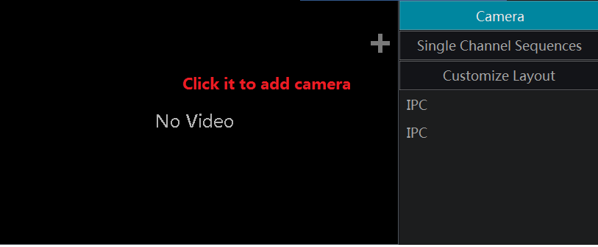

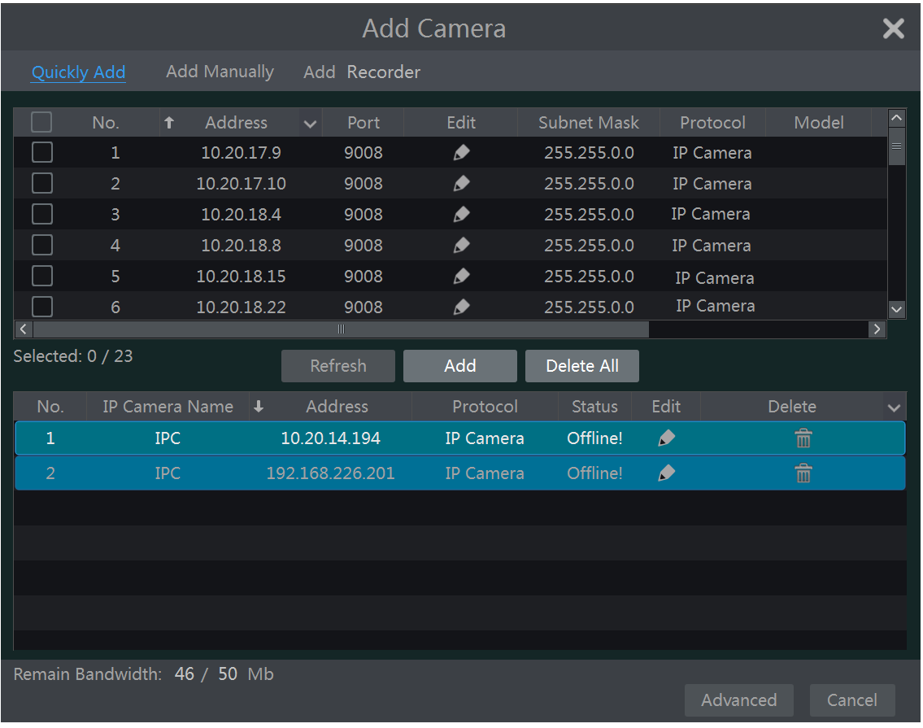

- Quickly Add
Check the cameras and then click “Add” to add cameras. Click to edit the camera’s IP address, username and password and so on. Click “Default Password” to set the default username and password of each camera.

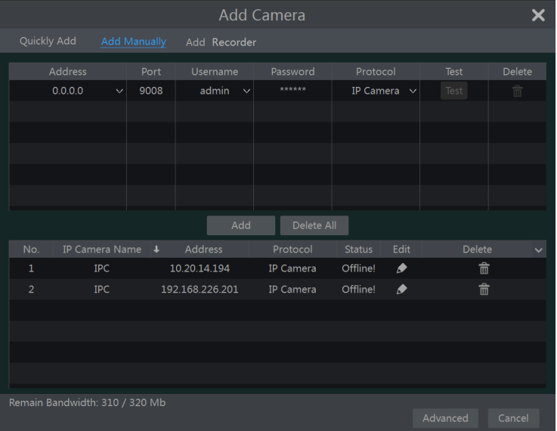

- Add Manually
Enter the IP address or domain name (click in the IP address column to pop up the domain name input window, enter the domain name of the IPC in the window and then click “OK” button), port, username and password of the camera and then select the protocol. Click “Test” to test the effectiveness of the input information and then click “Add” button (you can input one camera’s information or above such as IP address, username and password before clicking “Add” button). Click to delete the camera. Click “Default Password” to set the default username and password of each camera.

Note: Some models may not support this function.
Click StartSettingsSystemBasicGeneral Settings to check “Enable Add IPC by Zero Operation”. If the NVR has unoccupied channels, it can add IPC without any operation by restarting.

- Add Recorder

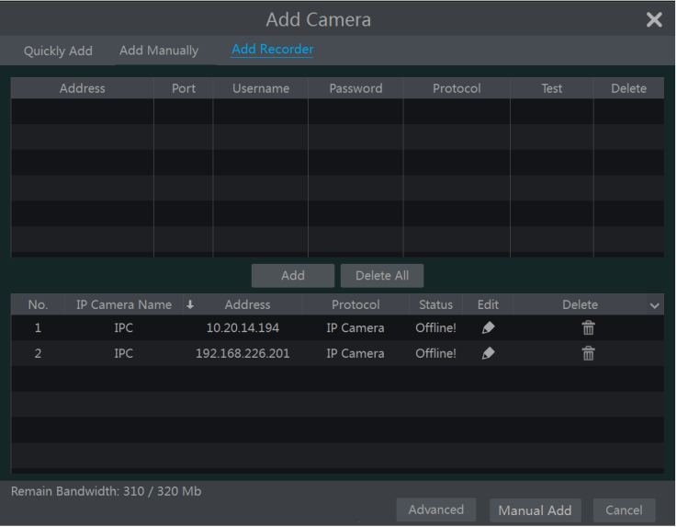

- Quickly Add：Select the searched NVR/DVR and the click “Add” to add NVR in the same local network.
- Manually Add：Click “Manual Add” and then enter the IP address or domain name, port, username and password of the NVR/DVR. Check the added remote channel number and click “Test” to test the effectiveness of the input information. Then click “OK” button to return to the previous interface.

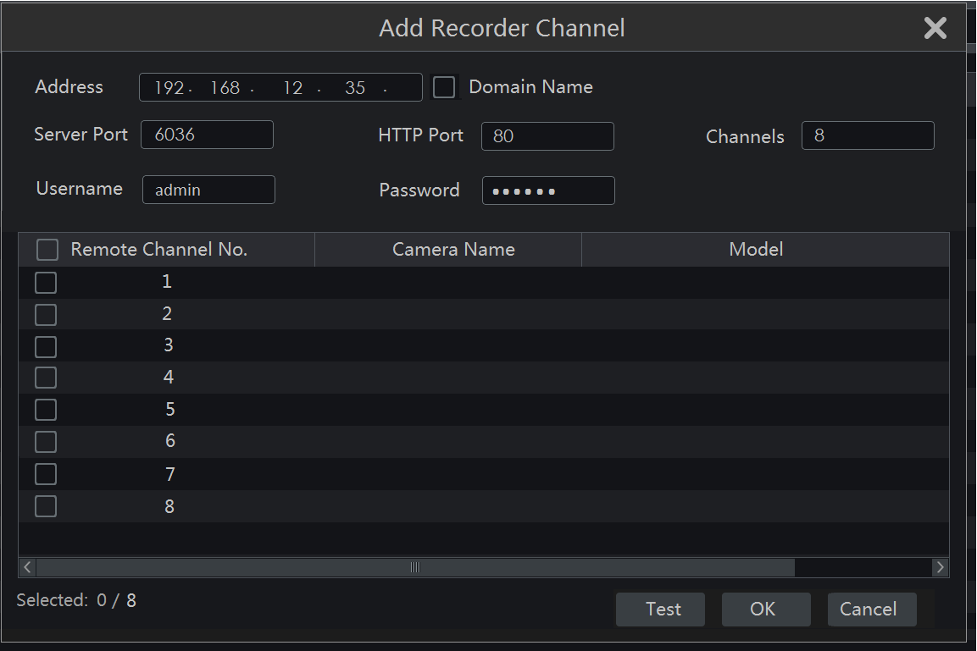

Note: Only the local NVR has unoccupied channels, may the IPC of other NVR/DVR in the same local network be added. And the added IPC supports previewing and recording.

Edit Camera
Click “Edit Camera” in the setup panel to go to the interface as shown below. Click 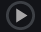to view the live image of the camera in the popup window. Click to edit the camera (see Add camera in 3.1 Startup Wizard for details). Click to delete the camera. Click in the “Operation” header line and then click “Modify IPC Password” to pop up a window (check the IPCs in the window, set the new password and then click “OK” button; only the online IPCs’ passwords can be modified and a batch of IPCs’ passwords can be modified at the same time). Click to upgrade an online IPC ( or click in the “Upgrade” header line and then click “IPC Batch Upgrade” to upgrade a batch of IPCs), select the device which stores the upgrade file in the “Device Name” item of the popup window and the upgrade file in the list(you should select the upgrade IPC model in the window if a batch of IPCs’ passwords need to be modified) and then click “Upgrade” button to start upgrading(the IPC will restart automatically after the upgrade is completed successfully).

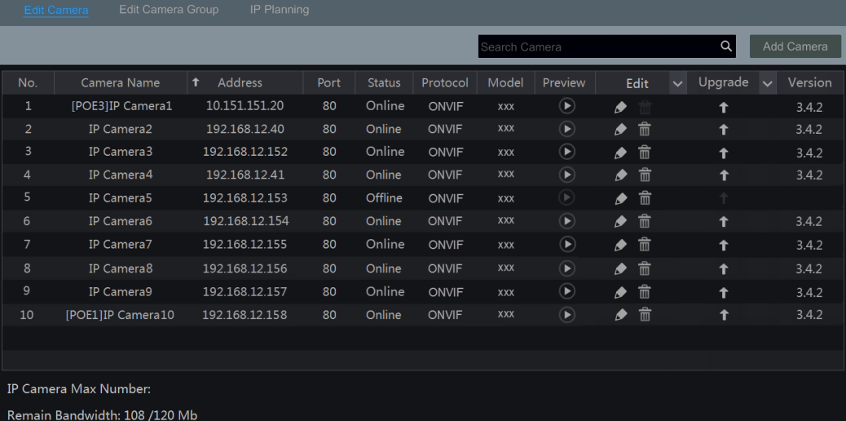

The IP cameras with PoE function which are directly connected to the PoE port of the NVR will be displayed automatically in the camera list. Refer to the picture below. The IP camera which occupies the PoE resource has a prefix shown before its camera name. The prefix consists of PoE plus PoE port number. The IP camera which connects to the PoE port cannot be deleted from the camera list manually.

- The IP camera directly connected to the PoE port of the NVR through private protocol will be shown automatically in the camera list.
- One of the two conditions must be met if the IP camera which is directly connected to the PoE port of the NVR through ONVIF protocol should be shown automatically in the camera list.
- The IP camera which is directly connected to the PoE port is in the same network segment with the internal Ethernet port.
- The DHCP (obtain an IP address automatically) of the IP camera which is directly connected to the PoE port is enabled.

If the IP camera which is connected to the PoE port cannot be displayed automatically in the camera list, please refer to Q6 in Appendix A FAQ for details.

Add/Edit Camera Group

Add Camera Group
Click “Edit Camera Group” in the above interface to go to the interface as shown below.

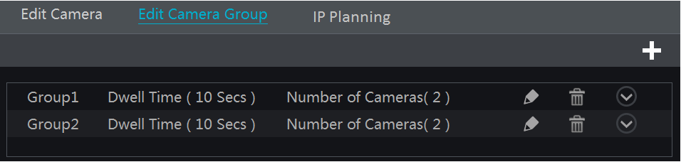

Click to pop up the window as shown below. Set the group name and dwell time (the dwell time of the camera group sequence view) in the window. Check the cameras and then click “Add” to add group. Click to view the cameras in the group after adding group.

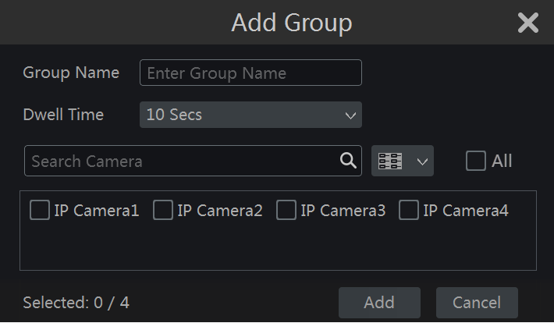

Edit Camera Group

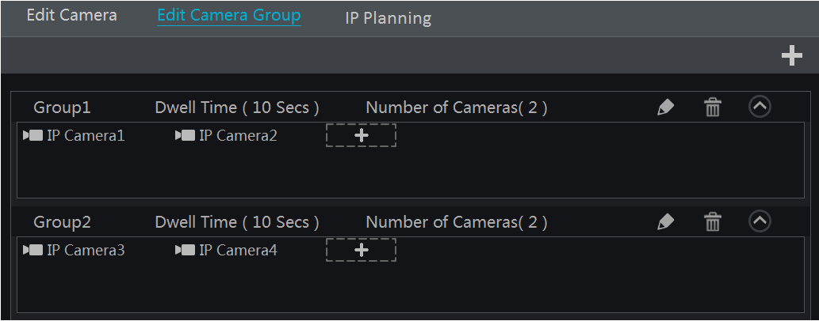

Click to modify the group information such as group name and dwell time. Click to delete the group.

IP Planning
Some models may not support this function.
Click “IP Planning” to go to the interface as shown below. This function supports searching other NVRs/DVRs that is in the same local network as the local NVR. The user may add camera channels of other NVRs/DVRs into the unoccupied channels of the local NVR.

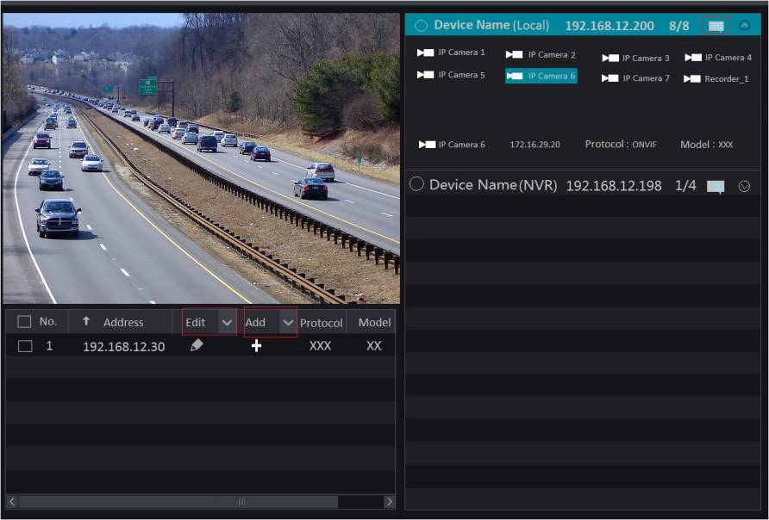

Click to edit the IP address, user name or password and other information of the NVRs.
Click behind “Add” button to add the camera channels selected and the user may edit the IP address, user name or password by clicking behind “Edit” button.

Live View Introduction

Live View Interface Introduction
You should add a camera first after logging on to the system (see 4.1.1 Add Camera for details). Refer to the interface as shown below, drag one camera in the preview window to another window for camera window exchanging.
The record symbols with different colors in the live view window refer to different record types when recording: green stands for manual record, red stands for sensor based record, yellow stands for motion based record, blue stands for schedule record and cyan stands for intelligence record.

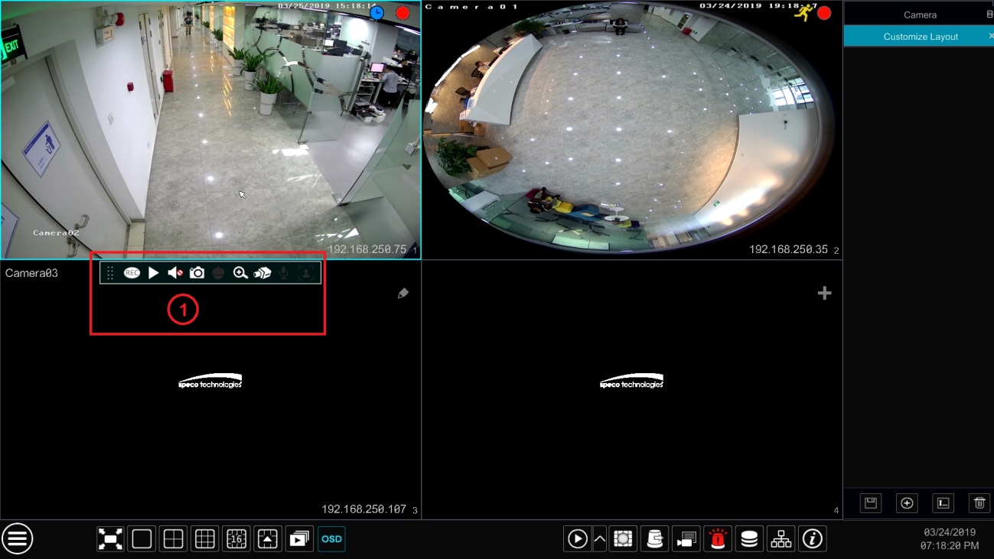

Click the preview window to show the tool bar as shown in area ①; right click the preview window to show the menu list. The tool bar and menu list are introduced in the table below.

Button | Menu List | Meaning
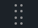 | -- | Move tool. Click it to move the toolbar anywhere.
 | Manually Record On | Click it to start recording.
 | Instant Playback | Click to playback the record; click “Instant Playback” to select or self-define the instant playback time. See 8.1 Instant Playback for details.
 | Enable Audio | Click it to enable audio. You can listen to the camera audio by enabling audio.
 | Snap | Click it to pop up the snap window. Click “Save” in the window to save the image. Click “Export” to export the image.
 | PTZ Control | Click it to go to PTZ control interface. See Chapter 6 PTZ for details.
 | Zoom In | Click it to go to single channel amplification interface.
 | -- | Click it to go to image adjustment interface. Refer to 5.4.5 Image Adjustment for details.
-- | Camera Info | Click it to view the camera information.

The single channel zoom interface is as shown below. Press and drag the blue box to select the zoom in area. Click / to zoom the image. Click the camera selection box to select other cameras for amplification. Click “Back” to return to the live view interface.

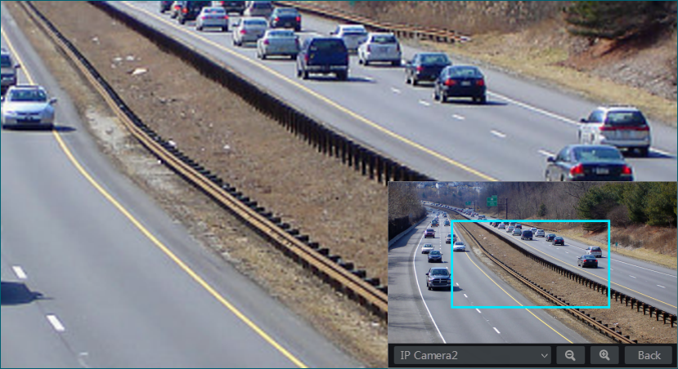

View Mode

Display Mode
Set different screen modes and cameras’ display sequences as needed and then save the display modes classified by surveillance areas, priorities and so on. Refer to the picture below. Double click one display mode in the display mode list to view the live images in this mode.

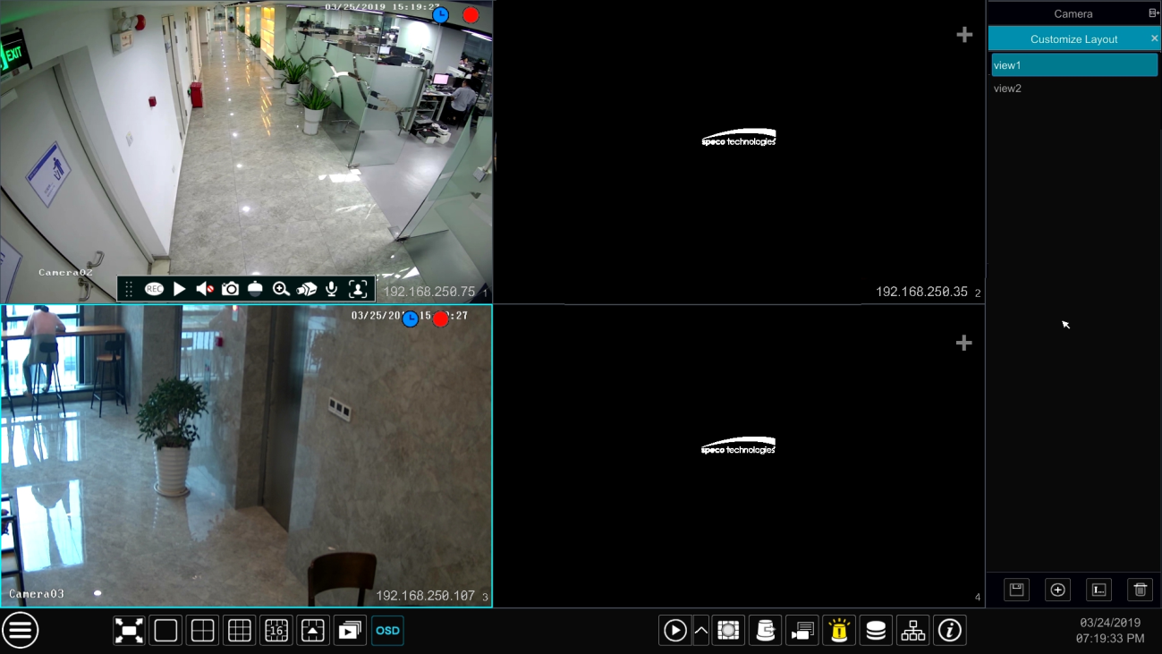

- Add Display Mode
Method One:
- Click “Customize Layout” in the above interface
- Click  to add a display mode name and then set the screen mode.
- Add the cameras and adjust the cameras’ display sequence as required.
- Click 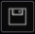 under the display mode list.

Method Two:
- ClickStartSettingsSystemBasicOutput Settings to go to the interface and then set the screen mode.
- Double click the camera or camera group in the list to add them to the selected window.
- Click  to save the current display mode (refer to 5.2.4 Scheme View In Sequence for detail configurations). The display mode will be saved and displayed in the display mode list in the live view interface.

- Edit Display Mode
Click “Customize Layout” tab in the live view interface and then select one display mode in the list. Click 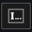 to edit the display mode name; click 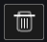 to delete the display mode.

Quick Sequence View
You can start quick sequence view if the scheme has not been created. If the scheme has been created, please refer to 5.2.4 Scheme View in Sequence for details.

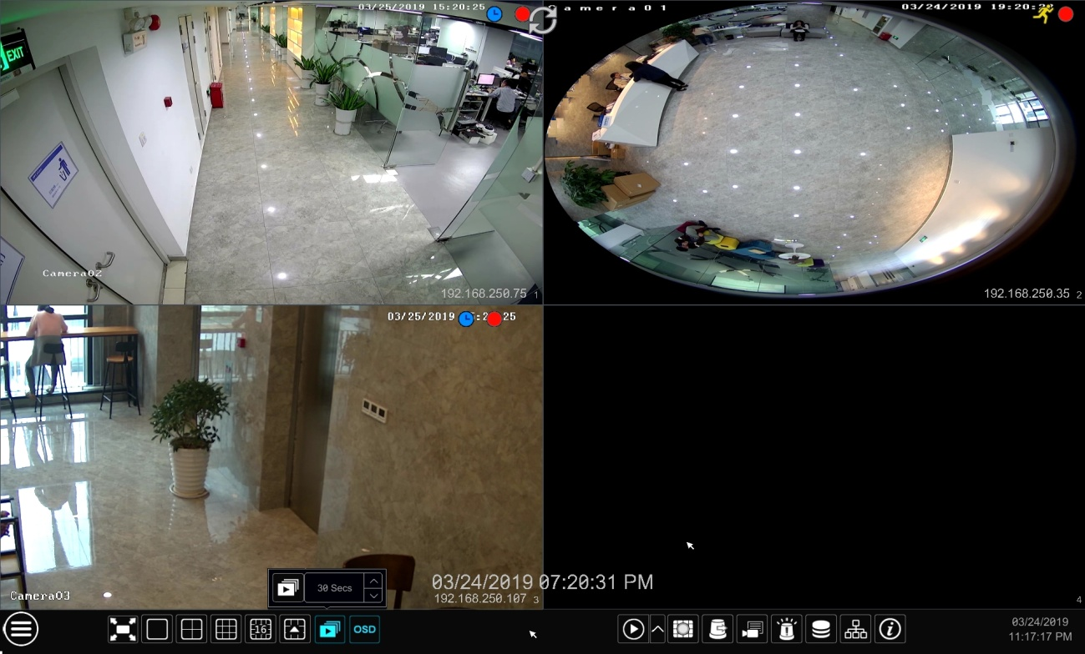

Go to the live view interface and then click  to pop up a little window. Set the dwell time in the window and then click to view the live group by group according to the camera number of the current screen mode. Double click the sequence view interface to pause the view; double click again to restore the view. Click  to stop the view.

Camera Group View In Sequence
You can start camera group view in sequence if camera group has been created (see 4.2.1 Add Camera Group for details).
- Go to the live view interface and then select a camera window.

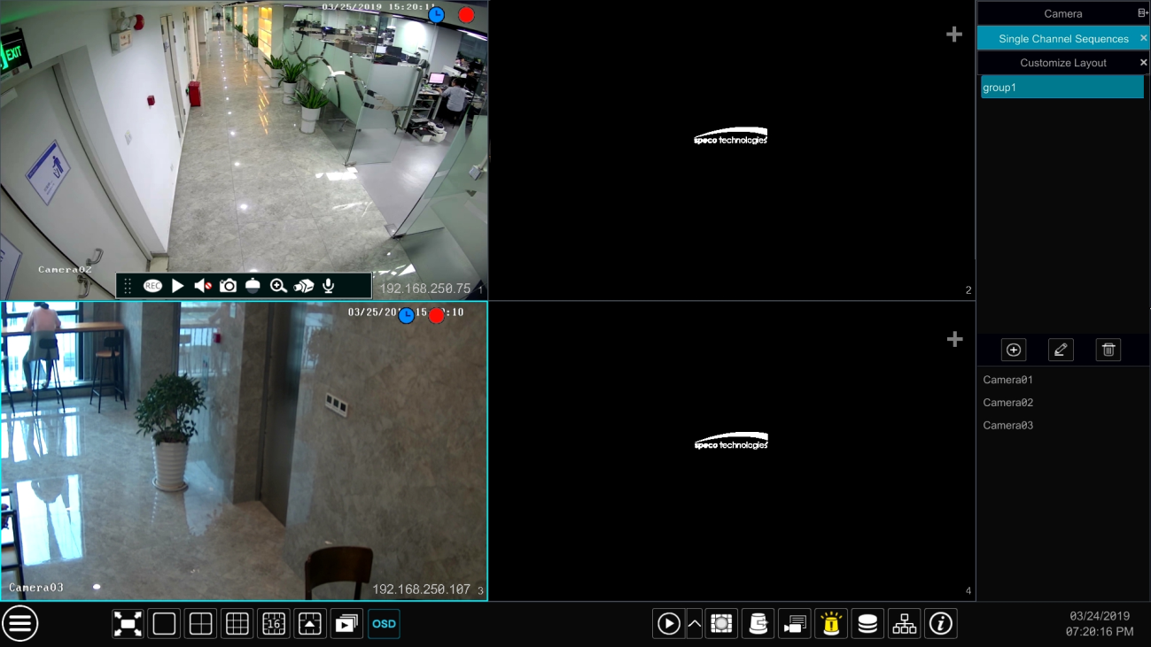

- Double click one camera group on the right side of the interface. The cameras in the group will start camera group view one by one in the selected camera window.
You can also drag the group directly to any preview window. Right click on the group view window and then click “Close Dwell” button to stop the view.
You can also add camera group in the live view interface. Select “Single Channel Sequences” and then click  to add camera group. Click 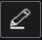 to modify the group name and sequence interval. Click  to delete the group.

Scheme View In Sequence
Click StartSettingsSystemBasicOutput Settings to go to the interface as shown below.
Area ① displays all the dwell schemes; area ② shows the detailed information of the scheme; area ③ displays all the cameras and groups; area ④ is the tool bar (: clear button;: favorite button, click it to pop up a window, enter the display mode name in the window and then click “OK” to save the current display mode; other buttons are screen mode buttons).

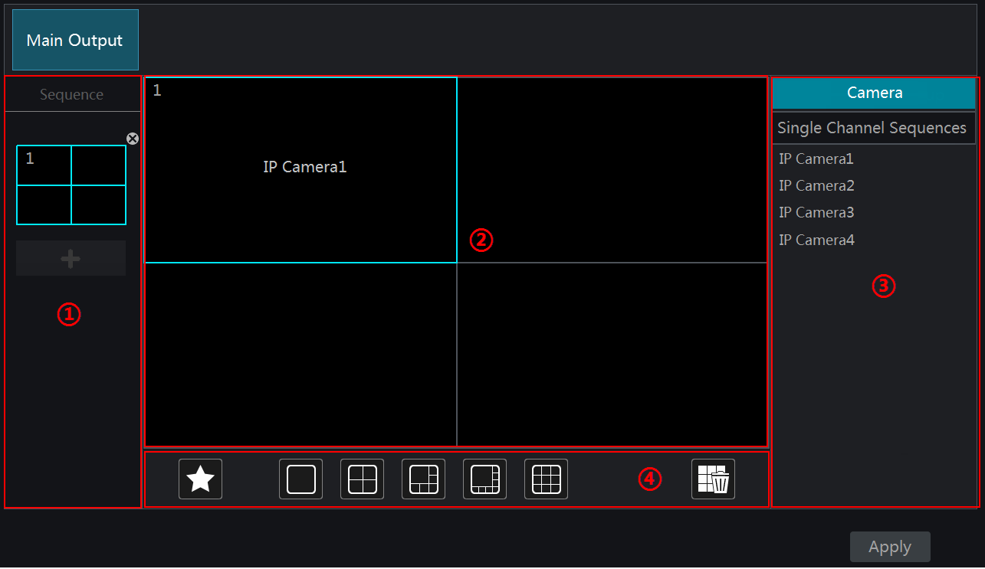

- Add Scheme
Click in area ① to create a new scheme. Click 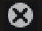 on the top right corner of the scheme to delete it.

- Configure Scheme
- Select a scheme in area ① and then click the screen mode button on the tool bar to set the screen mode of the scheme.
- Select a camera window in area ② and then double click the camera or group in area ③. The camera or group will be added into the selected window. One camera in the same scheme cannot repeat. You can click the right-click menu “Clear” in area ② to remove a single camera or click to remove all the cameras.
- Click “Apply” to save the settings.

- Start Sequence View
Go to the live view interface and then click to open a window. Set the dwell time in the window and then click to start scheme view in sequence. Double click the sequence view interface to pause the view; double click again to restore the view. Click to stop the view.

Image Configuration

OSD Settings
Click StartSettingsCameraImageOSD Settings to go to the interface as shown below. Select the camera, enter the camera name (or double click the camera name in the camera list to change the camera name), enable or disable the name and time OSDs (if enabled, drag the red name and time OSDs directly in the image view area to change the OSDs’ display position) and select the date and time formats. Click “Apply” to save the settings.
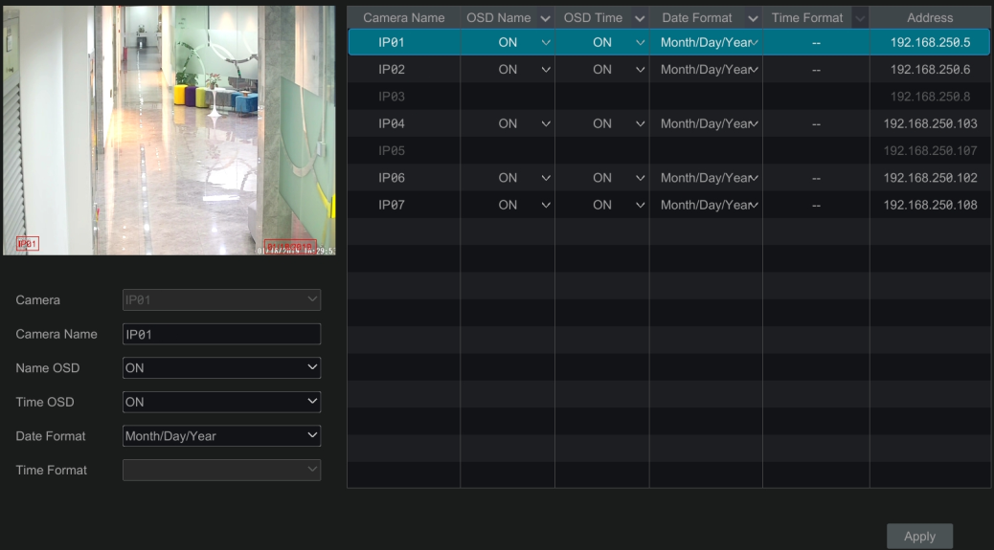

Image Settings
Click StartSettingsCameraImageImage Settings to go to the following interface. Select the camera and then set the brightness, contrast, saturation and hue of the camera. Click “Advanced” button or 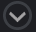 in the camera list on the right side of the interface to pop up “Image Adjust” interface and then set the relevant setting items. Please refer to 5.4.5 Image Adjustment for detailed introductions of these items.
You can click “Default” to restore the image settings to the default factory settings.

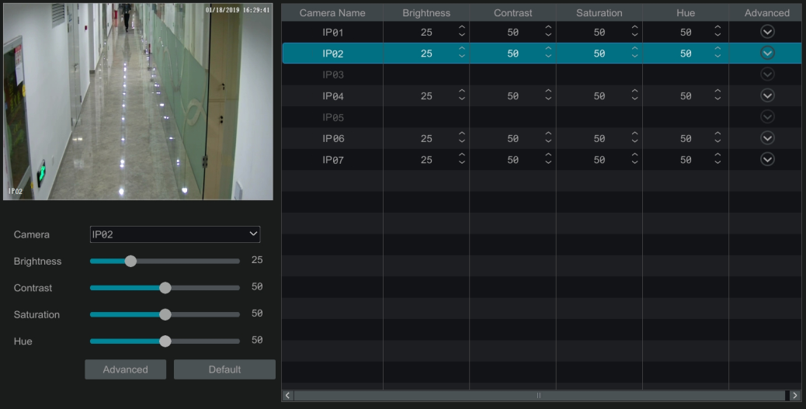

Mask Settings
Some areas of the image can be masked for privacy. Up to four mask areas can be set for each camera. Click StartSettingsCameraImageMask Settings to go to the interface as shown below. Select the camera and enable the mask. Click “Draw” button and then drag the mouse on the image area to set the mask area; click “Delete” button to delete the mask areas; click “Apply” to save the settings.

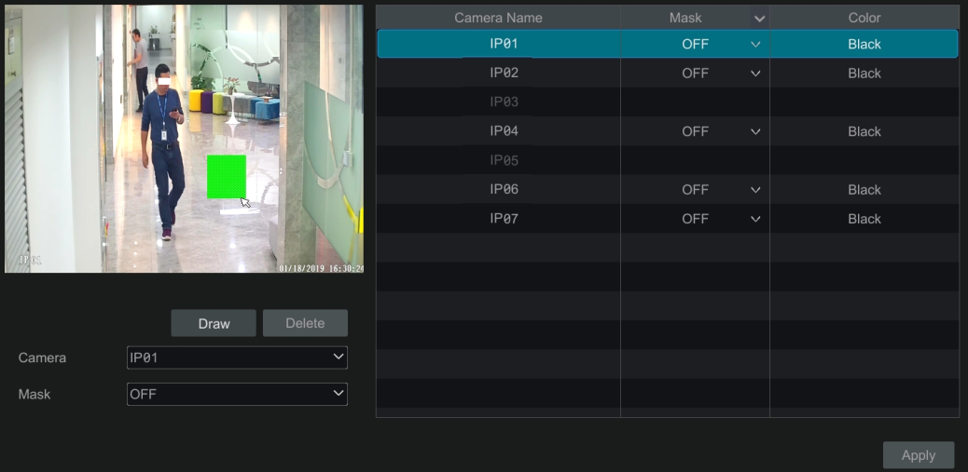

Fisheye Settings
Some models may not support this function.
Click StartSettingsCameraImageFisheye Settings to go to the interface as shown below. Select the camera and the mode of fisheye and installation.

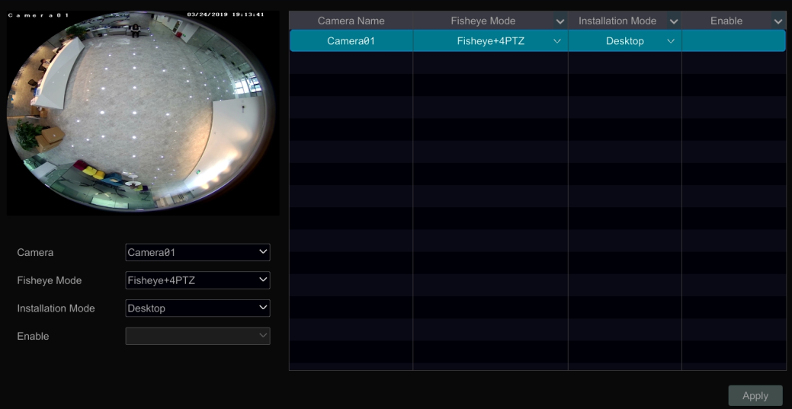

Image Adjustment
Go to the live view interface and then click button on the tool bar under the camera window to go to the image adjustment interface.

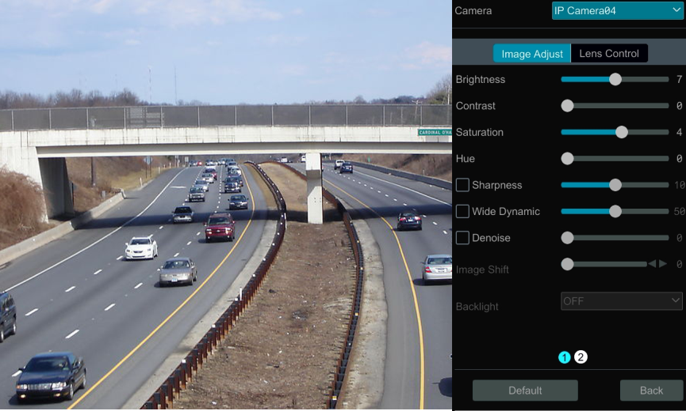

- Image Adjustment
Select the camera and then click “Image Adjustment” to go to image adjustment tab. Refer to the above picture. Drag the slider to set the camera’s brightness, contrast, saturation and hue value. Check sharpen, wide dynamic and denoise and then drag the slider to set the value. Click “Default” button to set these parameters to default values.
The introductions of these parameters are as follows:

Parameter | Meaning
Brightness | It is the brightness level of the camera’s image.
Contrast | It is the color difference between the brightest and darkest parts.
Saturation | It is the degree of color purity. The color is purer, the image is brighter.
Hue | It relates to the total color degree of the image.
Sharpen | It relates to the resolution level of the image plane and the sharpness level of the image edge.
Wide Dynamic | The wide dynamic range (WDR) function helps the camera provide clear images even under back light circumstances. When there are both very bright and very dark areas simultaneously in the field of view, WDR balances the brightness level of the whole image and provide clear images with details.
Denoise | Adopt the noise reduction technology to decrease the noise and make the image more thorough. Increasing the value will make the noise reduction effect better but it will reduce the image resolution.
White Balance | White balance is the white rendition function of the camera to adjust the color temperature according to the environment automatically.
BLC | HLC: lowers the brightness of the entire image by suppressing the brightness of the image’s bright area and reducing the size of the halo area.  BLC: If enabled, the auto exposure will activate according to the scene so that the object of the image in the darkest area will be seen clearly.
Image Mirror | Reverse the current video image right and left.
Image Flip | Turn the current video image upside down.

- Lens Control
Select the camera and then click “Lens Control” to go to lens control tab. Click 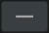 or 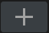 to adjust the zoom and focus parameters of the camera’s lens. Click “Save” to save the settings.
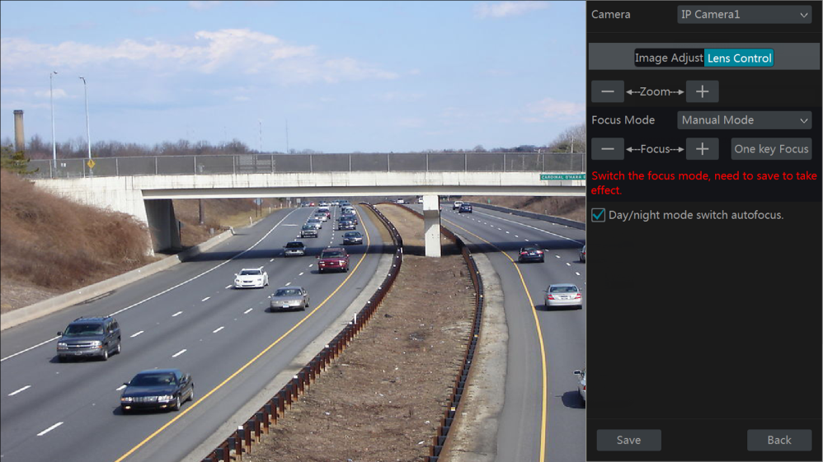

The introductions of these parameters and buttons are as follows.

Button/Parameter | Meaning
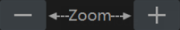 | Click / to zoom in/out the image.
Focus Mode | If manual mode is selected, focus button & “One Key Focus” & “Day/night mode switch autofocus” will be available; if auto mode is selected, the time interval setup will be available.
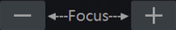 | Click / to increase/decrease the focal length.
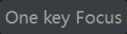 | Click it to focus instantly.
Day/night mode switch autofocus | If checked, the lens will focus automatically when the camera is switching day/night mode.
Time Interval | It is the time interval when camera lens is auto-focusing. The interval can be set in the drop-down list.

Note: if the lens of the camera connected to the NVR is fixed, the lens control function is unavailable.

PTZ

PTZ Control Interface Introduction
You can control the IP dome or PTZ which connects to the IP camera for PTZ control.
Click on the tool bar at the bottom of the live view window to go to the PTZ control interface as shown below. You can select another IP dome or PTZ which connects to the IP camera on the top right of the interface for PTZ control.

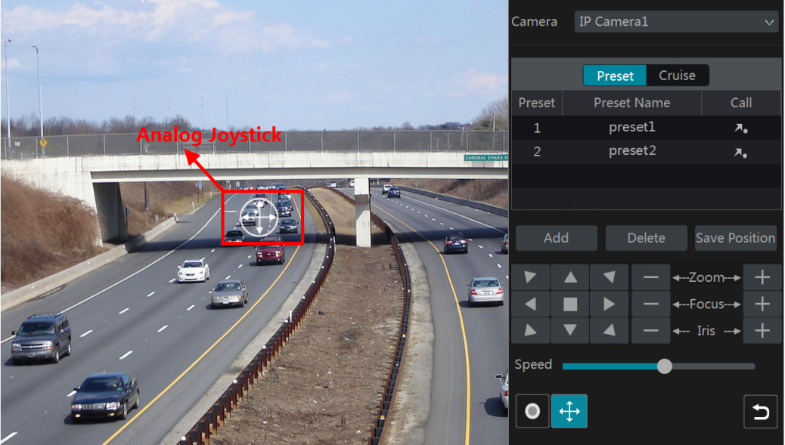

Introductions of the buttons on the bottom right of the interface:

Button | Meaning
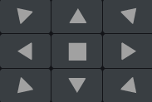 | Click  /  /  / /  / / / to rotate the dome. Click to stop rotating the dome.
 | Click / to zoom in / out the camera image.
 | Click / to increase / decrease the focal length.
 | Click / to increase / decrease the iris of the dome.
 | Drag the slider to adjust the rotating speed of the dome.
 /  | Click / to start / stop recording.
 /  | Click / to hide / show the analog joystick.
 | Click it to return to the live view interface.

- Analog Joystick Control
The analog joystick on the left side of the interface provides quick PTZ control. The dome or PTZ will rotate when you drag the analog joystick. The farther you drag the analog joystick from the middle of the image, the faster the dome or PTZ rotates. The dome or PTZ will stop rotating when you stop dragging the analog joystick.

- 3D Control
Click the camera image on any area and then the image will be centered on the clicked point.
Refer to the picture as shown below. Drag the mouse from A to B to get a green rectangle and the rectangle area will be zoomed in.

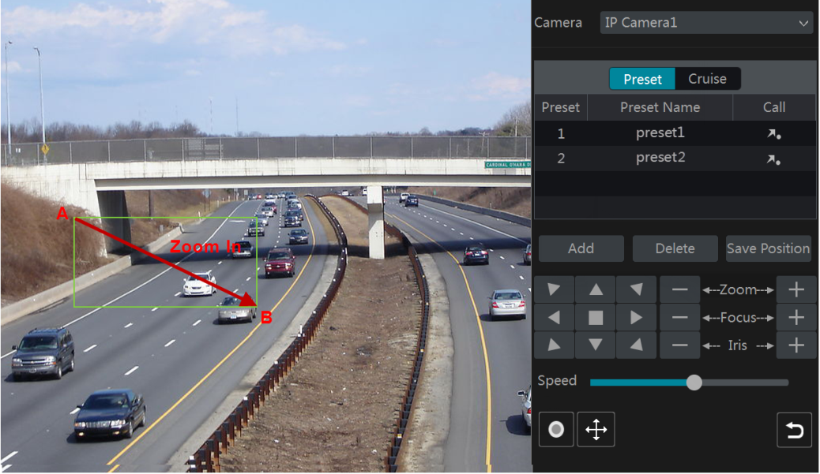

Refer to the picture as shown below. Drag the mouse from C to D to get a green rectangle and the rectangle area will be zoomed out.

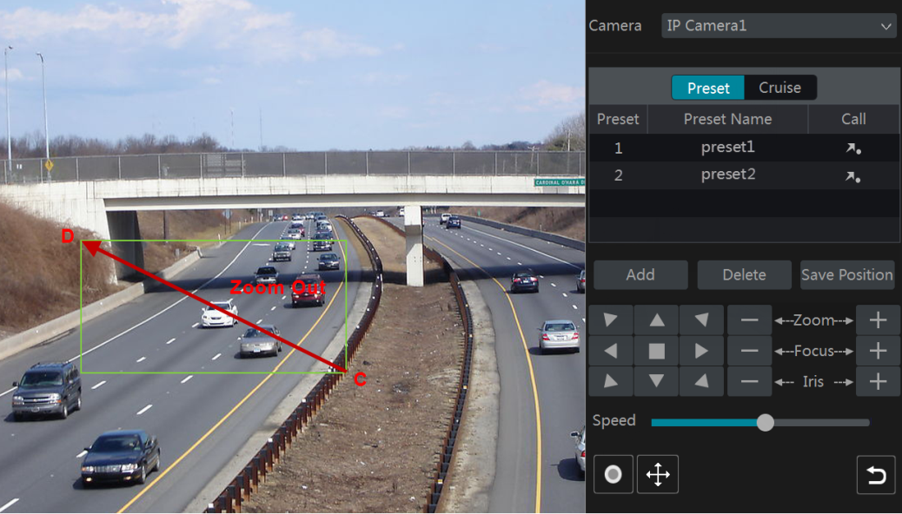

- Advanced 3D Control
Double click the left button of the mouse on any area of the camera image and then the image size will be doubled and centered on the clicked point.
Press and hold the left button of the mouse on any area of the camera image to zoom in the image; press and hold the right button to zoom out the image.
Move the cursor of the mouse to the camera image and then slide the scroll wheel of the mouse forward to zoom in the image, slide the scroll wheel of the mouse backward to zoom out the image.

- Preset Setting
Click “Preset” to go to preset operation tab and then click “Add” button to pop up a window as shown below. Select the preset and then enter the preset name in the window; finally click “OK” button to save the settings. You can add 255 presets for each dome at most.

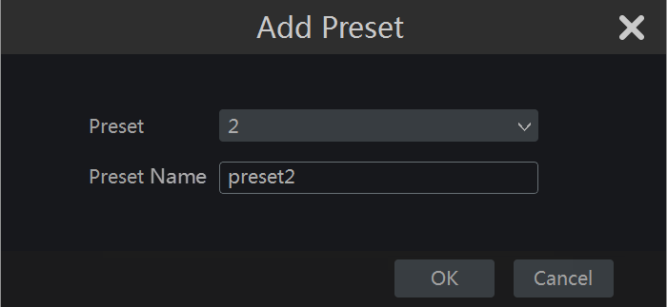

Adjust the dome’s direction and then click “Save Position” to save the current preset position (you can also click another preset in the preset list and then save the preset position after adjusting the dome’s direction); click in the preset list to call the preset; click “Delete” button to delete the selected preset.
You can also go to preset setting interface for preset setting, see 6.2 Preset Setting for details.

- Cruise Setting
Click “Cruise” to go to cruise operation tab and then click “Add” button to pop up a window as shown below left. You can add 8 cruises for each dome at most.

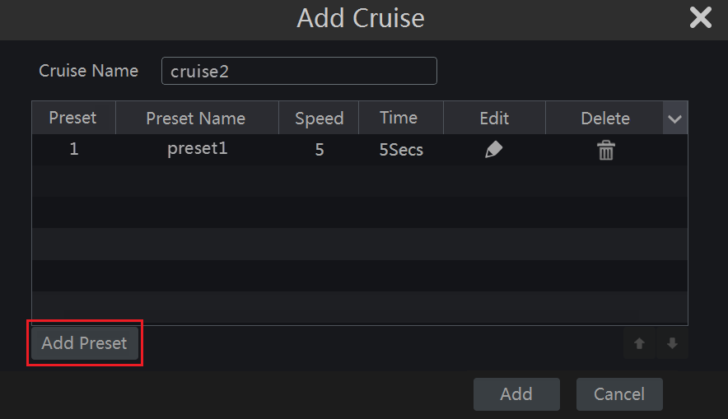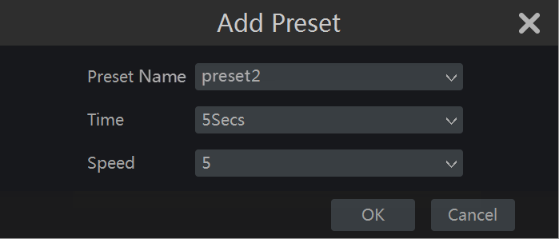

- Enter the cruise name in the “Add Cruise” window and then click “Add preset” to pop up the “Add Preset” window (Before adding preset to the cruise, please add preset of the dome first).
- In the “Add Preset” window, select the preset name, preset time and preset speed and then click “OK” button.
- In the “Add Cruise” window, you can click to reselect the preset, then change the preset time and speed. Click to delete the preset. Click “Add” button to save the cruise.
Click to start the cruise and click to stop the cruise in the cruise list of the cruise operation tab; click “Delete” button to delete the selected cruise.

You can also go to cruise setting interface for cruise setting, see 6.3 Cruise Setting for details.

Preset Setting
Click StartSettingsCameraPTZPreset to go to the interface as shown below.

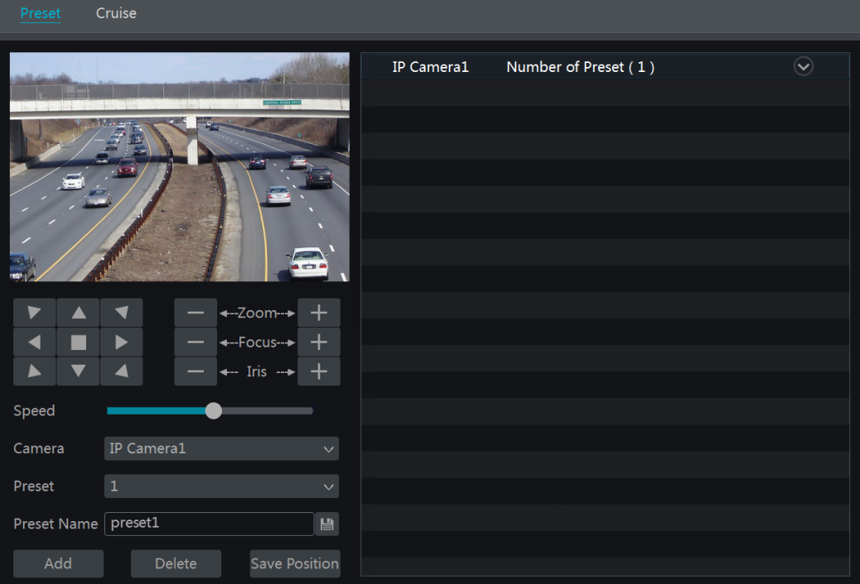

- Add preset
Select camera and then click “Add” button to add preset; or click in the camera list on the right side of the interface to display the preset information of the dome and then click to add preset. The operations of the “Add Preset” window are similar to that of the PTZ control interface; please see 6.1 PTZ Control Interface Introduction for details.

- Edit preset
Select camera and preset. You can enter the new name of the preset and then click to save the new preset name. Adjust the rotating speed, position, zoom, focus and iris of the preset and then click “Save Position” to save the preset.

- Delete Preset
Select camera and preset and then click “Delete” to delete the preset.

Cruise Setting
Click StartSettingsCameraPTZCruise to go to the interface as shown below.

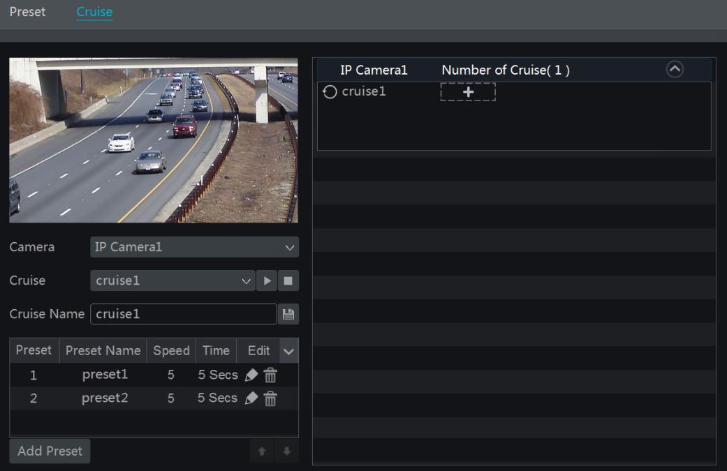

- Add Cruise
Click in the camera list on the right side of the interface to display the cruise information of the dome and then click to add cruise. The operations of the “Add Cruise” window are similar to that of the PTZ control interface; please see 6.1 PTZ Control Interface Introduction for details.

- Edit Cruise
Select the camera and cruise in the “Cruise” interface. Enter the new cruise name and then click to save the cruise name. Click “Add Preset” to add preset to the cruise. Click to edit the preset. Click to delete the preset from the cruise. Click one preset in the preset list and then click to move down the preset and click to move up the preset. Click to start the cruise and click to stop it.

- Delete Cruise
Click in the camera list on the right side of the interface to display the cruise information of the dome and then click on the top right corner of the cruise to delete the cruise.

Record& Disk Management

Record Configuration

Mode Configuration
Please format the HDDs before recording (refer to 7.5 Disk Management for details). Click StartSettingsRecordMode Settings to go to the mode settings interface. You can set the record time under the “Manual Record Settings” and then click “Apply” to save the settings. There are two record modes: auto mode and manual mode.

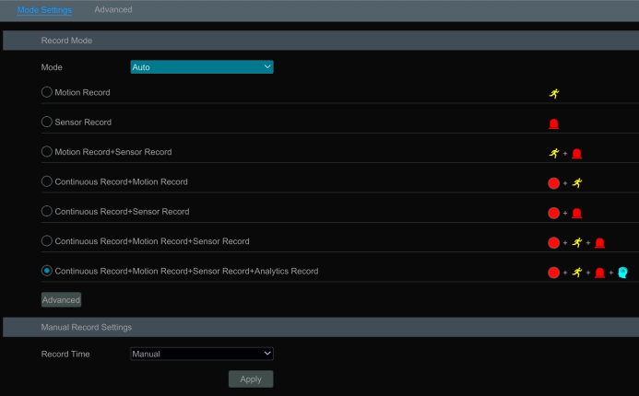

- Auto Mode

Motion Record: Motion alarm record will be enabled when motion alarm happens.
Sensor Record:Sensor alarm record will be enabled when sensor alarm happens.
Motion Record+Sensor Record:Motion/sensor alarm record will be enabled when motion/sensor alarm happens.
Continuous Record+Motion Record:Normal record is enabled all the time; motion alarm record will be started when motion alarm happens.
Continuous Record+Sensor Record: Normal record is enabled all the time; sensor alarm record will be started when sensor alarm happens.
Continuous Record+MotionRecord+Sensor Record:Normal record is enabled all the time; motion/sensor alarm record will be enabled when motion/sensor alarm happens.
Continuous Record+MotionRecord+Sensor Record+ Analytics Record:Normal record is enabled all the time; motion/sensor/analytics alarm record will be enabled when motion/sensor/intelligence analytics alarm happens.
You can add more auto modes on intelligence record. Click “Advanced” button to pop up a window as shown below. Check the modes in the window and then click “Add” button to show the modes in the record mode list (in the window, the checked modes can be showed in the record mode list while the unchecked modes cannot; you shall check “Analytics Record”).

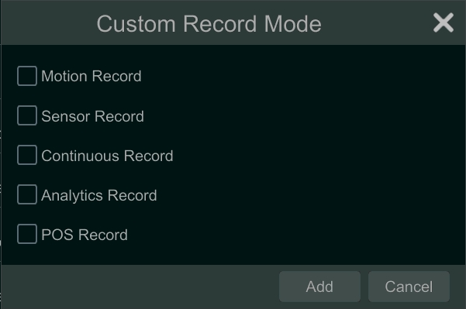

Select one auto mode to pop up the corresponding window. Set the encode, GOP, resolution, FPS, bitrate type, quality, max bitrate and audio of each camera and then click “OK” to save the settings. Please adjust the parameters according to the actual condition.

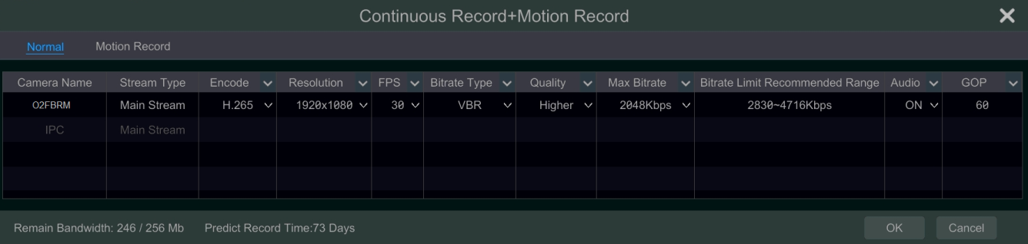

Video Encode: the available options will be H.265 and H.264 if the connected IP camera supports H.265, or the option will be H.264 only.
GOP: group of pictures.
Resolution: the higher the resolution is, the clearer the image is.
FPS: the higher the frame rate is, the more fluency the video is. However, more storage room will be taken up.
Bitrate Type: CBR and VBR are optional. CBR means that no matter how much change is seen in the video scene, the compression bitrate will be kept constant. VBR means that the compression bitrate will be adjusted according scene changes. For example, for scenes that do not have much movement, the bitrate will be kept at a lower value. This will help to optimize the network bandwidth.
Quality: When VBR is selected, you need to choose image quality. The higher the image quality you choose, the more bitrate will be required.
Max Bitrate: 32Kbps ~10240Kbps are optional.

- Manual Mode
If the manual mode is selected, you need to set the encode parameters and record schedules of each camera. See 7.2 Encode Parameters Setting and 7.3 Schedule Setting for details.

Advanced Configuration
Click StartSettingsRecordAdvanced to go to the following interface. Enable or disable“Overwrite record” (Overwrite record: the earliest record data will be replaced by the latest when the disks are full). Set the pre-alarm record time, post-alarm record time and expiration time of each camera and then click “Apply” to save the settings.
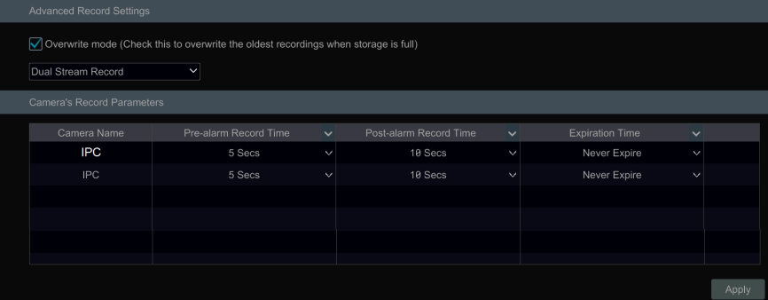

Pre-alarm Record Time: set the time to record before the actual recording begins.
Post-alarm Record Time: set the time to record after the actual recording is finished.
Expiration Time: set the expiration time for recorded video. If the set date is overdue, the recorded data will be deleted automatically.

Encode Parameters Setting
Click StartSettingsRecordEncode Parameters to go to the interface as shown below. Set the encode, resolution, FPS, GOP, bitrate type, quality, max bitrate and audio of main stream for each camera in “Event Recording Settings” and “Schedule Recording Settings” interfaces. Click “Apply” to save the settings. You can set the record stream of each camera one by one or batch set them for all cameras.

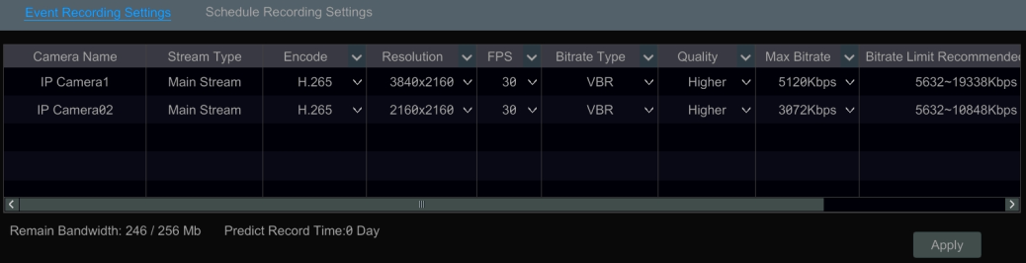

Click StartSettingsRecordStream Settings to go to “Sub-stream” interface. Set the encode, resolution, FPS, GOP, bitrate type, quality and max bitrate of sub-stream for each camera in the interface and then click “Apply” to save the settings.
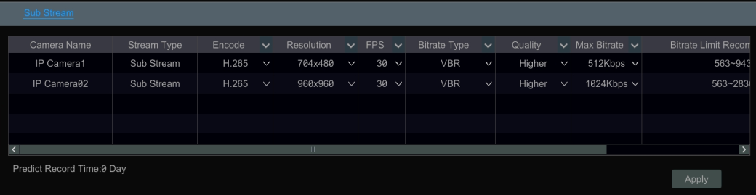

Schedule Setting

Add Schedule
Click StartSettingsRecordRecord ScheduleEdit Schedules to go to the interface as shown below. “24ⅹ7”, “24ⅹ5” and “24ⅹ2” are the default schedules; you cannot edit or delete “24ⅹ7” while “24ⅹ5” and “24ⅹ2” can be edited and deleted. Click the schedule name to display the detailed schedule information on the left side of the interface. The seven rows stand for the seven days in a week and each row stands for 24 hours in a day. Blue stands for the selected time and gray stands for unselected time.

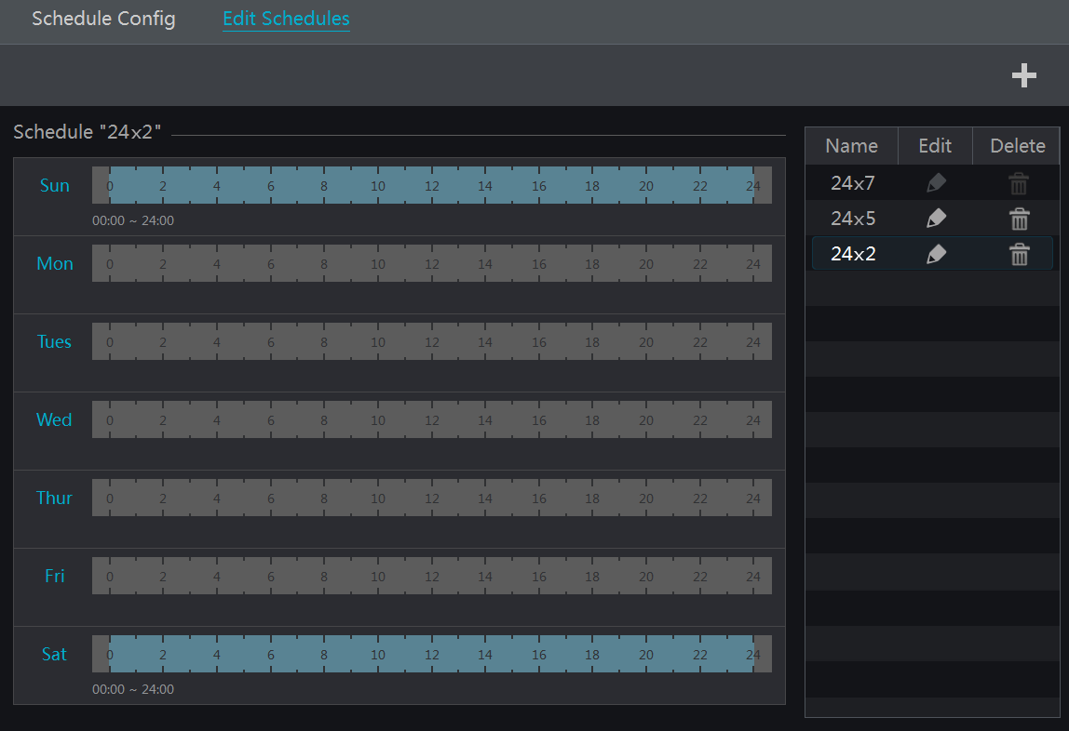

Click to add a new schedule. Refer to the picture below.

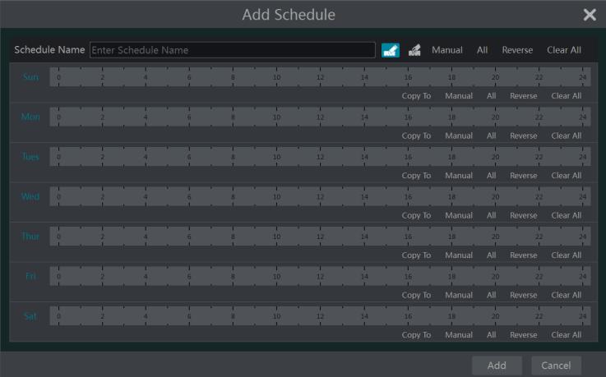

Set the schedule name and schedule time and then click “Add” to save the schedule. You can set day schedule or week schedule. 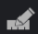: add button; 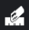: delete button.

- Set Day Schedule
Click and then drag the cursor on the time scale to set record time; click and then drag the cursor on the time scale to delete the selected area.
You can manually set the record start time and end time. Click or and then click “Manual” on each day to pop up a window as shown below. Set the start and end time in the window and then click “OK” to save the settings.

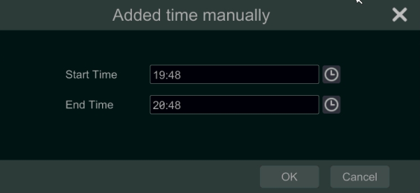

Click “All” to set all day recording; click “Reverse” to swap the selected and unselected time in a day; click “Clear All” to clear all the selected area in a day.
Click “Copy To” to copy the schedule of the day to other days. Refer to the picture below. Check the days in the window and then click “OK” to save the settings.

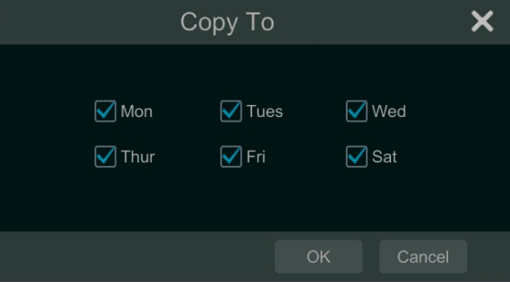

- Set Week Schedule
Click or and then click “Manual” beside to set the week schedule. Refer to the picture below. Set the start and end time, check the days in the window and then click “OK” to save the settings.

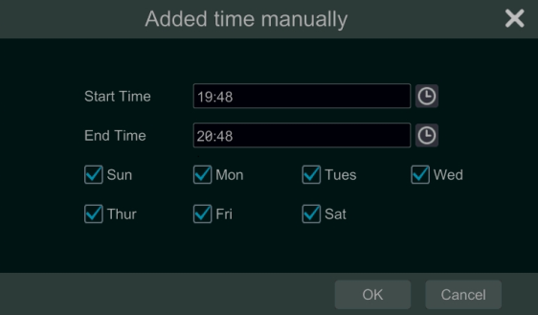

Click “All” to set all week recording; click “Reverse” to swap the selected and unselected time in a week; click “Clear All” to clear all the selected area in a week.

Record Schedule Configuration
Click StartSettingsRecordRecord ScheduleSchedule Configuration to go to the interface as shown below. Set the schedule of sensor record, motion record, timed record and intelligence record. Click “None” in the drop-down menu to clear the schedule. Click “Apply” to save the settings.

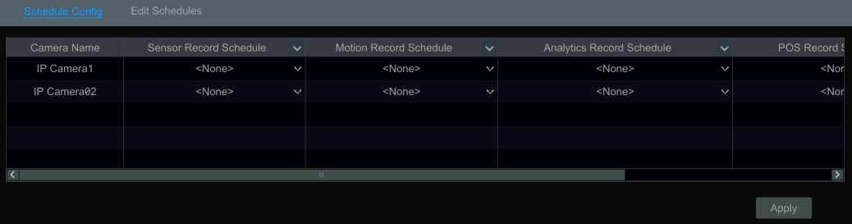

Go to “Edit Schedules” interface and then click to edit the schedule. The settings of “Edit Schedule” are similar to that of the “Add Schedule”. Click to delete the schedule.

Record Mode

Manual Recording
Method One: Click 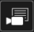 on the tool bar at the bottom of the live view interface to enable recording of the camera.
Method Two: Go to the live view interface and then click the right-click menu “Manually Record On” in the camera window or click on the tool bar under the camera window to start recording.
Note: Click StartSettingsRecordMode Settings and then set the manual record time in the interface. Click “Apply” to save the settings.

Timing Recording
Timing Recording: the system will record automatically according to the schedule.
Set the timing record schedule of each camera. See 7.3 Schedule Setting for details.

Motion Based Recording
Motion Based Recording: the system will start motion based recording when the motion object appears in the setup schedule. The setup steps are as follows:
- Set the motion based recording schedule of each camera. See Setting for details.
- Enable the motion and set the motion area of each camera. See 9.2.1 Motion Configuration for details.
The camera will start motion based recording once you finish the above settings.

Sensor Based Recording
- Set the sensor based recording schedule of each camera. See Setting for details.
- Set the NO/NC type of the sensor, enable the sensor alarm and then check and configure the “Record”. See 9.1 Sensor Alarm for details.

Analytics Recording
- Set the analytics recording schedule of each IP camera. See 7.3 Schedule Setting for details.
- Enable the intelligence alarm detection (object detection, exception, tripwire or intrusion) and draw alert surface or warning area of each IP camera. See Event for details.
The camera will start analytics recording once you finish the above settings. This function is only available for some IPCs.

Disk

Disk Management
- Disk Management
Click StartSettingsDiskDisk Management to go to disk management interface. You can view the NVR’s disk number and disk status and so on in the interface. Click “Formatting” button to format the HDD.

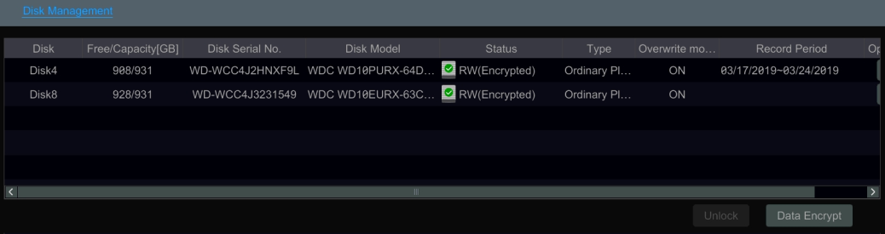

Data Encryption:
① Click “Data Encrypt”.
② Enter the username and password used to log in the NVR. This user shall have the permission of disk management.
③ Check the disk you want to encrypt and then enter the password.
After you encrypt the data of a disk, this disk cannot be read by other NVRs unless it is unlocked.

Data Decryption:
① Click “Change Encrypt”.
② Enter the username and password used to log in the NVR. This user shall have the permission of disk management.
③ Check the disk you want to decrypt and then empty the password.
④ Click “Close Encrypt”.

Unlock the disk: when one encrypted disk is transferred from another NVR to this NVR, it will be in locked status. Then you can select this locked disk and click “Unlock”. After you enter the password of its data encryption, its status will be “Read Only”. Now you can read the data of this disk but it cannot be written anything.
- RAID

① Enable RAID
(Go to StartSettingsDiskDisk Mode)

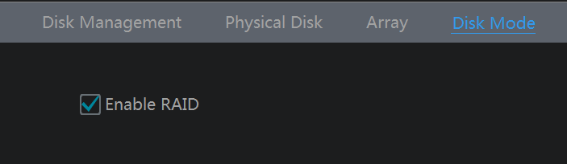

② Create an array. (Go to StartSettingsDiskPhysical Disk)
a. Click “Physical Disk” tab and then click “Create an array”.
b. Enter the user name and password which has the authority of Disk Management.
c. Enter array name and select array type (like RAID5).

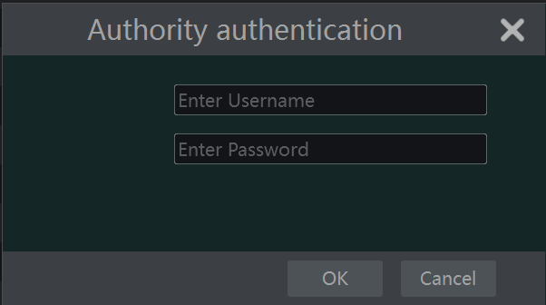
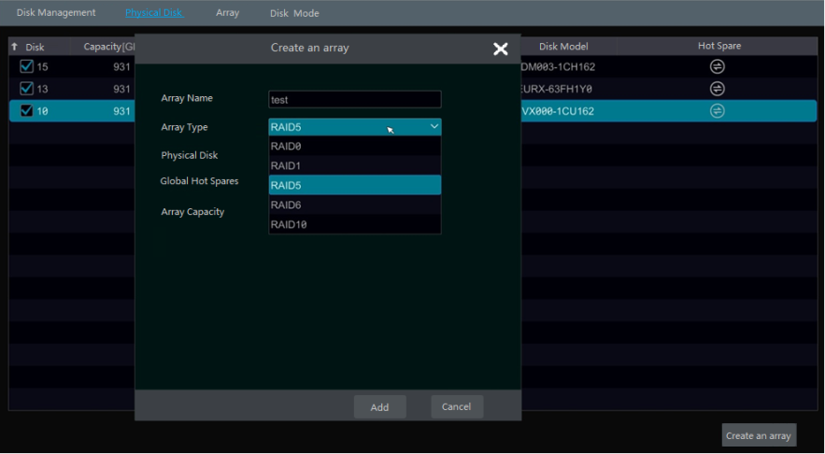
a
b
C

d. Select physical disk.
If you have 16 disks, please check 15 disks. The remaining one should be set to a hot spare.
If higher data security is needed, you can decrease physic disks and increase hot spare disks. Please set them as needed.

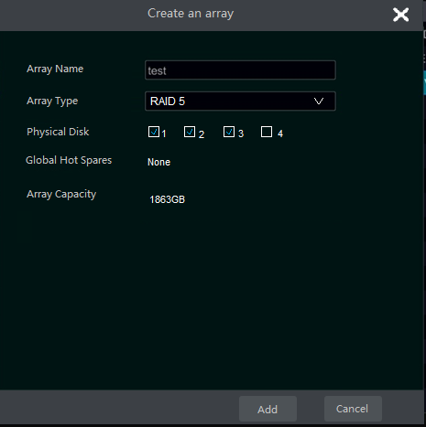

e. Select a hot spare. In the physical disk interface, select the disk that is not in the array and click  as shown in the following pictures.

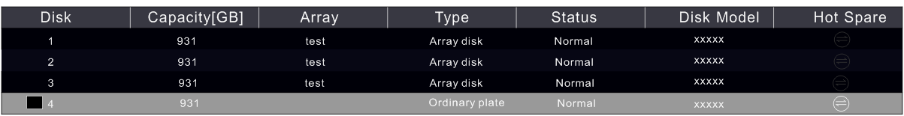
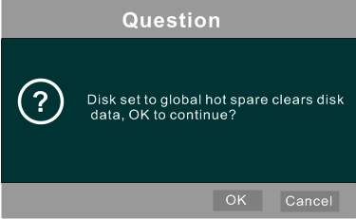

- RAID Rebuilding
If one of your disks is broken, the disk indicator on the front panel will turn red. Of course, a warning tip will pop up if the relevant HDD exception alarm is set. You need to rebuild the RAID after you replace the broken disk with a new one.

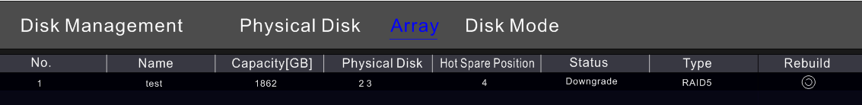

Click the above circled icon and then select the physical disk to rebuild.

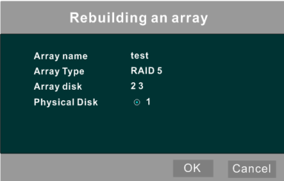

Storage Mode Configuration
Click StartSettingsDiskStorage Mode to go to the interface as shown below.

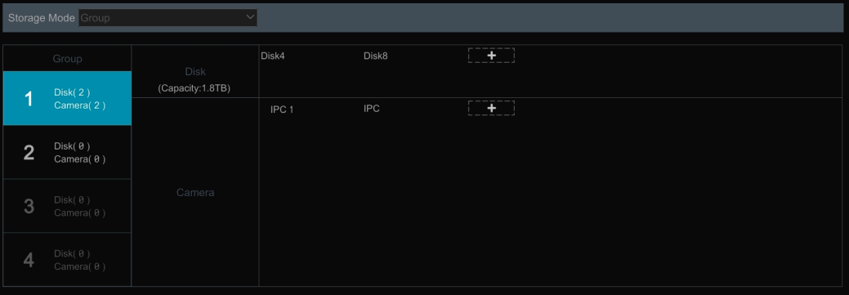

There are all four disk groups. By using disk group, you can correspond the camera to disk (the record data of the camera in the group will be stored into the disks in the same group). The NVR with e-SATA interface supports e-SATA recording.

The added disks and cameras will be added into group one automatically. The disks and cameras in the groups can be deleted except group one (select a disk group and then click on the top right corner of the added disk or camera to delete it from the group). The deleted disks and cameras will be moved into group one automatically.

Each group can add the disks and cameras from other groups. Each disk and camera can only be added into one group. Select a disk group and then click in the disk or camera row to pop up a window. Check the disks or cameras in the window and then click “Add”.

View Disk and S.M.A.R.T. Information
Click StartSettingsDiskView Disk Information to view the HDD information; click “S.M.A.R.T. Information” to view the working status of the HDD. Refer to the picture below.

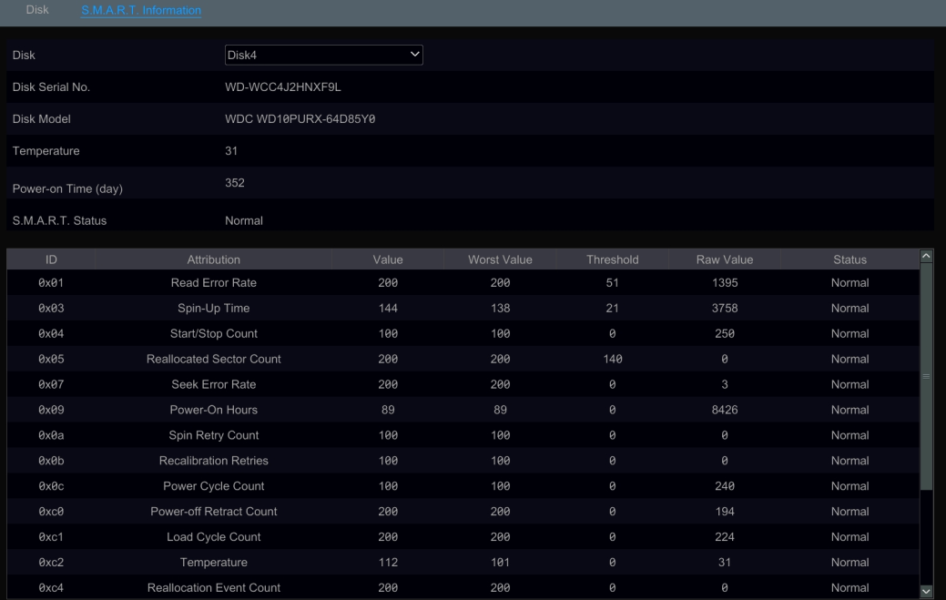

Playback& Backup

Instant Playback
Click on the tool bar at the bottom of the preview camera window to play back the record (click on the tool bar at the bottom of the live view interface to set the default playback time). Refer to the picture below. Drag the playback progress bar to change the playback time. You can also click the right-click menu “Instant Playback” in the camera window and then set the instant playback time to play back the record.

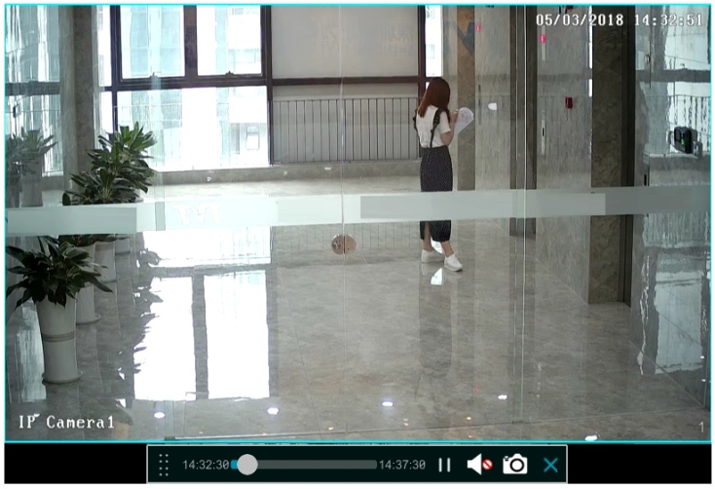

Playback Interface Introduction
Click  on the tool bar at the bottom of the live view interface or click StartPlayback to go to the playback interface as shown below (click on the tool bar at the bottom of the live view interface to set the default playback time).

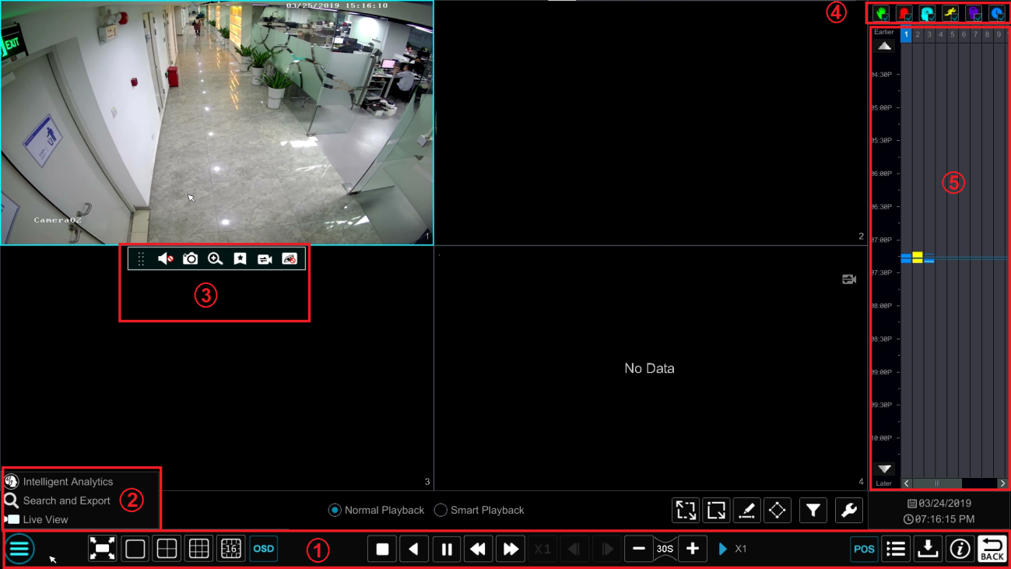

On the panel on the right you will see the channel number and the recorded data coded by color. The bar that runs across them represents the playback time being viewed. You can move this bar around to export, highlight a section of the desired recording, click export and follow the prompts. You can export single or multiple channels at the same time.

The added cameras will playback their records in the playback interface automatically. You can also add the playback camera manually. Click  in the playback window to pop up the “Add Camera” window. Check the cameras in the window and then click “Add” to add playback camera. The system supports a maximum of 16 synchronous playback cameras.

The buttons on the tool bar (area ①) at the bottom of the playback interface are introduced in the table below.

Button | Meaning
 | Start button. Click it to pop up area ②.
 | Full screen button. Click it to show full screen; click it again to exit the full screen.
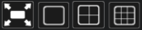 | Screen mode button.
 | OSD ON button. Click it to enable OSD; click it again to disable OSD.
 | Stop button.
 | Rewind button. Click it to play video backward.
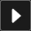 | Play button. Click it to play video forward.
 | Pause button.
 | Deceleration button. Click it to decrease the playing speed.
 | Acceleration button. Click it to increase the playing speed.
 | Previous frame button. It works only when the forward playing is paused in single screen mode.
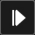 | Next frame button. It works only when the forward playing is paused in single screen mode.
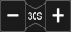 | Click 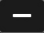 to step backward 30s and click to step forward 30s.
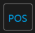 | Open/close POS information.
 | Event list/tag button. Click it to view the event record of manual/schedule/sensor/ motion and the tag information.
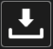 | Backup button. Drag the mouse on the time scale to select the time periods and cameras, and then click the button to back up the record.
 | Backup status button. Click it to view the backup status.
 | Back button. Click it to return.
 | Full screen motion button.
 | Motion button.
 | Draw line button. You can search the record of crossing the line after drawing the line.
 | Draw quadrilateral. You can search the record in this quadrilateral after drawing it.
 | Smart playback settings. Click it to set smart playback.

Introduction of area ②:

Button | Meaning
 | Click it to go to the intelligent analytics interface.
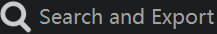 | Click it to go to record search and export interface; see 8.4 Record Search, Playback & Backup for details.
 | Click it to Go to the live view interface; see Chapter 5 Live View Introduction for details.

Click on the playback window to show the tool bar as shown in area ③; right click on the window to show the menu list. The tool bar and menu list are introduced in the table below.

Button | Menu List | Meaning
 | -- | Move tool. Click it to move the tool bar anywhere.
 | Enable Audio | Click it to enable audio. You can listen to the camera audio by enabling audio.
 | Snapshot | Click it to snap.
 | Zoom In | Click it to go to the zoom in interface. The zoom in interface is similar to that of the camera window in the live view interface. Click 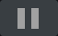 to pause the record playing; click to play the record. When the record is paused in forward playing mode, you can click to view the previous frame and click to view the next frame.
 | Add Tag | Click it to add tag. You can play back the record by searching the added tag. Click it and then enter the tag name in the popup window. Click “Add” to add tag.
 | Switch Camera | Click it to switch the playback camera. Click it and then check the camera in the popup window. Click “OK” to change the camera.
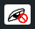 | Close Camera | Click it to close the playback camera.

Introduction of area ④:
You can check the record type as required for record playback; first you should click on the tool bar at the bottom of the interface to clear all the playback camera, then check the record type (: manual record; : sensor based record; 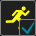: motion based record; : schedule record; : analytics record; and finally click in the playback window to add camera for playback (the record time scale will show the record data of the checked record type only after the above operations).

Introduction of the record time scale (area ⑤):
Click to set the date; click to set the time and then the playback camera will play the record from the time you set.
A tool bar will appear after moving the mouse to the record time scale. Click / to zoom the timeline; click to recover the timeline to 24 hours’ ratio. Drag the timeline or slide the scroll wheel of the mouse on the time scale to show the hidden time on the top or bottom of the timeline. You can also click  to show the hidden time on the top of the timeline or click  to show the hidden time on the bottom of the timeline. Drag the slider at the bottom of the time scale to show the hidden playback cameras.
The record time scale shows different record types with different colors. The green block stands for manual record, red block stands for sensor based record, yellow block stands for motion based record, blue block stands for schedule record and cyan block stands for intelligence record. Click the record block to set the time and then the playback camera will play the record from the time you set.
Drag the color block on the time scale to select the backup area and then right click the area or click to pop up an export information window. Click button in the window to pop up the export window. Select the device, export path and format and then click “Export” button to start the backup.

Smart Playback
- Smart Playback Settings
Click  to go to the following interface. Set the value of “Speed of non-interest video” (Please skip this one if you click “Skip non-interest video”), “Speed of interest video” and “Intrusion percentage”.

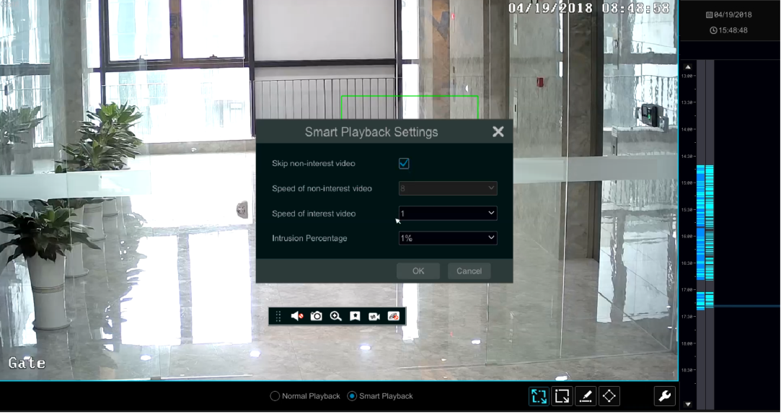

- Smart Playback by Drawing Rectangle

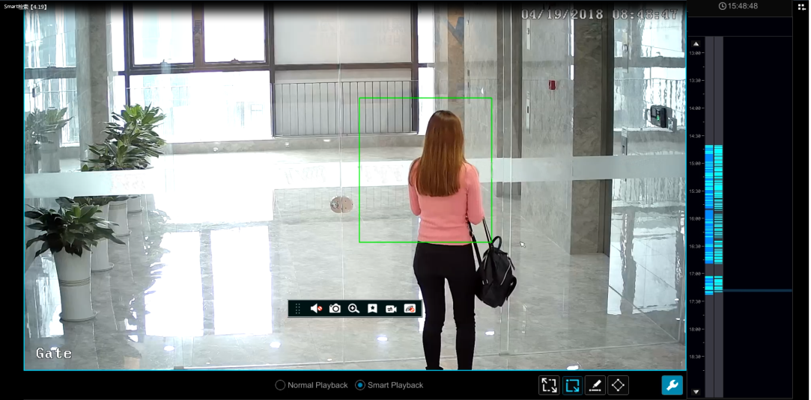

Click and draw a rectangle in the desired area. Then the system will automatically search the record files of this area. The cyan blocks indicate that there are intelligent recording files. Move the cursor to such block and click to play the record.

- Smart Playback by Drawing Line
Click and draw a line in the desired area. Then the system will automatically search the record files about crossing this line. The cyan blocks indicate that there are intelligent recording files. Move the cursor to such block and click to play the record.

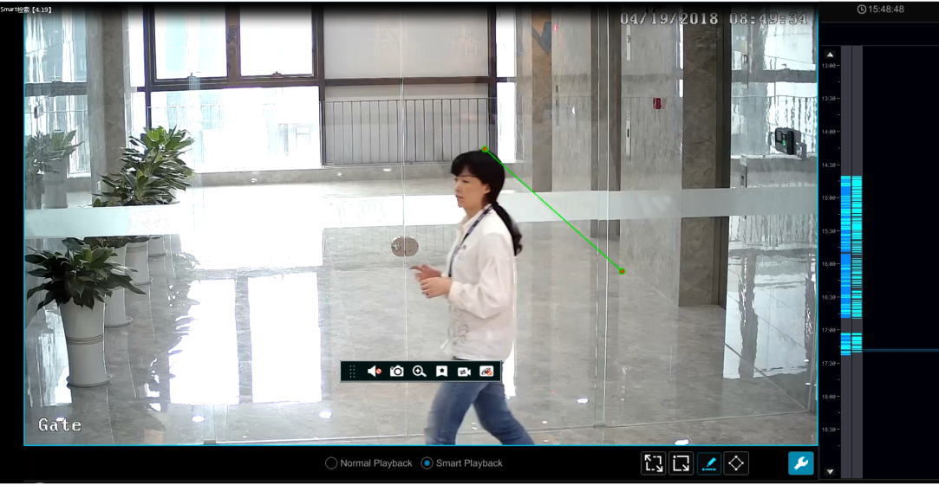

- Smart Playback by Drawing Quadrilateral
Click and draw a quadrangle in the desired area. Then the system will automatically search the record files of this area. The cyan blocks indicate that there are intelligent recording files. Move the cursor to such block and click to play the record.

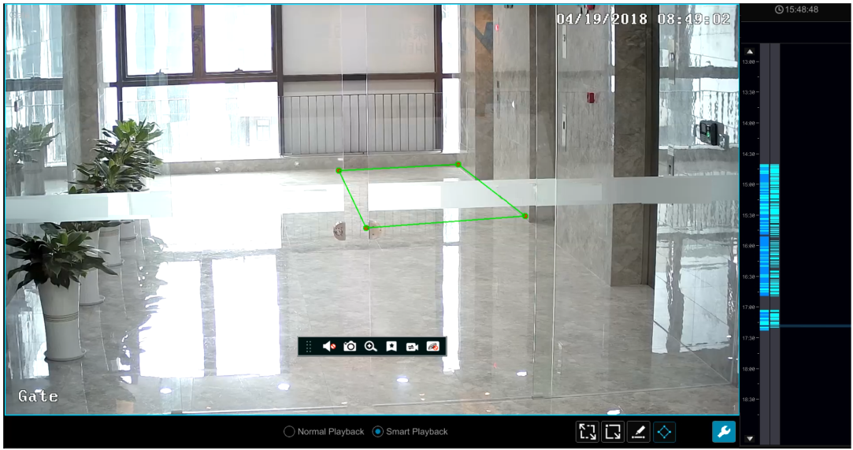

Record Search, Playback &Export
The record data and the captured pictures can be exported through network, USB (U disk or USB mobile HDD). The file system of the export devices should be FAT32 format.

EZ Search
- Click StartSearch and ExportEZ Search to go to the “EZ Search” tab. There are two view modes: by time and by camera. In the time view mode, a maximum of 64 camera thumbnails can be shown. If the camera thumbnail number is more than 64, the cameras will be listed directly by their camera name, not the thumbnail. A maximum of 196 camera names can be listed. If the camera name number is more than 196, the time view mode will be disabled and the camera view mode will be available only.

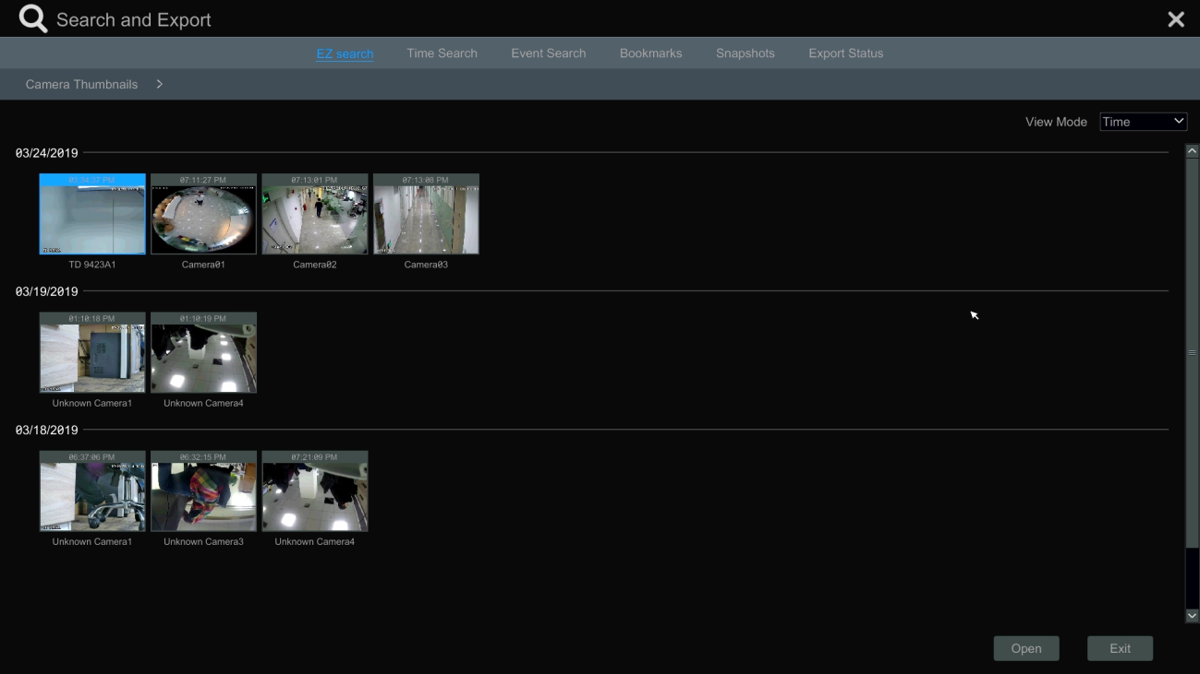

- Select one camera in the interface and then click “Open” button.
- Click the image box to play the record in the small playback box on the left side of the interface (the box which has image inside indicates that the record data exist).
- Refer to the picture below. Drag the color blocks on the time scale to select the record data and then click “Export” button to pop up the “Record Backup” window as shown below. Select the device name, backup format and path and then click “Export” button to start the backup.

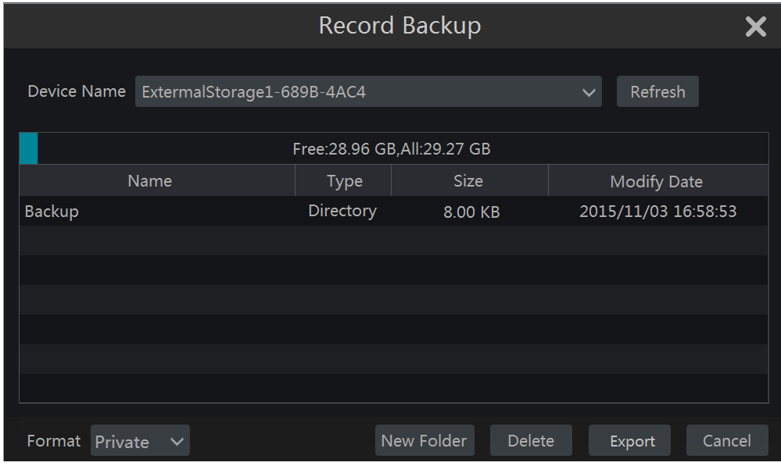

Note: If you back up the record in private format, the system will back up a RPAS player to USB device automatically. The private format record can be played by RPAS player only.

- Click “Playback” button to play the record in the playback interface (refer to 8.2 Playback Interface Introduction for details). Click “Exit” to exit the interface.
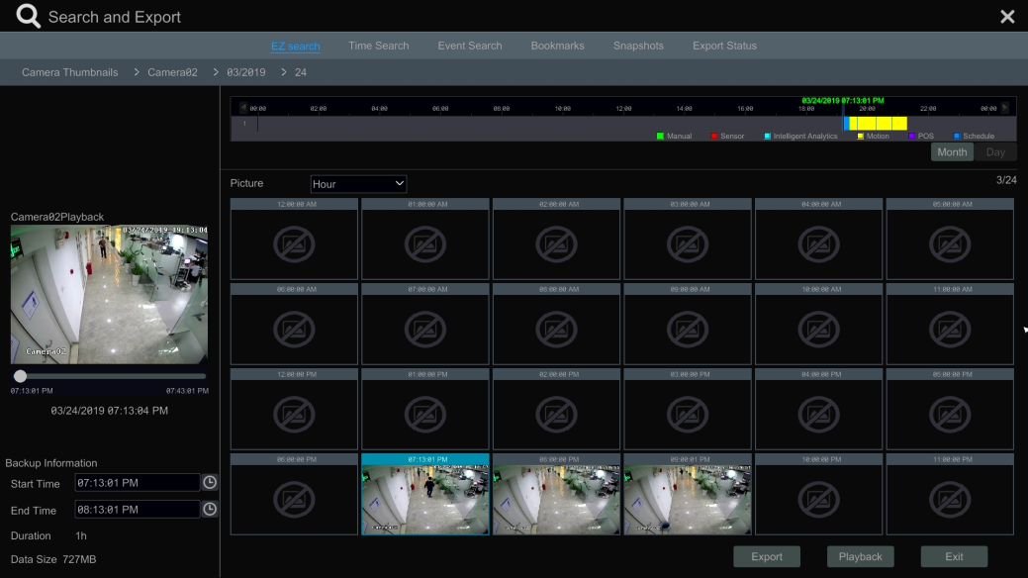

Time Slice Search:
Method One: Click “Year”, “Month” or “Day” button under the record time scale to select the time slice mode. In “Day” mode, click / on the left/right side of the time scale to view the record of the last/next day; click “Minute” in the “Picture” option under the time scale to select “Minute” mode (in “Minute” mode, click the time scale to change the time of the 60 display windows) and click “Hour” to select “Hour” mode.
Method Two: Click beside “Camera Thumbnail” on the left top corner of the interface to select the time slice mode.
Method Three: Right-click the mouse on any area of the time-sliced interface to go back to the upper interface.

Time Search
- Click Start Search and ExportTime Search to go to the “Time Search” tab as shown below.
- Click 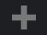 on the bottom of the interface to add playback camera. A maximum of 16 cameras can be added for playback. Click “Modify” on the top right corner of the camera window to change the camera and click “Clear” to remove the camera.
- Click the camera window to play the record in the small playback box on the left side of the interface. You can set the date on the top left of the interface, check the event type as required and click the time scale or click under the time scale to set the time. The camera window will play the record according to the time and event type you set.
- Drag the color blocks on the time scale to select the record data (or click “Set Backup Time” button on the bottom left corner of the interface to set the backup start time and end time) and then click “Export” button for record backup. Click “Playback” button to play the record in the playback interface.

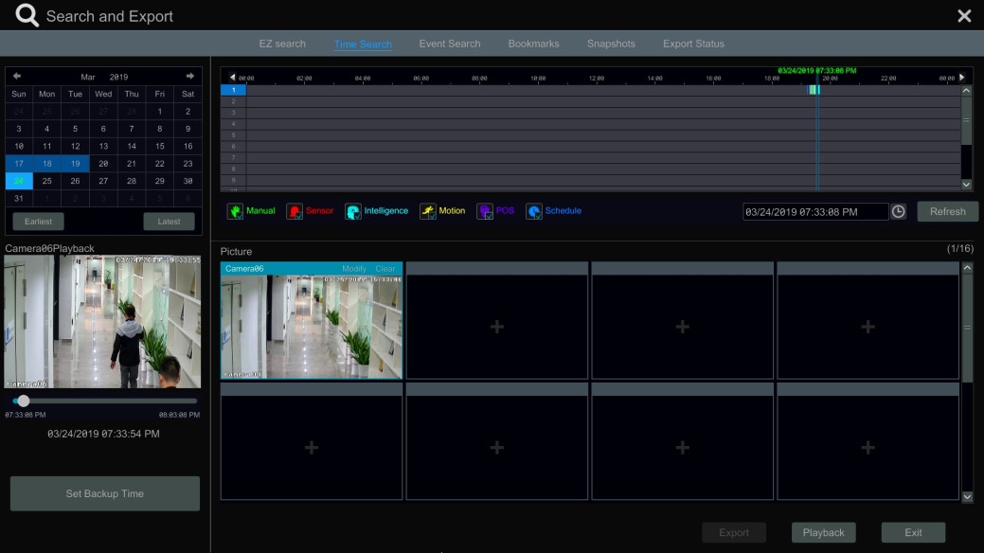

Event Search

- Click StartSearch and ExportEvent Search to go to “Event Search” tab as shown below.

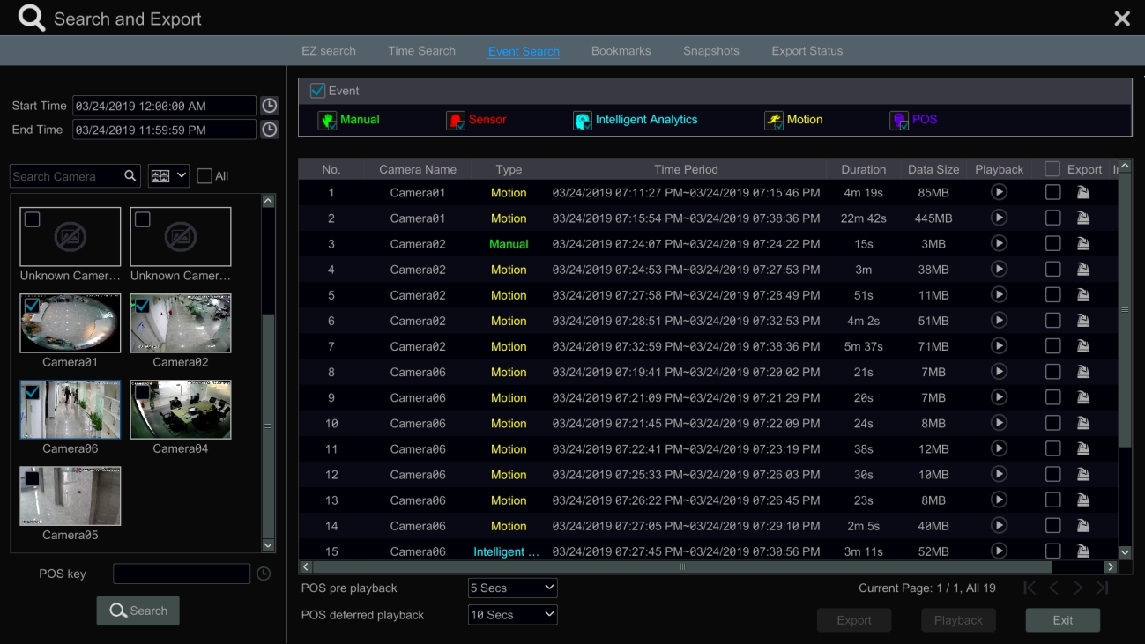

- Check the event type in the interface as required.
- Click to set the start time and end time on the top left of the interface.
- Check cameras on the left side of the interface or check “All” to select all the cameras and then click to search the record. The searched record will be displayed in the list.
- Click in the list to play back the record in the popup window. Click to back up one record data or check multiple record data in the list and then click “Backup” button for record batch backup.
- Select one record data in the list and then click “Playback” button to play the record in the playback interface.

Bookmark Search

Only if you add the tags can you play the record by tag search. Click StartPlayback to go to the playback interface and then click on the bottom of the camera window to add bookmarks when you want to mark the playback time point of the selected camera.
Click StartSearch and ExportBookmarks to go to “Bookmarks” tab.

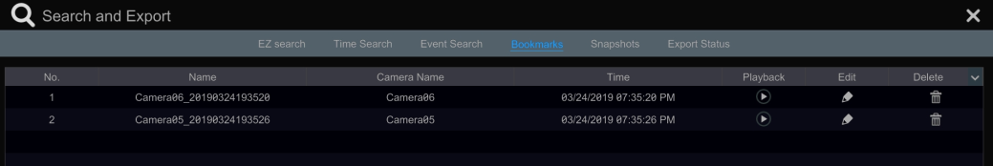

Click in the interface to play the record. Click to edit the tag name. Click to delete the tag.

Snapshots
Click StartSearch and ExportSnapshots to go to “Snapshots” tab. The system will display all the captured images automatically in the list.

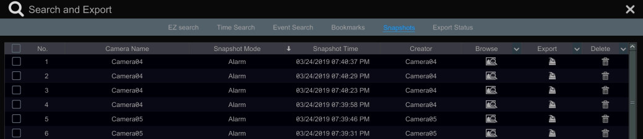

Click to delete the image. Click to pop up the “Export” window. Select the device name and save path in the window and then click “Save” button.
Click to pop up the “View Image” window. Click to export the image. Click to view the previous image; click to view the next image; click to delete the image; click to play all the images.

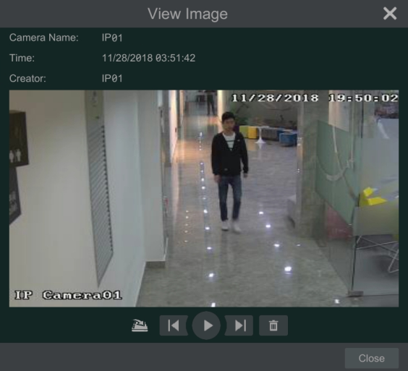

View Export Status
Click StartSearch and ExportExport Status or click on the tool bar at the bottom of the playback interface to view the export status.

Behavior Search
- Click StartIntelligent AnalyticsMuseum SearchBehavior to go to the following tab as shown below.
Behavior Detection: when you select the smart playback mode, the system will analyze the video containing the object detection, exception, tripwire and intrusion detection.
- Click “Behavior”. Set the searching time period and you will search the channel which has the intelligence detection record.
- Check the channel and select the intelligence playback.
- Set the backup time and select the channel to backup.

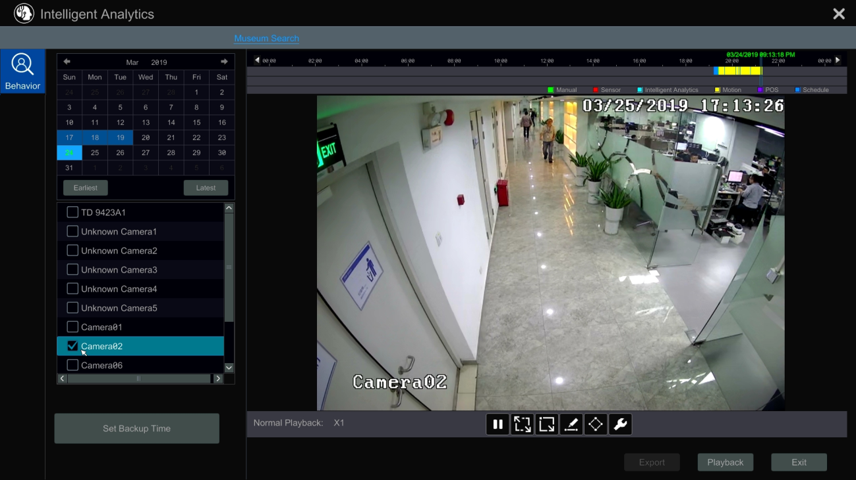

: Smart playback settings button. Click it to set intrusion percentage.
: Full screen motion button.
: Motion button.
: Draw line button. You can search the record of crossing the line after drawing the line.
: Draw quadrilateral. You can search the record in this quadrilateral after drawing it.

Alarm Management

Sensor Alarm
To complete the entire sensor alarm settings, you should enable the sensor alarm of each camera and then set up the alarm handling of each camera.
- Click StartSettingsAlarmSensor Alarm to go to the following interface.

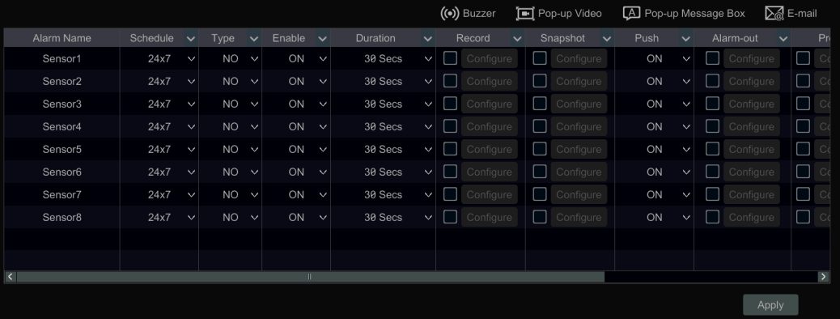

- Select schedule and the alarm type (NO or NC) according to trigger type of the sensor.
- Enable the sensor alarm of each camera.
- Check the “Duration”, “Record”, “Snapshot”, “Push”, “Alarm-out” and “Preset” and enable or disable the “Buzzer”, “Pop-up Video”, “Pop-up Message Box” and “E-mail” as required.
- Click “Apply” to save the settings.

The configuration steps of the above mentioned alarm linkages are as follows.
Duration: it refers to the interval time between the adjacent motion detections. For instance, if the duration time is set to 10 seconds, once the system detects a motion, it will go to alarm and would not detect any other motion (specific to camera) in 10 seconds. If there is another motion detected during this period, it will be considered as continuous movement; otherwise it will be considered as a single motion.
Record: check it and then the “Trigger Record” window will pop up automatically (you can also click “Configure” button to pop up the window). Select camera on the left side and then click to set the camera as the trigger camera. Select trigger camera on the right side and then click to cancel the trigger camera. Click “OK” button to save the settings. The trigger cameras will record automatically when the sensor alarm is triggered.
Snapshot: check it and then the “Trigger Snapshot” window will pop up automatically. Configure the trigger camera in the window. The trigger cameras will snap automatically when the sensor alarm is triggered.
Push: check it and choose ON or OFF. If it is ON, the system will send messages when the sensor alarm is triggered.
Alarm-out: check it and then the “Trigger Alarm-out” window will pop up automatically. Configure the trigger alarm-out in the window. The system will trigger the alarm-out automatically when the sensor alarm is triggered. You need to set the delay time and the schedule of the alarm outputs. See 9.6.1 Alarm-out for details.
Preset: check it and then the “Trigger Preset” window will pop up automatically. Configure the trigger preset of each camera. To add presets, please see 6.2 Preset Setting for details.
Buzzer: if enabled, the system will begin to buzz when the sensor alarm is triggered. To set the delay time of the buzzer, please see 9.6.4 Buzzer for details.
Pop-up Video: After camera setting, the system will pop up the corresponding video automatically when the sensor alarm is triggered. To set the duration time of the video, please see 9.6.3 Display for details.
Pop-up Message Box: if enabled, the system will pop up the corresponding alarm message box automatically when the sensor alarm is triggered. To set the duration time of the message box, please see 9.6.3 Display for details.
E-mail: if enabled, the system will send an e-mail when the sensor alarm is triggered. Before you enable the email, please configure the recipient’s e-mail address first (see 11.1.5 E-mail Configuration for details).

Motion Alarm
Motion Alarm: when the motion object appears in the specified area, it will trigger the alarm. You should enable the motion of each camera first and then set the alarm handling of the camera to complete the whole configuration of the motion alarm.

Motion Configuration
- Click StartSettingsCameraMotion to go to the following interface.

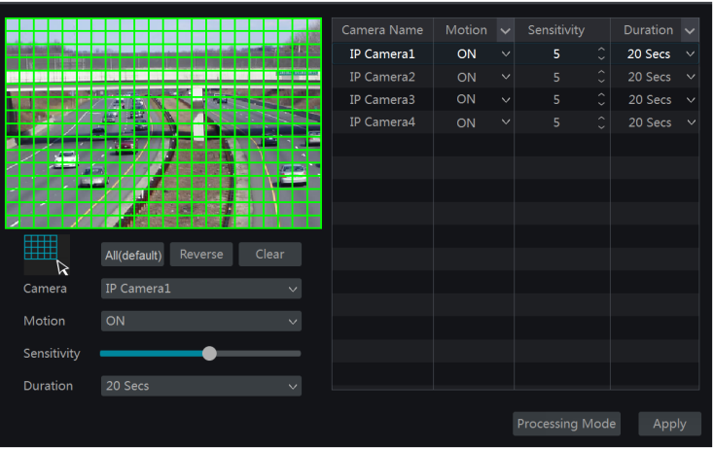

- Select the camera, enable the motion and set the sensitivity and duration of the camera.
Sensitivity: the higher the value is, the more sensitive it is to motion. You should adjust the value according to the practical conditions since the sensitivity is influenced by color and time (day or night).
Duration: it refers to the interval time between the adjacent motion detections. For instance, if the duration time is set to 10 seconds, once the system detects a motion, it will go to alarm and would not detect any other motion (specific to camera) in 10 seconds. If there is another motion detected during this period, it will be considered as continuous movement; otherwise it will be considered as a single motion.

- Drag the camera image to set the motion area. Click “All” to set the whole camera image as the motion area. Click “Reverse” to swap the motion area and the non-motion area. Click “Clear” to clear all the motion areas.
- Click “Apply” to save the settings. Click “Processing Mode” to go to the alarm handling configuration interface of the motion alarm.

Motion Alarm Handling Configuration
- Click StartSettingsAlarmMotion Alarm to go to the following interface.

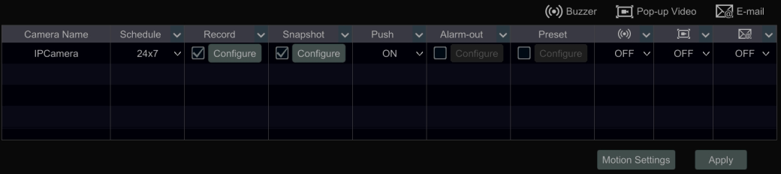

- Enable or disable “Record”, “Snapshot”, “Push”, “Alarm-out”, “Preset”, “Buzzer”, “Pop-up Video” and “E-mail”. The alarm handling settings of motion alarm the same as the sensor alarm (see 9.1 Sensor Alarm for details).
- Click “Apply” to save the settings. You can click “Motion Settings” to go to the motion configuration interface.

Combination Alarm
① Click StartSettingsAlarm Combination Alarm to go to the following interface.
② Customize combination alarm. Set alarm name and click “Configure” under the Combined Alarm Configuration item. Then select alarm type and alarm source. Finally, click “OK” to save the settings.
③ Enable or disable “Record”, “Snapshot”, “Push”, “Alarm-out”, “Preset”, “Buzzer”, “Pop-up Video” and “E-mail”. The alarm handling setting of combination alarm is similar to that of the sensor alarm (see 9.1 Sensor Alarm for details).
④ Click “Apply” to save the settings.

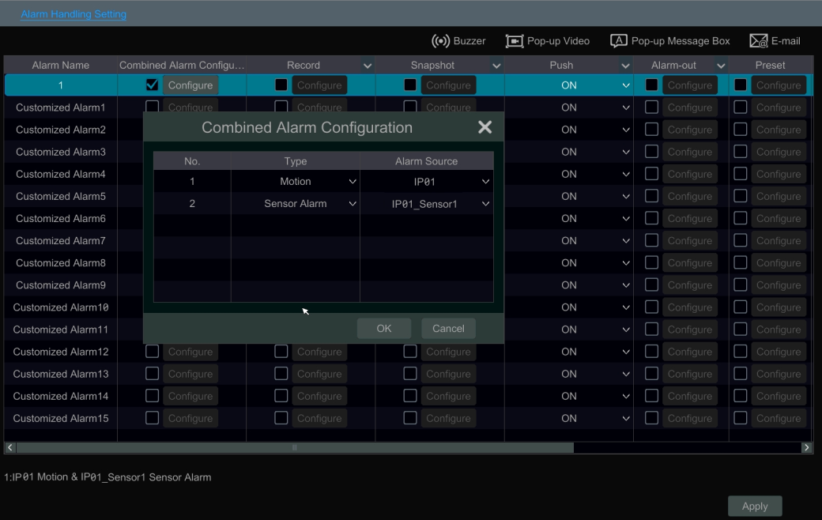

Smart Event

Face Detection
Face Detection: Alarms will be triggered if target people intrude into the pre-defined alarm areas.
- Click StartSettingsCamera Smart Settings Face Detection to go to the following interface.

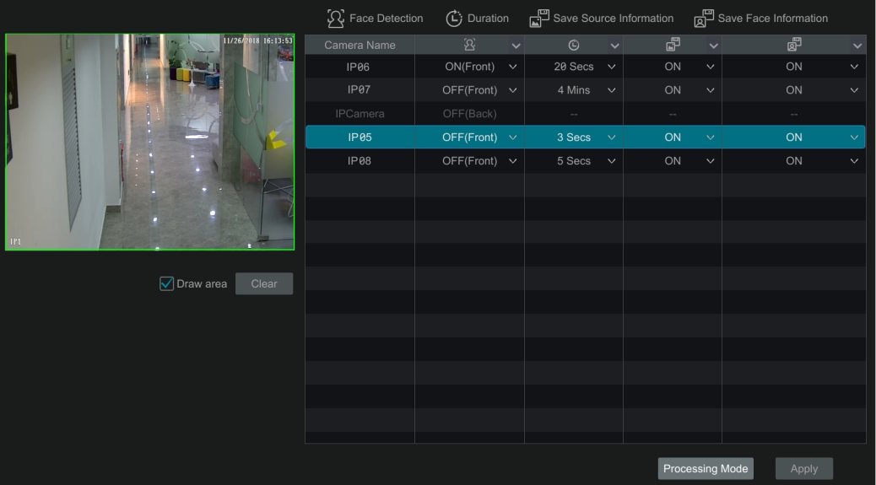

- Select the camera, enable the face detection and set the duration.
If the added cameras are face detection cameras, on (front) or off (front) can be selected.
- Enable save source information and save face information.
- Select the alarm area. Draw the alarm area of the intrusion detection. Refer to the interface as shown below. Check “Draw area” and then drag the mouse to draw a detection area. Click “Clear” to delete the alarm area.
- Click “Apply” to save the settings.
- Click “Processing Mode” to go to the alarm handling configuration interface of face detection.

Face Detection Alarm Handling Configuration:
- Click StartSettingsAlarm Face Detection to go to the following interface.

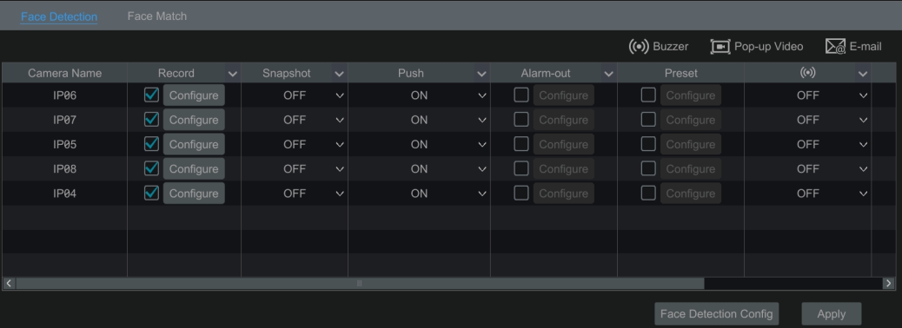

- Enable or disable “Snapshot”, “Push”, “Alarm-out”, “Preset”, “Buzzer”, “Pop-up Video” and “E-mail”. The alarm handling setting of face detection alarm is the same as the sensor alarm (see 9.1 Sensor Alarm for details).
Click “Apply” to save the settings. You can click “Face Detection Config” to go to the face detection configuration interface.

Crowd Density Detection
Only some versions may support this function. If your NVR doesn’t support this function, please skip the following instructions.
Crowd Density Configuration:
Alarms will be triggered if the crowd density exceeds the set threshold value in the pre-defined area.
① Click StartSettingsCameraSmart SettingsCrowd Density to go to the following interface.
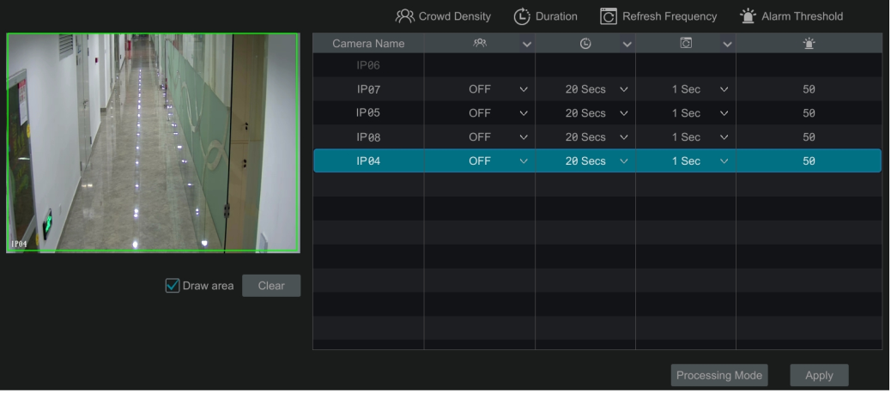

②Select the camera, enable the crowd density detection and set the duration, refresh frequency and alarm threshold.
Refresh Frequency: It refers to the refresh time of the detection result report.
Alarm Threshold: Alarms will be triggered once the percentage of the crowd density in a specified area exceeds the pre-defined threshold value.
③ Select the alarm area. Draw the alarm area of the crowd density detection. Refer to the interface as shown below. Check “Draw Area” and then drag the mouse to draw a rectangle area. Uncheck the “Draw Area” if you finish the drawing. Click the “Clear” to delete the alarm area.
④ Click “Apply” to save the settings.
⑤Click “Processing Mode” to go to the alarm handling configuration interface of crowd density detection.

Crowd Density Detection Alarm Handling Configuration:
① Click StartSettingsAlarm Crowd Density to go to the following interface.

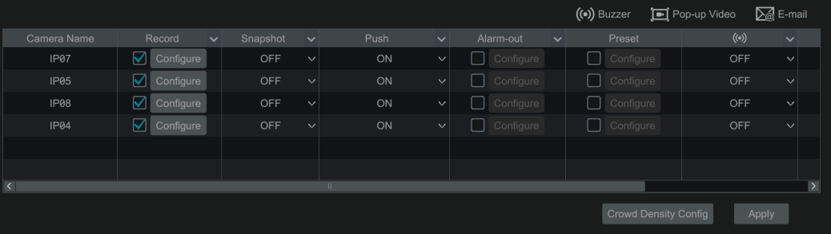

② Enable or disable “Record”, “Snapshot”, “Push”, “Alarm-out”, “Preset”, “Buzzer”, “Pop-up Video” and “E-mail”. The alarm handling setting of crowd density detection alarm is similar as the sensor alarm (see 9.1 Sensor Alarm for details).
③ Click “Apply” to save the settings. You can click “Crowd Density Config” to go to the crowd density detection configuration interface.

People Intrusion Detection
Only some versions may support this function. If your NVR doesn’t support this function, please skip the following instructions.
People Intrusion Configuration:
Alarms will be triggered if someone enters into the detection area.
① Click StartSettingsCamera Smart SettingsPeople Intrusion to go to the following interface.

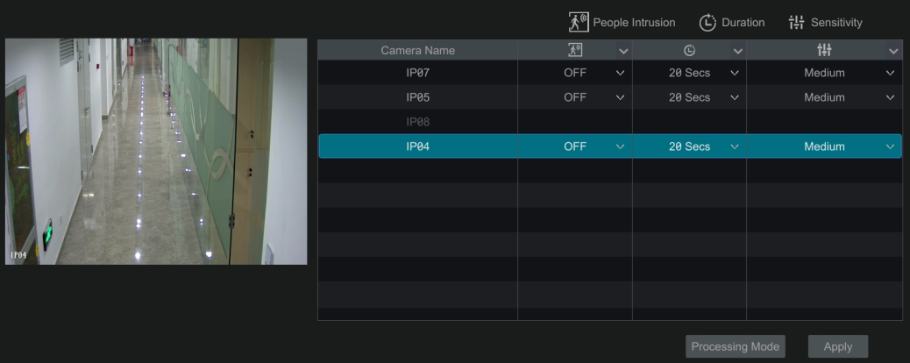

②Select the camera, enable the people intrusion detection and set the duration and sensitivity.
③ Click “Apply” to save the settings.
④Click “Processing Mode” to go to the alarm handling configuration interface of people intrusion detection.

People Intrusion Detection Alarm Handling Configuration:
① Click StartSettingsAlarm People Intrusion to go to the following interface.

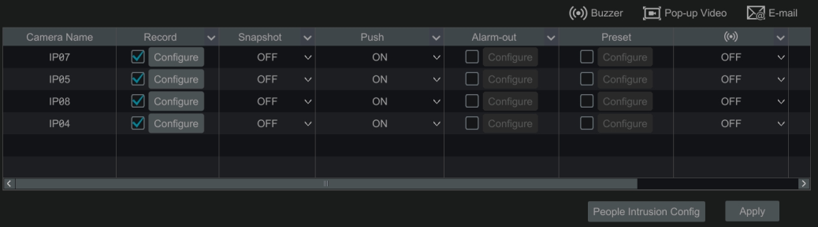

② Enable or disable “Record”, “Snapshot”, “Push”, “Alarm-out”, “Preset”, “Buzzer”, “Pop-up Video” and “E-mail”. The alarm handling setting of people intrusion detection alarm is similar to that of the sensor alarm (see 9.1 Sensor Alarm for details).
③ Click “Apply” to save the settings. You can click “People Intrusion Config” to go to the people intrusion detection configuration interface.

People Counting
Only some versions may support this function.
People Counting Configuration:
This function is to calculate the number of people entering or exiting in the detected area on the video by detecting, tracking and counting the head shapes of people.
① Click StartSettingsCamera Smart SettingsPeople Counting to go to the following interface.
② Select the camera, enable the people counting detection and set the duration, sensitivity, statistic cycle, enter threshold, departure threshold and retention threshold.
Statistic cycle: All, daily, weekly and monthly are optional.
Reset: The current number of people counting will be cleared and the statistic cycle will restart by clicking “Reset” button.
③ Set the alarm area and entrance direction. Click “Draw Area” and drag the mouse to draw a rectangle area. Drag the four corners of the rectangle to modify its size and drag the lines of the rectangle to change its position. Uncheck the “Draw Area” if you finish the drawing. Click “Clear” to clear the area. Click and drag the arrow or the other end of the arrow line to change the people entrance direction.
④ Click “Apply” to save the settings.
⑤Click “Processing Mode” to go to the alarm handling configuration interface of people counting detection.

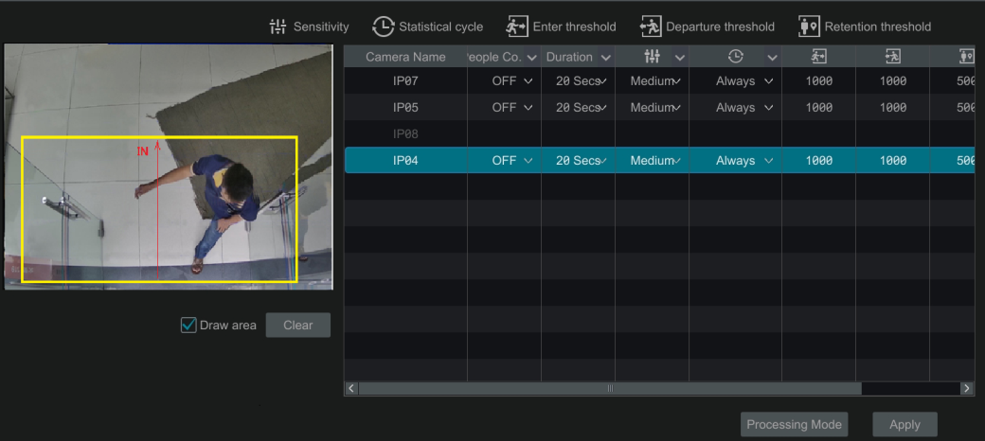

People Counting Detection Alarm Handling Configuration:
① Click StartSettingsAlarm People Counting to go to the following interface.

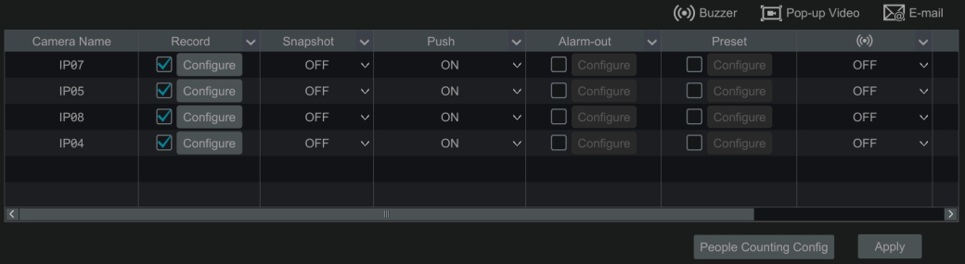

② Enable or disable “Record”, “Snapshot”, “Push”, “Alarm-out”, “Preset”, “Buzzer”, “Pop-up Video” and “E-mail”. The alarm handling setting of people counting detection alarm is similar to that of the sensor alarm (see 9.1 Sensor Alarm for details).
③ Click “Apply” to save the settings. You can click “People Counting Config” to go to the people counting detection configuration interface.

Object Detection
Object Detection Configuration:
- Click StartSettingsCameraSmart SettingsObject Detection to go to the following interface.
- Select the camera, enable the object detection and set the detect type. There are two detect types: Abandoned object and missing object.
Abandoned object: Alarms will be triggered if there are articles left in the pre-defined detection area.
Missing object: Alarms will be triggered if there are articles missing in the detection area drew by the users.
- Select the alarm area. A maximum of 4 alarm areas can be set.
- Draw the alarm area of the object detection. Refer to the interface as shown above. Check “Draw Area” and then click around the area where you want to set as the alarm area in the image (the alarm area should be a closed area). Uncheck the “Draw Area” if you finish the drawing. Click the “Clear” to delete the alarm area.
- Click “Apply” to save the settings.
- Click “Processing Mode” to go to the alarm handling configuration interface of object detection.

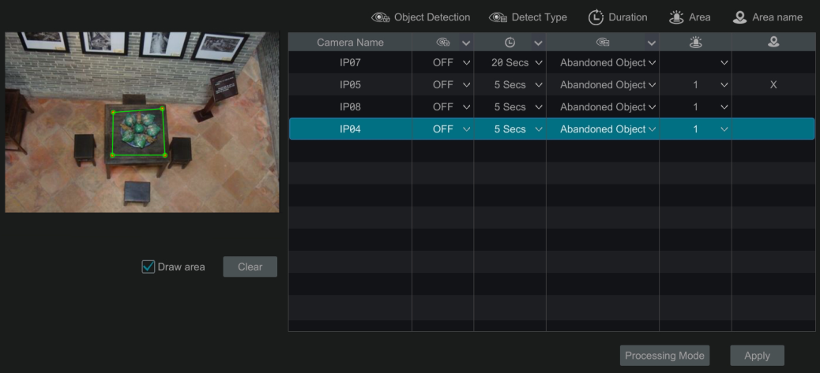

Object Detection Alarm Handling Configuration:
- Click StartSettingsAlarmSmart EventObject Detection to go to the following interface.

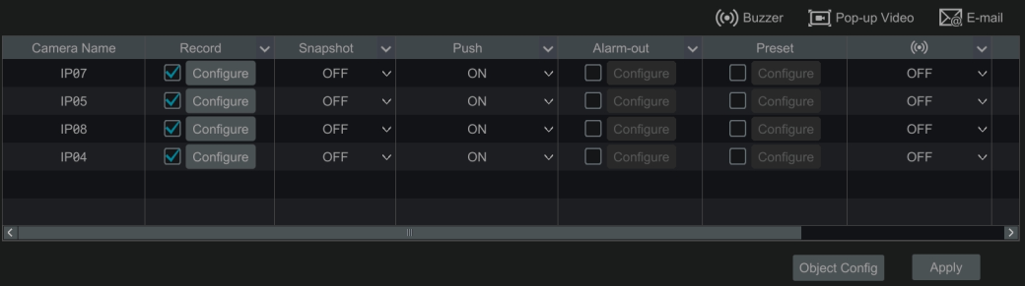

- Enable or disable “Snapshot”, “Push”, “Alarm-out”, “Preset”, “Buzzer”, “Pop-up Video” and “E-mail”. The alarm handling setting of object detection alarm is similar to that of the sensor alarm (see 9.1 Sensor Alarm for details).
- Click “Apply” to save the settings. You can click “Object Config” to go to the object detection configuration interface.

Tampering
Tampering Configuration:
- Click StartSettingsCamera Smart SettingsTampering to go to the following interface.

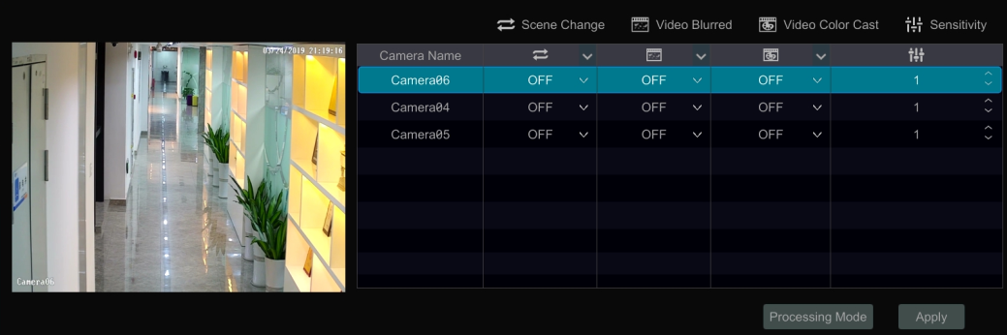

- Select the camera and enable the relevant detection as needed.
Scene Change: Alarms will be triggered if the scene of the monitor video has changed.
Video Blurred: Alarms will be triggered if the video becomes blurry.
Video Color Cast: Alarms will be triggered if the video becomes obscured.
- Set the sensitivity of the exception detection.
- Click “Apply” to save the settings.
- Click “Processing Mode” to go to the alarm handling configuration interface of exception detection.

Exception Alarm Handling Configuration:
- Click StartSettingsAlarm Smart EventException to go to the interface.

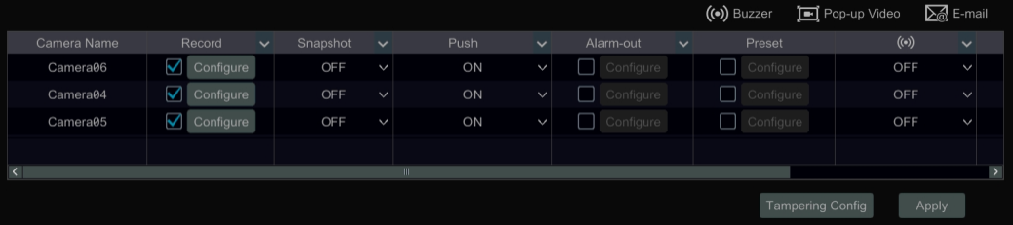

- Enable or disable “Snapshot”, “Push”, “Alarm-out”, “Preset”, “Buzzer”, “Pop-up Video” and “E-mail”. The alarm handling setting of exception detection alarm is similar to that of the sensor alarm (see 9.1 Sensor Alarm for details).
- Click “Apply” to save the settings. You can click “Exception Config” to go to the exception detection configuration interface.

Tripwire
Line Crossing Configuration:
Alarms will be triggered if someone or something crosses the pre-defined alarm line.
- Click StartSettingsCamera Smart SettingsTripwire to go to the following interface.
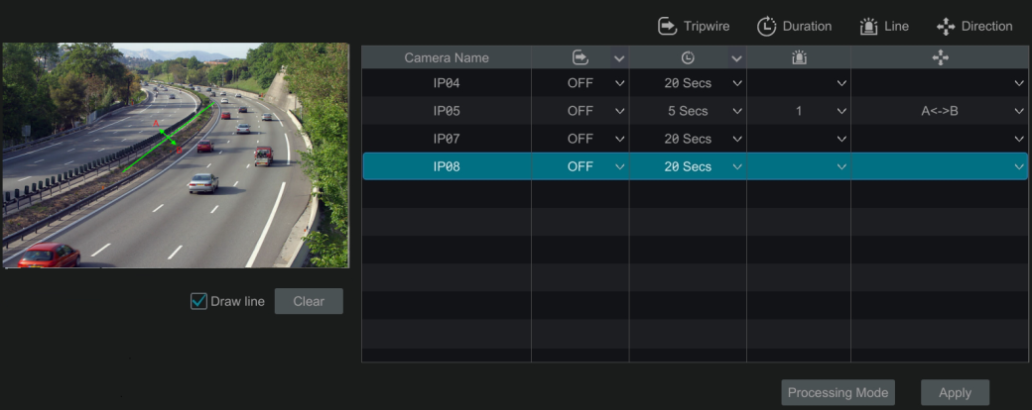

- Select the camera, enable the line crossing detection.
- Select the direction.
Direction: A<->B, A->B and A<-B optional. It is the crossing direction of the intruder who crosses over the alert line.
A<->B: the alarm triggers when the intruder crosses over the alert line from B to A or from A to B.
A->B: the alarm triggers when the intruder crosses over the alert line from A to B.
A<-B: the alarm triggers when the intruder crosses over the alert line from B to A.
- Draw line. Refer to the interface as shown above. Check “Draw line” and then drag the mouse in the image to draw an alert line. Uncheck the “Draw line” if you finish the drawing. Click the “Clear” to delete the alert line.
- Click “Apply” to save the settings.
- Click “Processing Mode” to go to the alarm handling configuration interface of line crossing detection.

Tripwire Alarm Handling Configuration:
- Click StartSettingsAlarm Smart EventTripwire to go to the following interface.

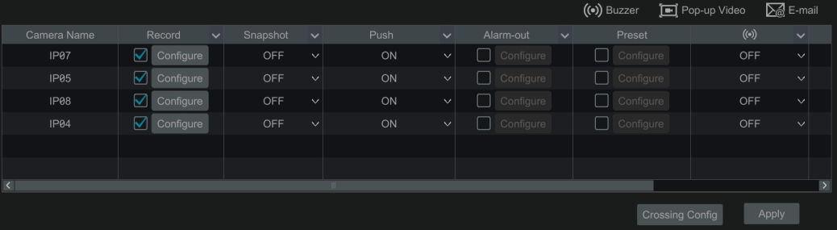

- Enable or disable “Snapshot”, “Push”, “Alarm-out”, “Preset”, “Buzzer”, “Pop-up Video” and “E-mail”. The alarm handling setting of line crossing alarm is similar to that of the sensor alarm (see 9.1 Sensor Alarm for details).
- Click “Apply” to save the settings. You can click “Crossing Config” to go to the line crossing configuration interface.

Intrusion Detection
Intrusion Configuration:
Alarms will be triggered if someone or something intrudes into the pre-defined area.
- Click StartSettingsCamera Smart SettingsIntrusion Detection to go to the following interface.
- Select the camera, enable the intrusion detection.
- Select the alarm area. Up to 4 alarm areas can be set up.
- Draw the alarm area of the intrusion detection. Refer to the interface as shown below. Check “Draw Area” and then click around the area where you want to set as the alarm area in the image (the alarm area should be a closed area). Uncheck the “Draw Area” if you finish the drawing. Click the “Clear” to delete the alarm area.
- Click “Apply” to save the settings.
- Click “Processing Mode” to go to the alarm handling configuration interface of intrusion detection.

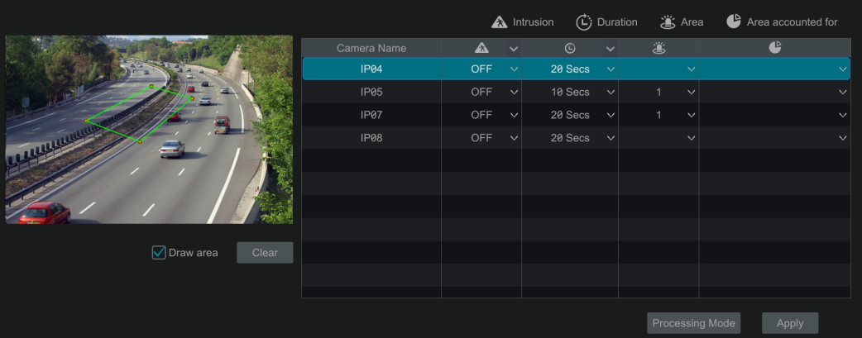

Intrusion Detection Alarm Handling Configuration:
- Click StartSettingsAlarm Smart EventIntrusion to go to the following interface.

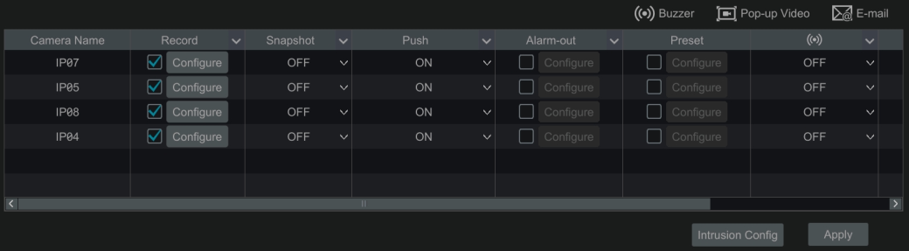

- Enable or disable “Snapshot”, “Push”, “Alarm-out”, “Preset”, “Buzzer”, “Pop-up Video” and “E-mail”. The alarm handling setting of intrusion detection alarm is similar to that of the sensor alarm (see 9.1 Sensor Alarm for details).
- Click “Apply” to save the settings. You can click “Intrusion Config” to go to the intrusion detection configuration interface.

Exception Alarm

IPC Offline Settings
- Click StartSettingsAlarmExceptionIPC Offline Settings to go to the interface as shown below.
- Enable or disable “Snapshot”, “Push”, “Alarm-out”, “Preset”, “Buzzer”, “Pop-up Video”, “Pop-up Message Box” and “E-mail”. The IPC Offline Settings are similar to that of the sensor alarm (see 9.1 Sensor Alarm for details).
- Click “Apply” to save the settings.

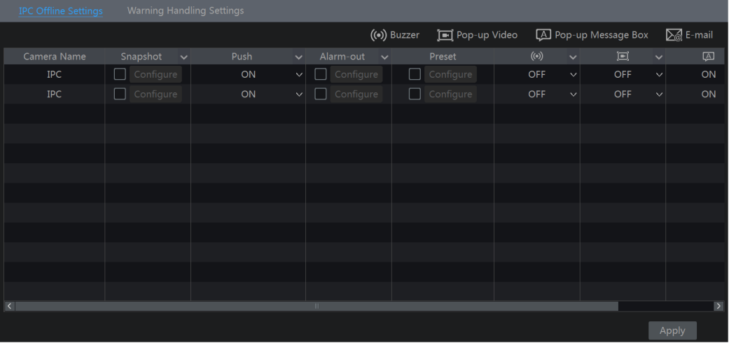

Warning Handling Settings
- Click StartSettingsAlarmExceptionWarning Handling Settings to go to the interface as shown below.
- Enable or disable “Push”, “Alarm-out”, “Buzzer”, “Pop-up Message Box” and “E-mail”. The exception handling settings are similar to that of the sensor alarm (see 9.1 Sensor Alarm for details).
- Click “Apply” to save the settings.

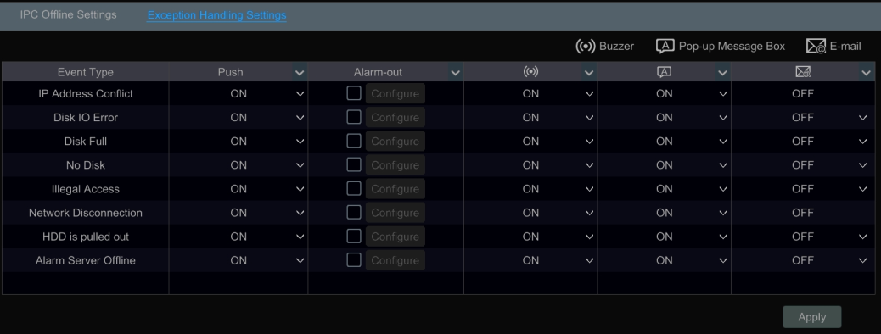

Alarm Event Notification

Alarm-out
- Click StartSettingsAlarmEvent Notification to go to the following interface.

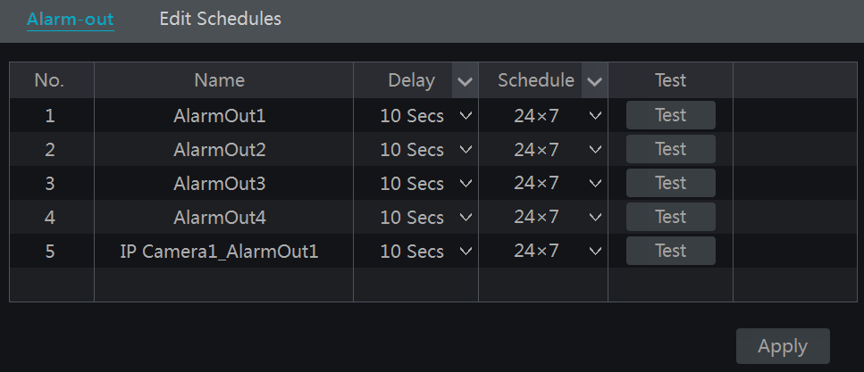

- Set the delay time and the schedule of each alarm-out. You can click “Edit Schedules” to edit the schedules (see 7.3.1 Add Schedule for details).
- Click “Apply” to save the settings. You can click “Test” to test the alarm output.

E-mail
Click StartSettingsAlarmEvent NotificationE-mail to go to the e-mail configuration interface. Set the e-mail address of the recipients. See 11.1.5 E-mail Configuration for details.

Display
Click StartSettingsAlarmEvent NotificationDisplay to go to the display configuration interface. Set the duration time of the pop-up video and the pop-up message box. Click “Apply” to save the settings.

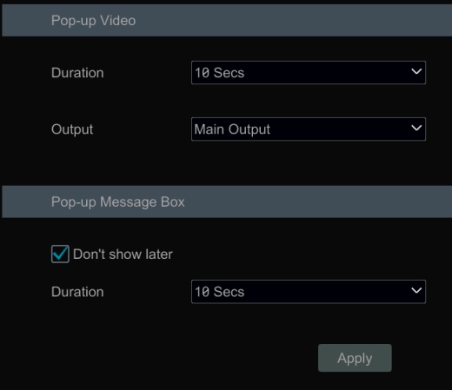

Buzzer
Click StartSettingsAlarmEvent NotificationBuzzer to go to the buzzer configuration interface. Set the delay time of the buzzer and then click “Apply” to save the setting. You can click “Test” to test the buzzer.

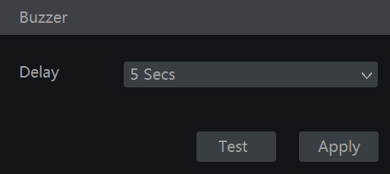

Push Message
Click StartSettingsAlarmEvent NotificationPush Message to go to the interface as shown below. Check “Enable” and then click “Apply” button to save the settings. If Push Server is online, it will push messages to the mobile clients.

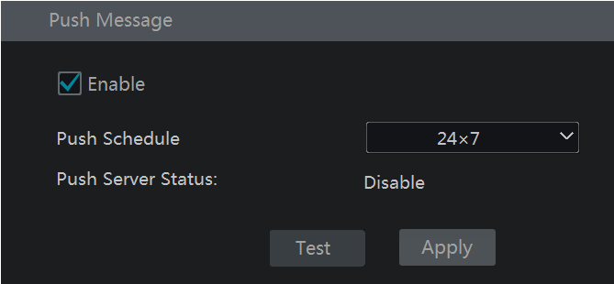

Alarm Server
Go to AlarmAlarm Server interface as shown below.
Enable the alarm server and enter server address and port of the alarm server. Then select protocol. If “Send Heartbeat” is enabled, set the interval times. After that, test the effectiveness of the alarm server. Having tested successfully, please click “Apply”. When an alarm occurs, the device will transfer the alarm event to the alarm server. If an alarm server is not needed, there is no need to configure this section.

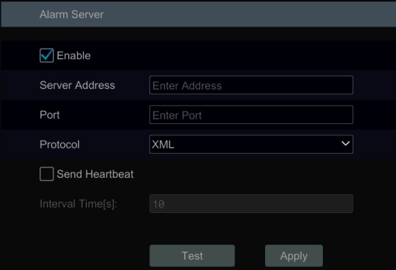

Manual Alarm
Click  on the tool bar at the bottom of the live view interface to pop up a window. Click “Trigger” to start alarm. Click “Clear” to stop alarm.

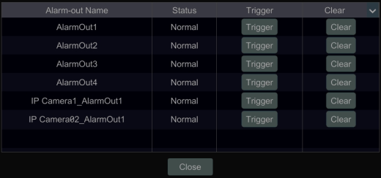

View Alarm Status
Click StartSettingsAlarmAlarm Status or click on the tool bar at the bottom of the live view interfaceto view the alarm status.

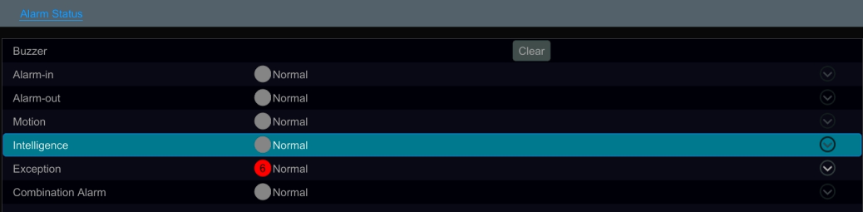

Click “Clear” button to stop the buzzer when the buzzer alarm happens. Click to view the detail information as shown below.

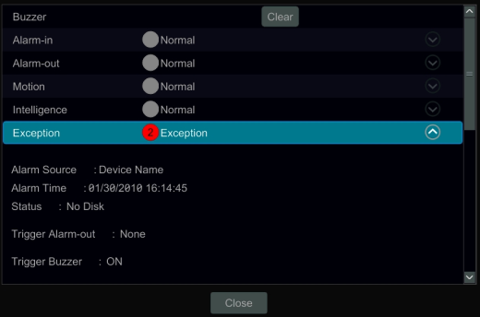

If the exception information is more than one page, you can enter the number in the box and then click 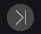 to jump to the specified page. Click  /  to view the exception alarm information in the previous/next page. Click to play the alarm record.

Account & Permission Management

Account Management
Click StartSettingsAccount and AuthorityAccountEdit User to go to the interface as shown below.

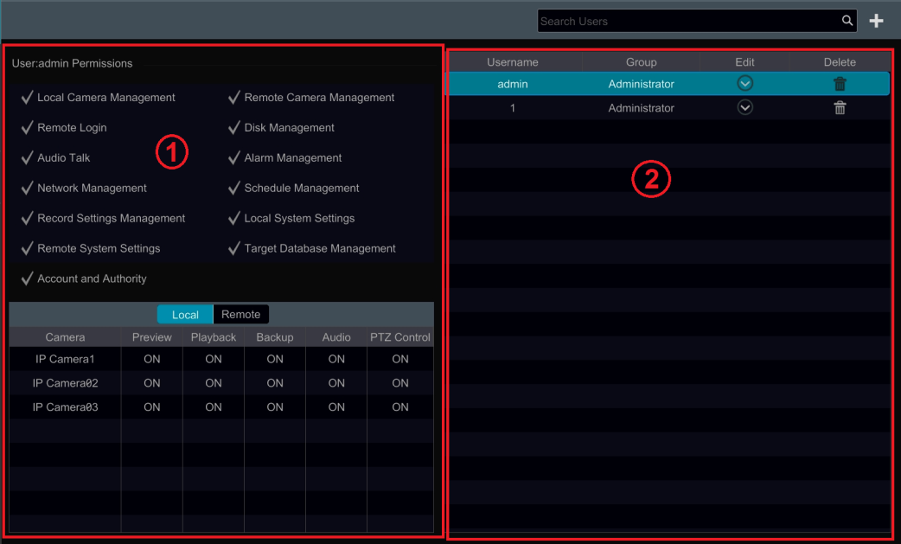

Area ① displays the user permissions. Area ② displays the user list. Click the user in the list to display its user permissions in area ①.
There are three default permission groups (“Administrator”, “Advanced” and “Common”) available when adding accounts. You can manually add new permission group (see 10.3.1 Add Permission Group for details).
Only admin and the users that have the “Account and Authority” permission can manage the system’s accounts. Group “Administrator” owns all the permissions displayed in area ① except “Account and Authority” and its permissions cannot be changed while the permissions of “Advanced” and “Common” can be changed.

Add User
- Click StartSettingsAccount and AuthorityAccountAdd User or click beside the search box to pop up the window as shown below.

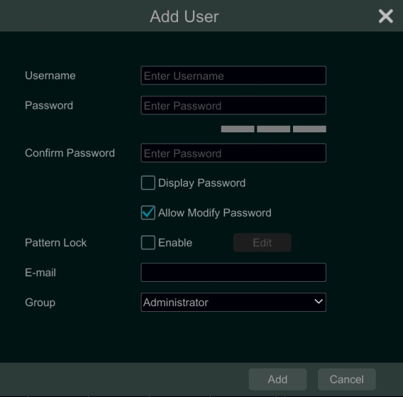

- Set the username, password and group. User can also set the pattern lock here. The e-mail address is optional. Click “Add” to add the user.

Edit User
Click StartSettingsAccount and AuthorityAccountEdit User and then click in the user list or double click the user to edit the user information. Click to delete the user (the user admin cannot be deleted).

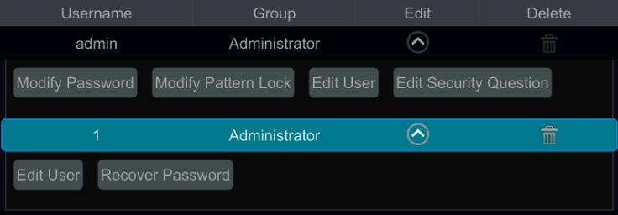

- Edit Security Question
You can set password security only for admin. Click “Edit Security Question” and then set questions and answers in the popup window. If you forget the password for admin, please refer to Q4 in Appendix A FAQ for details. The passwords of other users can be recovered by admin or the users that have the “Account and Authority” permission.

- Modify Password
Only the password of admin can be modified. Click “Modify Password” to pop up a window. Enter the current password and then set new password. Click “OK” to save the settings.

- Modify Pattern Lock
Some models may not support this function.
Click “Modify Pattern Lock” to pop up a window.

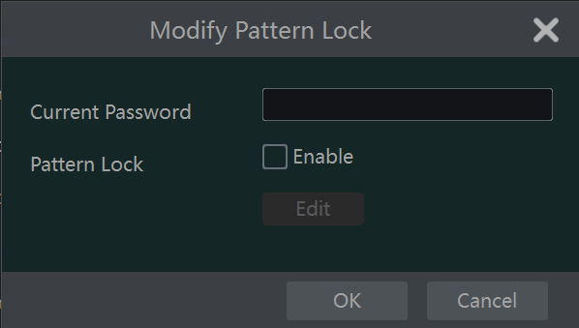

Enter current password and then check “Enable” to input pattern lock.

- Recover Password
Click “Recover Password” to reset the password.

- Edit User
Click “Edit User” to pop up the window as shown below. The admin is enabled, its permission control is closed and permission group cannot be changed by default. You can enable or disable other users (if disabled, the user will be invalid), open or close their permission control (if closed, the user will get all the permissions which admin has) and set their permission groups. Click “OK” to save the settings.

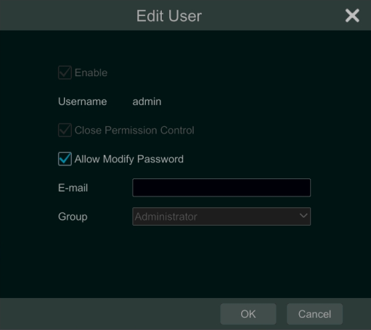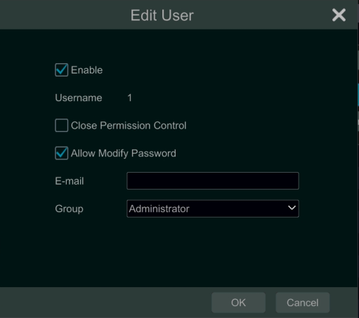

User Login & Logout
Login:Click StartLogin or directly click the preview interface and then select username and enter the password in the popup window. Click “Login” button to log in the system.
Logout: Click StartLogout or click StartShutdown to pop up the “Shutdown” window. Select “Logout” in the window and then click “OK” button to log out the system.

Permission Management

Add Permission Group
Click StartSettingsAccount and AuthorityAccountEdit Permission Group to go to the interface as shown below.

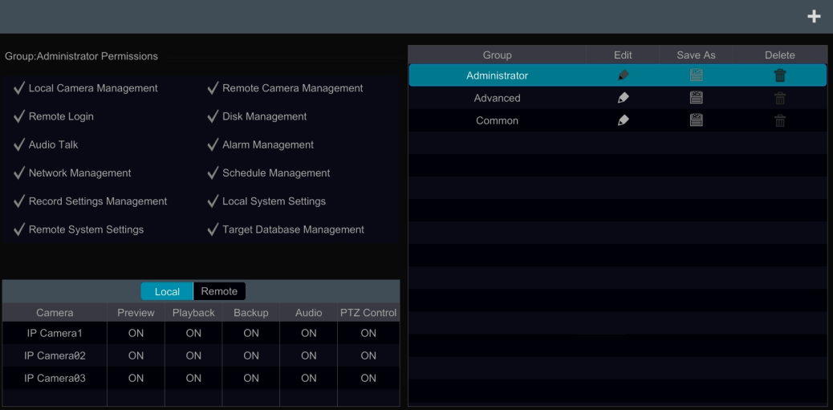

Click to add permission group. Set the group name, check the permissions as needed and then set the “Local” and “Remote” permissions. Click “Add” to save the settings.
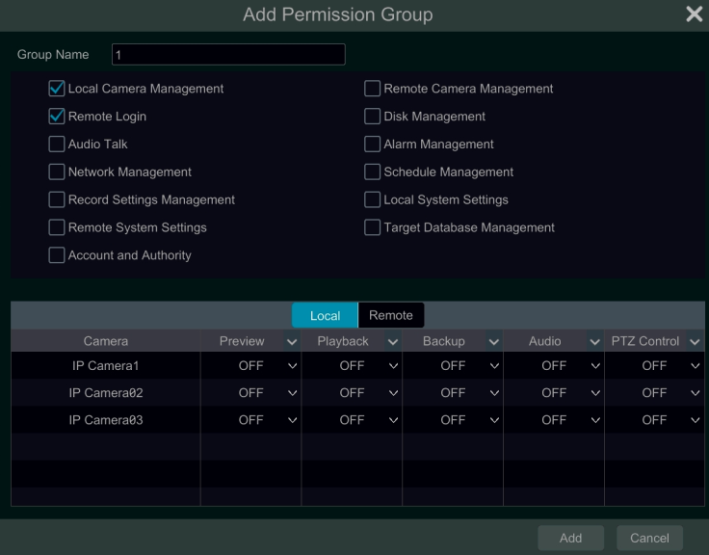

Edit Permission Group
Go to “Edit Permission Group” interface and then click in the group list to edit the permission group (the operations of the “Edit Permission Group” are similar to that of the “Add Permission Group”, please see 10.3.1 Add Permission Group for details). Click to save the group as another group. Click to delete the permission group. The three default permission groups (“Administrator”, “Advanced” and “Common”) cannot be deleted.

Block and Allow List
- Click StartSettingsAccount and AuthoritySecurity to go to the following interface.

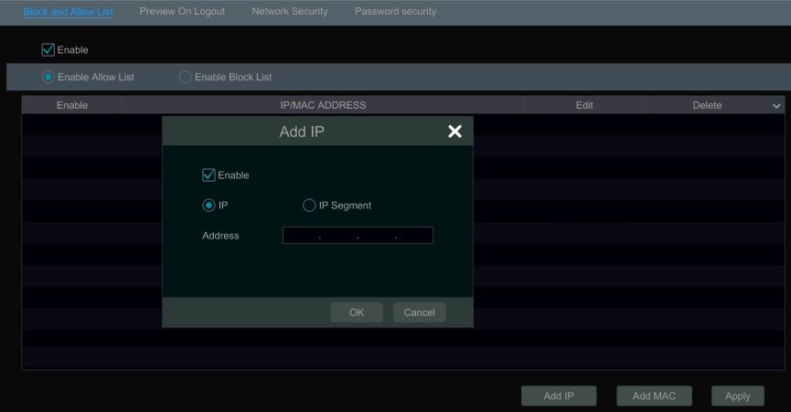

- Check “Enable” and then choose “Enable Allow List” or “Enable Block List” (the PC client of which the IP address is in the allow list can access NVR remotely while the PC client in the block list cannot).
- Add IP/IP segment/MAC. Click “Add IP” or “Add MAC” button and then check “Enable” in the popup window (only if you check it can the IP/IP segment/MAC you add be effective). Enter the IP/IP segment/MAC and then click “OK” button. In the above interface, click to edit IP/IP segment/MAC, click to delete it. Click “Apply” to save the settings.

Preview On Logout
Click StartSettingsAccount and AuthoritySecurityPreview on Logout to go to the following interface.
Set a camera and then enable or disable the preview permission on logout as required. If a camera’s preview permission on logout is “ON”, you can view the live image of the camera when the system is logged out, or the live image of the camera cannot be seen when logged out.

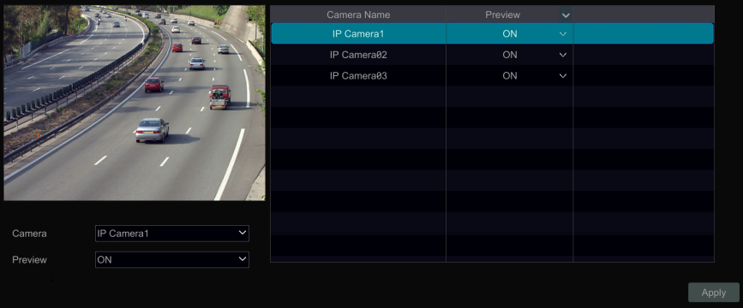

Network Security
Click StartSettingsAccount and AuthoritySecurityNetwork Security to go to the following interface. You can enable APR Guard.

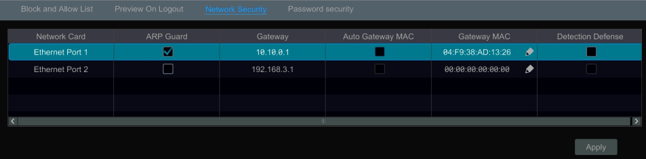
ARP Guard: Address Resolution Protocol Guard. This function can protect the LAN from APR attack and make the network run stably. If it is enabled, you can enable auto gateway MAC or manually set gateway MAC. Additionally, detection defense also can be enabled as needed.

Password Security
Click StartSettingsAccount and AuthoritySecurityPassword Security to go to the following interface.

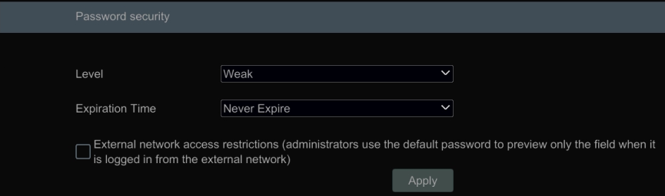

In this interface, you can set the level and expiration time of the password.

View Online User
Click StartSettingsAccount and AuthorityUser Status to view the online user information (you can view the online user name, login type, IP address and login time; click to pop up a window showing the preview occupied channel number and playback occupied channel number).

Device Management

Network Configuration

TCP/IP Configuration
Click StartSettingsNetworkTCP/IP to go to the following interface.
If the NVR has two network ports or above, you can select the network work pattern as required.

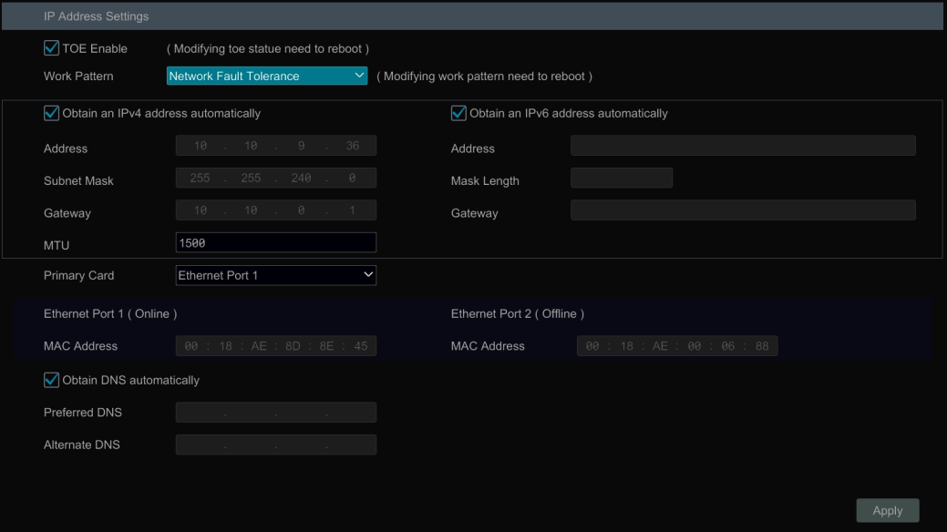

TOE: It is a technology for improving the network transmission speed. Please enable it according to the actual network situation. If TOE is enabled, it shall be high speed mode. Then multiple address setting or network fault tolerance can be chosen and configured. If TOE is not enabled, it shall be compatible mode. Then the network fault tolerance cannot be selected and set up.

Network Fault Tolerance:
The two network ports will be bound to one IP address if you select the “Network Fault Tolerance” pattern. There are many advantages of this work pattern: 1. increase the bandwidth; 2. form a network redundant array to share the load. When a failure happens to one network port, the other port will take over the entire load immediately. The takeover process is seamless and the network service will not be broken off.
If “Network Fault Tolerance” is selected, check “Obtain an IPv4 address automatically”, “Obtain an IPv6 address automatically” and “Obtain DNS automatically” to get the network addresses automatically, or manually enter the network addresses. You can modify the MTU value according to the network condition (MTU, Maximum Transmission Unit, can be modified according to network condition for higher network transmission efficiency). Click “Apply” to save the settings.

Multiple Address Setting:
If “Multiple Address Setting” is selected, the IP addresses of the two Ethernet ports should be set respectively. Refer to the picture as shown below.
Check “Obtain an IPv4 address automatically”, “Obtain an IPv6 address automatically” and “Obtain DNS automatically” to get the network addresses automatically, or manually enter the network addresses; select one Ethernet port as the default route and then click “Apply” to save the settings.

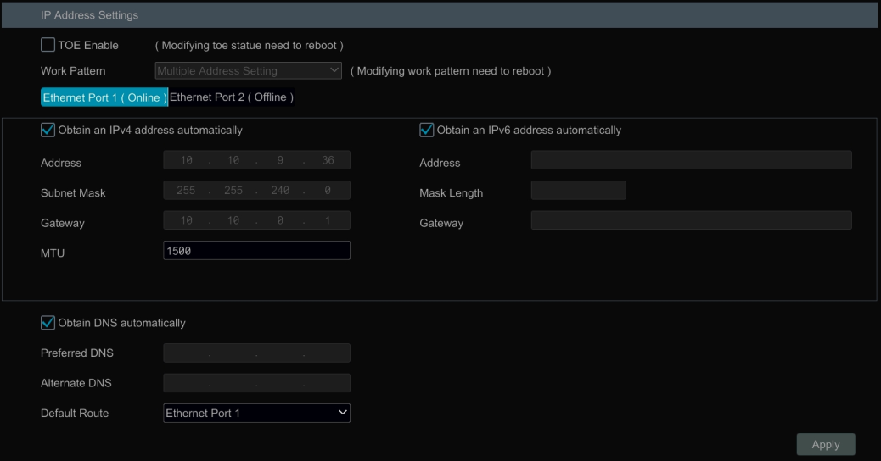

Port Configuration
Click StartSettingsNetworkPort to go to the interface as shown below. Enter the HTTP port, HTTPS port, server port and RTSP port of the NVR, enable “Anonymous” as needed and then click “Apply” button to save the settings.

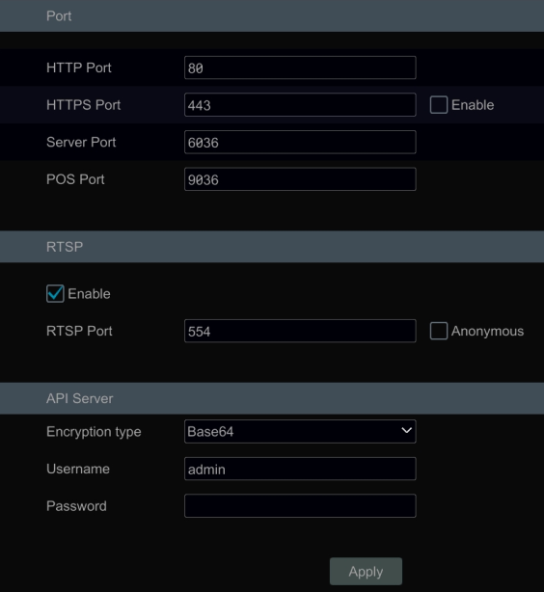

HTTP Port: the default HTTP port of the NVR is 80. The port number can be changed to others like 81. The port is mainly used for web client access. If you want to access the NVR through a web browser, you should enter IP address plus HTTP port in the address bar of the web browser like http://192.168.11.61:81.
HTTPS Port: the default HTTPS port of the NVR is 443.
HTTPs provides authentication of the web site and protects user privacy. How to use it?
① Enter IP address plus HTTP port in the address bar of the web browser. Then enter username and password to log in. Click Functional PanelNetworkHTTPS to go to the following interface.

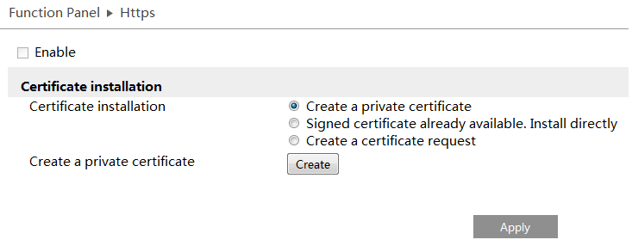
② Install a certificate.
* You can create a private certificate here. Click the “Create” button to create a private certificate. Enter the country (only two letters available), domain (NVR’s IP address/domain), validity date, password, province/state, region and so on. Then click “OK” to save the settings.
* If there is a signed certificate, click “Browse” to select it and then click “Install” to install it.
* Click “Create a certificate request” to enter the following interface.

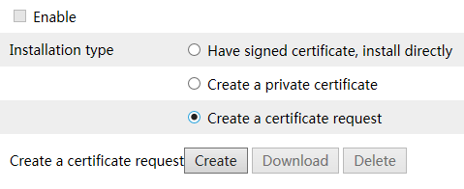

Click “Create” to create the certificate request. Then download the certificate request and submit it to the trusted certificate authority for signature. After receiving the signed certificate, import the certificate to the device.

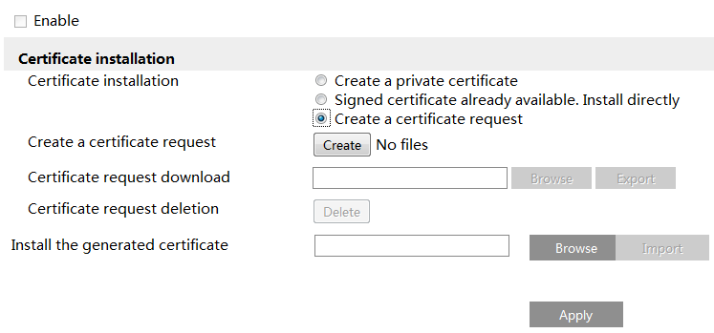

③ After the certificate has been installed, enable this function and apply it. Then the camera can be accessed by entering https://IP: https port via the web browser (eg.https://192.168.1.201:443).

Server Port: the default server port of the NVR is 6036. The server port number can be changed as required. The port is mainly used in network video management system.
POS Port: the default HTTP port of the NVR is 9036.
Note: The HTTP port and server port of the NVR should be mapped to the router before you access the NVR via WAN.

RTSP Port: RTSP real-time stream protocol can be used to control the sending of real-time data. By media player (like VLC player) which supports the RTSP real-time stream protocol, you can view the live images synchronously. The default RTSP port is 554 and it can be changed as needed. (The address format: rtsp://IP address:554/chID=1&streamType=main or rtsp://IP address:554/chID=1&streamType=sub; main indicators main stream; sub indicators sub stream; chID indicators channel ID).
Examples: ① Enable RTSP and “Anonymous”. Then open the VLC player and enter the address (for example: rtsp://192.168.1.88:554/chID=1&streamType=main) in the network address bar of the VLC player. Then you can view the video of channel 1.
② Enable RTSP and open the VLC player. After that enter the address (for example: rtsp://192.168.1.88:554/chID=1&streamType=sub) in the network address bar of the VLC player. Then a login box will pop up. Enter the username and password which shall be as the same as the username and password of API server. Then you can view the video of channel 1.
Note: only some versions may support API server function. Please skip the following instructions if your DVR doesn’t support it.

API Server: You can log in the media player which supports the RTSP protocol by the username and password here. Moreover, the third-party can further develop through API service.
Encryption type: Base64 and MD5 are optional.
Username: admin (it cannot be modified)
Password: Set it as needed.
Tips: The username and password of API Server here cannot be used to log in NVR. It is recommended to set the password of the API server different from the password of “admin” that is used to log in NVR.

PPPoE Configuration
Click StartSettingsNetworkPPPoE to go to the interface as shown below. Check “Enable” in “PPPoE Settings” and then enter the username and password obtained from the dealer. Click “Apply” to save the settings.

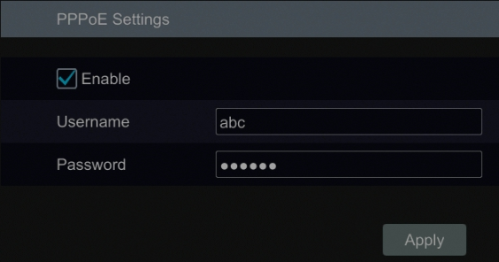

DDNS Configuration
The DDNS is used to control the dynamic IP address through domain name.Speco Technologies provides free DDNS service with US-based servers. You can access the NVR easily if the DDNS is enabled and configured. Click StartSettingsNetworkDDNS to go to the interface as shown below. The default DDNS type will be “specoddns.net”. The default domain name will be shown, you can use this for your domain name or enter your own. If invalid or taken, please select another domain name. Click on test to check if ok. If so, you may now go to [your domain name].specoddns.net with Internet Explorer and access your recorder remotely.

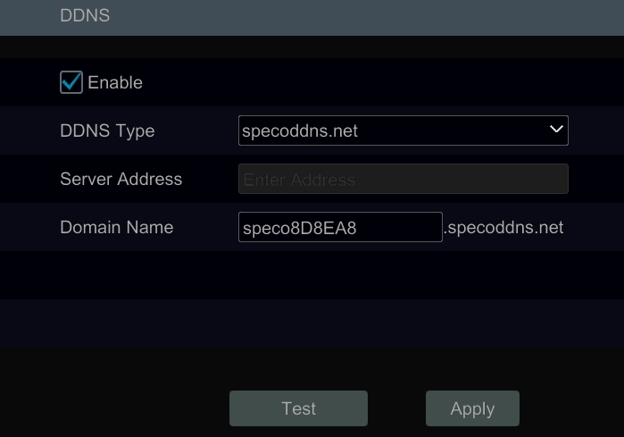

E-mail Configuration
Click StartSettingsNetworkE-mail to go to the following interface. Enter the sender’s name, e-mail address, SMTP server and SMTP port (you can click “Default” to reset the SMTP port to the default value) and then enable or disable the SSL and attaching image. Select the username (the username list will be updated automatically according to the email address you input) and enter the password of the sender and then click “Apply” to save the settings (you don’t have to enter the username and password if “Anonymous Login” is enabled). Click “Test” to pop up a window. Enter the e-mail address of the recipient in the window and then click “OK” button. The e-mail address of the sender will send an e-mail to the recipient. If the e-mail is sent successfully, it indicates that the e-mail address of the sender is configured correctly.

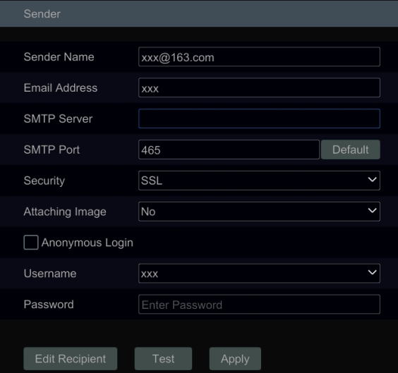

Click “Edit Recipient” to go to the following interface.

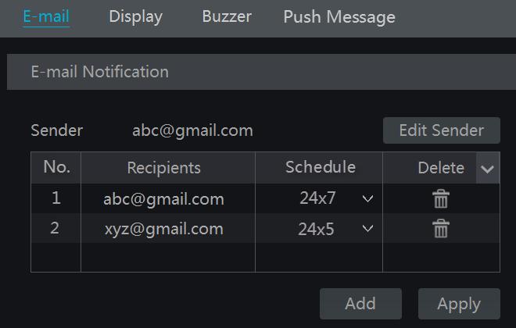
Click “Add” and then enter the recipient’s e-mail address and select the schedule (if a schedule is selected, the system will send the alarm email and the recipient will receive it only in the selected schedule time) in the popup window. Click “Add” in the window to add the recipient. You can also change the recipient’s receiving schedule by clicking in the “Schedule” column. Click to delete the recipient in the list. Click “Apply” to save the settings. Click “Edit Sender” to go to the e-mail configuration interface of the sender.

UPnP Configuration
By UPnP you can access the NVR through the web client which is in WAN via router without port mapping.
- Click StartSettingsNetworkUPnP to go to the following interface.
- Make sure the router supports UPnP function and the UPnP is enabled in the router.
- Set the NVR’s IP address, subnet mask and gateway and so on corresponding to the router.
- Check “Enable” in the interface as shown below and then click “Apply” button.

Click “Refresh” button to refresh the UPnP status. If the UPnP status were still “Invalid UPnP” after refreshing it for many times, the port number would be wrong. Please change the mapping type to “Manual” and then click to modify the port until the UPnP status turns to “Valid UPnP”. Refer to the following picture. You can view the external IP address of the NVR. Enter the external IP address plus port in the address bar of your browser to access the NVR such as http://183.17.254.19:81.

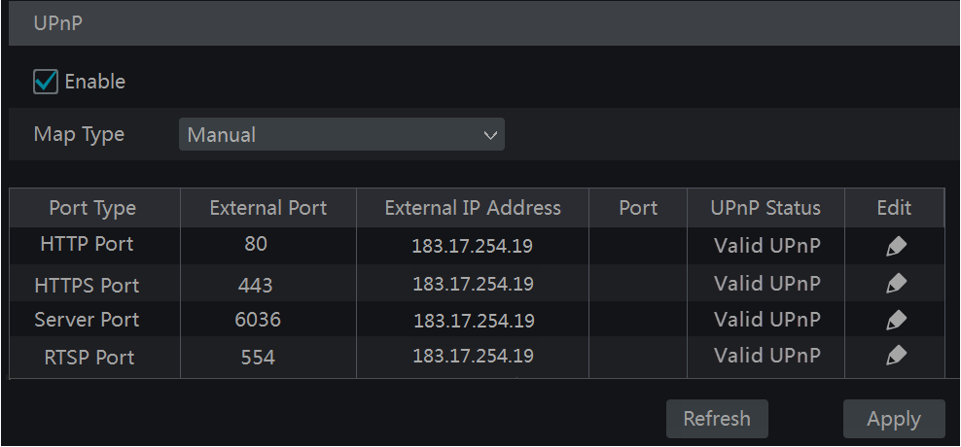

802.1X
If it is enabled, the NVR data can be protected. When the NVR is connected to the network protected by the IEEE 802.1X, user authentication is needed.

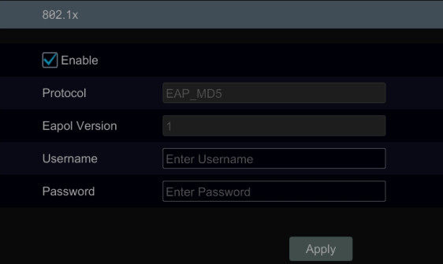
To use this function, the NVR shall be connected to a switch supporting 802.1x protocol. The switch can be considered as an authentication system to identify the device in a local network. If the NVR connected to the network interface of the switch has passed the authentication of the switch, it can be accessed via the local network.
Protocol type and EAPOL version: Please use the default settings.
User name and password: The user name and password must be the same with the user name and password applied for and registered in the authentication server.

NAT Configuration
Click StartSettingsNetworkNAT to go to the interface for NAT configuration and check “Enable”. Click “Apply” to save the settings and make note of the QR code number under the QR code. Via Internet Explorer, go to connect.specotech.cloud, input the QR code number, your username and password to login.
You can also scan the QRCode through mobile client which is installed in the mobile phone or PAD to log in the mobile client instantly.

View Network Status
Click StartSettingsNetworkNetwork Status to view the network status or click on the tool bar at the bottom of the live view interface to view network status conveniently.

Basic Configuration

General Configuration
Click StartSettingsSystemBasicGeneral Settings to go to the following interface. Set the device name, device No., language, video format and main output. Enable or disable wizard, “Log In Automatically”, “Log Out Automatically” (if checked, you can set the wait time), “App Live Self-Adaption” and “Dwell Automatically” (if checked, you can set the wait time). Click “Apply” to save the settings.

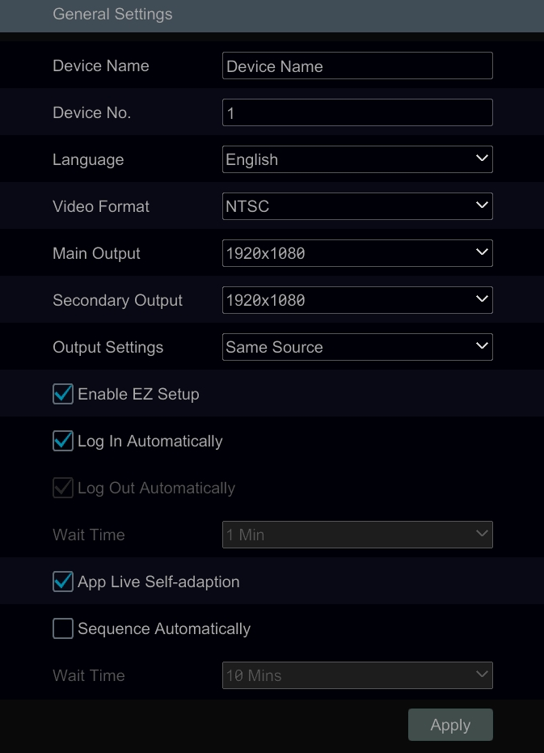c

Device Name: The name of the device. It may display on the client end or CMS that help user to recognize the device remotely.
Video Format: Two modes: PAL and NTSC. Select the video format according to the camera.
Sequence Automatically: Check it and set “wait time”. The system will sequence automatically if it is not operated during the time you set.

Date and Time Configuration
Click StartSettingsSystemBasicDate and Time to go to the interface as shown below.
Set the system time, date format, time format and time zone of the NVR. The default time zone is GMT+08 Beijing, Hong Kong, Shanghai, Taipei. If the selected time zone includes DST, the DST of the time zone will be checked by default. Click “Apply” to save the settings.
You can manually set the system time or synchronize system time with network through NTP.
Manual: select “Manual” in the “Synchronous” option and then click after the “System Time” option to set the system time.
NTP: select “NTP” in the “Synchronous” option and then enter the NTP server.

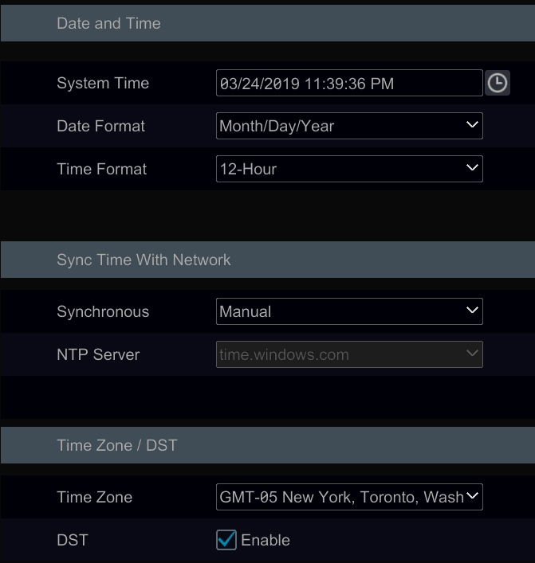

Recorder OSD Settings
Click StartSettingsSystemBasicRecorder OSD settings to go to the following interface. OSD name and icon can be enabled here.

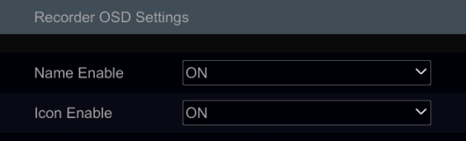

Factory Default
Click StartSettingsSystemMaintenanceFactory Default and then click “Reset to factory default” button in the interface to reset to the factory default settings (check “Reset retain Network Configuration” to retain the network settings).

Note: Resetting to the factory default settings will not change time zone.

Device Software Upgrade
- Upgrade
You can click StartSettingsSystemInformationBasic to view MCU, kernel version and firmware version and so on. Before upgrade, please get the upgrade file from your dealer.
The upgrade steps are as follows:
- Copy the upgrade software into the USB storage device.
- Insert the USB storage device into the USB interface of the NVR.
- Click StartSettingsSystemMaintenanceUpgrade to go to “Upgrade” interface. Select the USB device in “Device Name” option and go to the path where the upgrade software exists. Select the upgrade software and then click “Upgrade”. The system may automatically restart during upgrading. Please wait for a while and do not power off the NVR during upgrading.

Note: The file system of the USB mobile device which is used for upgrading, backing up and restoring should be FAT32 format.

- Flash Upgrade
The upgrade steps are as follows:
- Copy the flash upgrade files into the USB storage device.
- Insert the USB storage device into the USB interface of the DVR.
- Restart the DVR. Then the system will automatically upgrade.
- Cloud Upgrade
- Click StartSettingsSystemMaintenanceCloud Upgrade to go to “Cloud Upgrade” interface.
- Enable “Auto-check for updates” to check if the current version is the latest one automatically. You can also click “Check for updates” to check the version by yourself. If it is not the latest one, obtain the latest version from the cloud server and then click “Upgrade”. The system may automatically restart during upgrading. Please wait for a while and do not power off the device during upgrading.

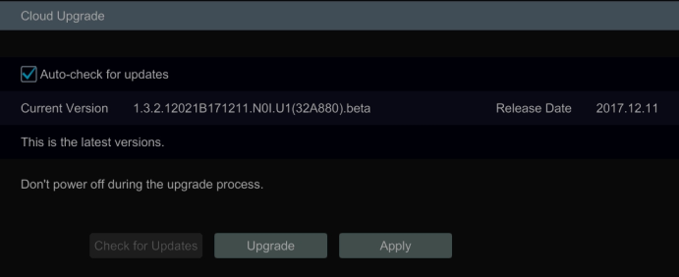

Backup and Restore
You can back up the configuration file of the NVR by exporting the file to other storage devices; you can recover the configuration to other NVRs which are of the same model with the NVR by importing the configuration file to other NVRs for time saving.
Insert the USB storage device into the USB interface of the NVR and then click StartSettingsSystemMaintenanceBackup and Restore to go to the interface.

- Backup
Select the USB device in “Device Name” option; go to the path where you want to store the configuration backup file and then click “Backup” button; finally click “OK” button in the popup window.

- Recover
Select the USB device in “Device Name” option; find the configuration backup file and then click “Recover” button; finally click “OK” button in the popup window.

Restart Automatically
You can set the automatic restart time for the NVR to maintain it regularly. Click StartSettingsSystemMaintenanceAuto Maintenance to go to the interface as shown below. Enable auto maintenance, set the interval days and point of time and then click “Apply” to save the settings. The NVR will restart automatically at the pointed time every interval days.

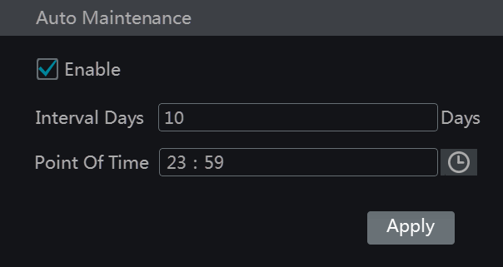

View Log
Click StartSettingsSystemMaintenanceView Log to go to the log view interface. Select the log main type, click to set start time and end time and then click “Search” button. The searched log files will be displayed in the list.

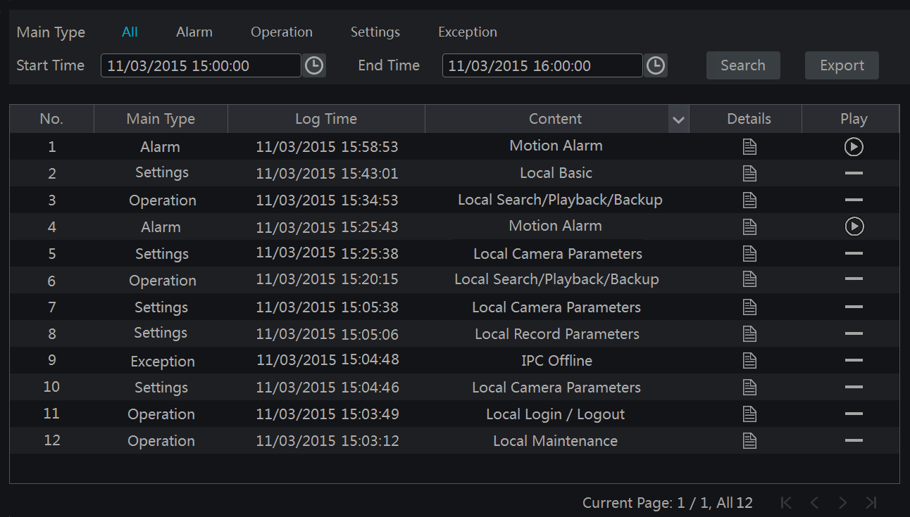

Choose the log file in the list and then click “Export” button to export the log file. Click on the “Content” title bar to pop up a menu list. Check contents in the menu list and then the log list will show the checked log contents only. Click to play the video log.

View System Information
Click StartSettingsSystemInformation and then click the corresponding menu to view the “Basic”, “Camera Status”, “Alarm Status”, “Record Status”, “Network Status” and “Disk” information of the system.

Remote Surveillance

Mobile Client Surveillance
- Enable NAT in the NVR. Refer to 11.1.8 NAT Configuration for details.
- Scan the QRCode through the Speco Blue App available for iOS and Android to easily and securely view your cameras.
- Run the mobile client, go to the “Add Device” interface and then click  to scan the QRCode of the NVR (Go to StartSettingsSystemInformationBasic to view the QRCode of the NVR).
- After scanning the QRCode successfully, enter the login password to log in mobile client.

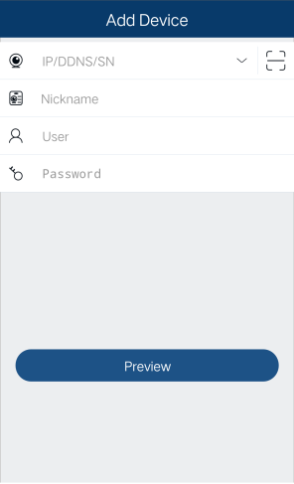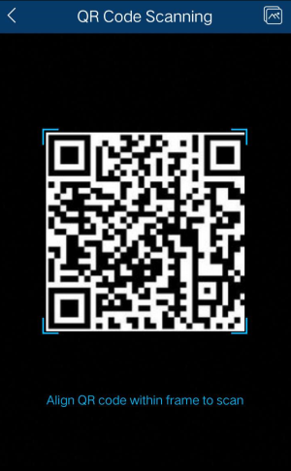

Web LAN Access
- Click StartSettingsNetworkTCP/IP to go to the “TCP/IP” interface. Set the IP address, subnet mask, gateway, preferred DNS and alternate DNS of the NVR.
- Open the web browser on your computer, enter the IP address of the NVR in the address bar and then press enter to go to the login interface as shown below. You can change the display language on the top right corner of the login interface. Enter the username and password of the NVR in the interface and then click “Login” to go to the live view interface.

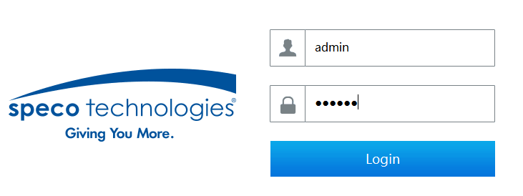

Notes: 1. Please make sure that the IP address of the NVR and the computer are both in the same local network segment. For example, supposing that the IP address of the computer is 192.168.1.41, the IP address of the NVR shall be set to 192.168.1.XXX.
2. If the HTTP port of the NVR is not 80, but other number instead, you need to input the IP address plus port number in the IE address bar when accessing the NVR over network. For example, the HTTP port is 81. You should enter http://192.168.1.42:81 in the IE address bar.

Web WAN Access
- Set the network of the NVR. Please refer to 11.1.1 TCP/IP Configuration for details.
- Click Start→Settings→Network→NAT to go to the interface for NAT configuration and check “Enable”. Click “Apply” to save the settings and make note of the QR code number under the QR code. Via Internet Explorer, go to connect.specotech.cloud, input the QR code number, your username and password to login.

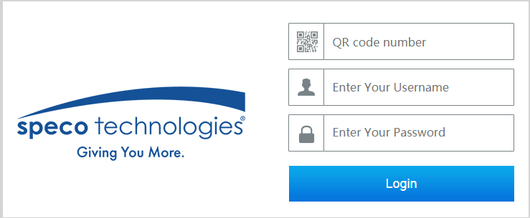

- PPPoE Access
- Click StartSettingsNetworkPPPoE to go to the “PPPoE” interface. Check “Enable” in the “PPPoE settings” and then enter the username and password you get from your ISP. Click “Apply” to save the settings.
- Click StartSettingsNetworkNetwork Status to view the IP address of the NVR.
- Open the web browser on your computer, enter the IP address of the NVR like http://210.21.229.138 in the address bar and then press enter to go to the login interface. Enter the username and password of the NVR in the interface and then click “Login” to go to the live view interface.

- Router Access
- Click StartSettingsNetworkTCP/IP to go to the “TCP/IP” interface. Set the IP address, subnet mask, gateway, preferred DNS and alternate DNS of the NVR.
- Set the HTTP port (it is suggested to modify the HTTP port because the default HTTP port 80 might be taken up) and enable UPnP function in both the NVR and the router. If the UPnP function is not available in the router, you need to forward the LAN IP address, HTTP port and server port of the NVR to the router. Port mapping settings may be different in different routers, so please refer to the user manual of the router for details.
- Get the WAN IP address of the NVR from the router. Open the web browser on your computer, enter the WAN IP address plus HTTP port like http://116.30.18.215:100 in the address bar and then press enter to go to the login interface. Enter the username and password of the NVR in the interface and then click “Login” to go to the live view interface.

Note: If the WAN IP address is a dynamic IP address, it is necessary for you to use the domain name to access the NVR. Click StartSettingsNetworkDDNS to set DDNS (see 12.1.4 DDNS Configurationfor details). By using DDNS function you can use the domain name plus HTTP port like http://sunshine.dvrdydns.com:100 to access the NVR via internet.

Web Remote Control
The supported browsers for remote access are IE8/9/10/11, Firefox, Opera and Chrome (available only for the versions lower than 45) in Windows system and Safari in MAC system. Here we take IE browser for example. When you access the NVR through IE for the first time, you need to download and install the relative components for normal preview and playback. Please refer to the tips in the remote interfaces for details. The buttons and icons on the top right corner of the remote interface are introduced as follows.
admin: the current login username.
Logout: click it to log out and return to the login interface.
Modify Password: click it to change the password of the current login user. Enter the current password and then set a new password in the popup window. Click “OK” button to save the new password.
Local Settings: click it to change the local settings. Set the snapshot number and click “Browse” to set the snapshot path and record path as shown below. Click “Apply” button to save the settings.

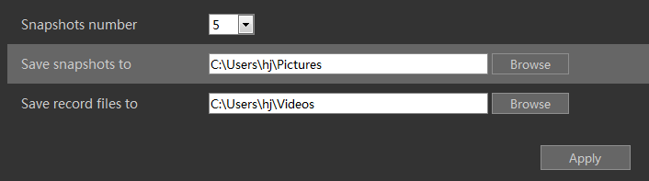

Remote Preview
Click “Live View” in the remote interface to go to the live view interface. The live view interface consists of the four areas marked in the following picture.

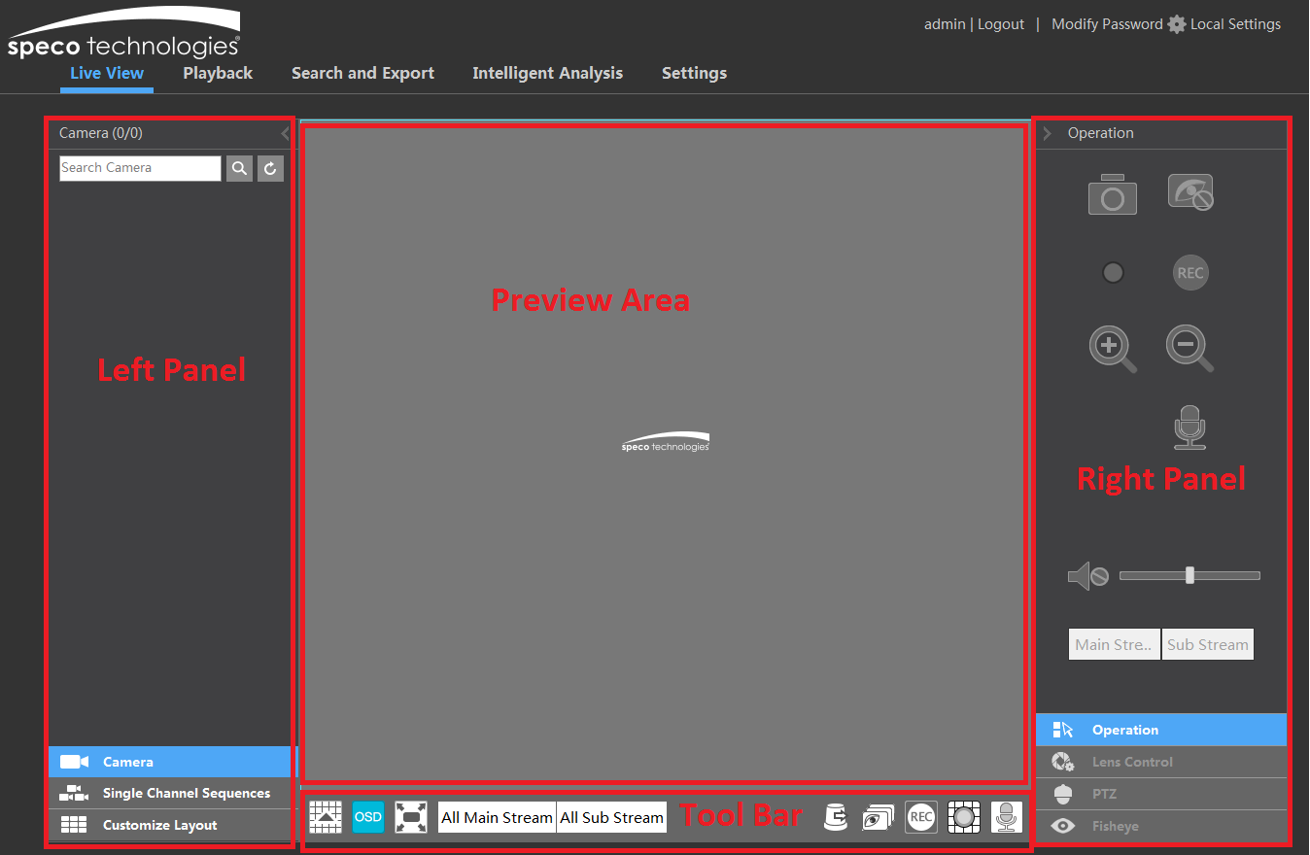

- Start Preview
Select a window in the preview area and then click one online camera on the left panel to preview the camera in the window. You can click 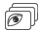 in the tool bar to view all the cameras.

- Left Panel Introduction
Click on the left panel to hide the panel and click to show the panel. You can view all the added cameras and groups on the left panel.
- View Camera
Click to view the cameras. You can view the number of all the added cameras and the online cameras. For instance, the left number 3 in on the left panel stands for the number of online cameras; the right number 4 stands for the number of all the added cameras. Enter the camera name in the search box and then click to search the camera. Click to refresh the camera list.
- View Group
Click to view the groups. All groups and all cameras in the group can be shown in the left panel.

- View Scheme
Click to view the scheme (or planning). All schemes can be shown in the left panel. Double click the scheme name to invoke it quickly

- Tool Bar Introduction

Button | Meaning
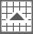 | Screen mode button.
 | Click it to disable OSD. Click to enable OSD.
 | Click it to show full screen. Right click on the full screen to exit full screen.
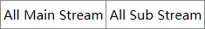 | Click “All Main Stream” or “All Sub Stream” to set the stream of all the cameras.
 | Manual alarm button. Click it to pop up a window and then trigger and clear the alarm-out in the window manually.
 | Click it to preview all cameras.
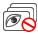 | Click it to close all the preview cameras.
 | Click it to start recording for all cameras to computer. Click  to stop recording.
 | Click it to start manual record for all cameras to the NVR. Click  to stop manual record for all cameras.
 | Click it to enable talk with the NVR.

- Right Panel Introduction
Click on the right panel to show the panel and click to hide the panel. Click at the bottom of the panel to go to “PTZ” panel. Click to go to “Lens Control”. Click to go to “Operation” panel.

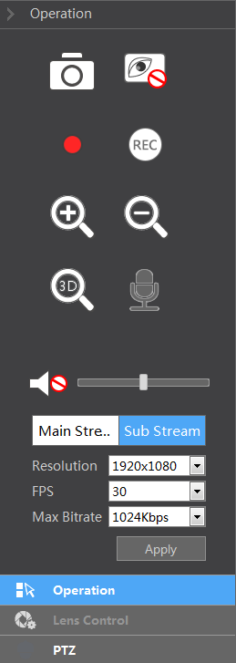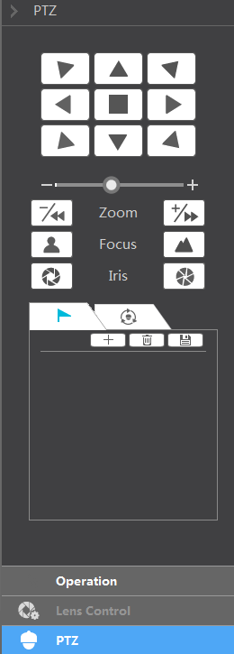

Click one camera window in the preview area and then click 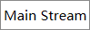 to set the camera’s live view stream and record stream to main stream in manual record mode; click 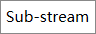 to set the camera’s live view stream and record stream to sub stream. In sub stream tab, set the resolution, FPS and bitrate and then click “Apply” to save the settings.

Operation panel introduction:

Button | Meaning
 | Click it to take snapshots.
 | Click it to start recording to computer; click it again to stop recording.
 | Click it to zoom in the image of the camera and then drag the mouse on the camera image to view the hidden area.
 | Click it to zoom out the image of the camera.
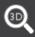 | The 3D zoom in function is designed for P.T.Z. Click it and then drag the image to zoom in or zoom out the image; click the image on different areas to view the image of the dome omni-directionally.
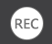 | Click it to start record to the NVR
 | Click it to close the preview camera.

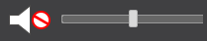 | Click it to enable audio and then drag the slider bar to adjust the volume. You can listen to the camera audio by enabling audio.

PTZ panel introduction:
Button | Meaning
 | Click  /  /  /  /  /  / / to rotate the dome; click to stop rotating the dome.
 | Drag the slider to adjust the rotating speed of dome.
 | Click / to zoom in/out camera image.
 | Click / 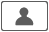 to increase/ decrease the focal length.
 | Click / to increase/decrease the iris of the dome.
 | Click it to view the preset list and then click the button in the list to call the preset.
 | Click it to view the cruise list and then click the corresponding buttons in the list to start or stop the cruise.

Remote Playback
Click “Playback” in the remote interface to go to the playback interface.
- Check the record event types and cameras on the left panel. Set the record date on the calendar beside the time scale.
- Click 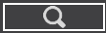 to search the record data and then click or directly click the time scale to play the record.
The operation of the playback time scale is similar to that of the time scale in the main program of the NVR. Please refer to 8.2 Playback Interface Introduction for details.

Introduction of playback control buttons:

Button | Meaning
 | Stop button.
 | Rewind button. Click it to play video backward.
 | Play button. Click it to play video forward.
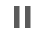 | Pause button.
 | Deceleration button. Click it to decrease the playing speed.
 | Acceleration button. Click it to increase the playing speed.
 | Previous frame button. It works only when the forward playing is paused in single screen mode.
 | Next frame button. It works only when the forward playing is paused in single screen mode.
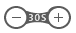 | Click to step backward 30s and click 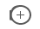 to step forward 30s.
 | Backup start time button. Click the time scale and then click it to set the backup start time.
 | Backup end time button. Click the time scale and then click it to set the backup end time.
 | Export button.
 | Backup tasks button. Click it to view the backup status.
 | Event list button. Click it to view the event record of manual/schedule/sensor/motion.

Remote Export
Click “Export” in the remote interface to go to the export interface. You can export the record by event search or by time search.

- Event Search
Check the record type on the left side of the interface and then click to set the start time and end time; check the cameras and then click on the right side to search the record (the searched record data will be displayed in the list); check the record data in the list and then click “Export” button to export the record.

- Time Search
Click to set the start time and end time on the left side of the interface; check the cameras and then click  on the right side to backup the record.

- Snapshots
The system will display all the captured images automatically in the list. Click to delete the image. Click to pop up the “Export” window. Click to pop up the “View Image” window. Click to export the image.

- View Export Status
Click “Export Status” to view the export status. Click “Pause” to stop the export; click “Resume” to continue the export; click “Delete” to delete the task.

Intelligent Analysis
Click “Intelligent Analysis” in the remote interface to configure smart search, statistics, target database, face attendance and face check in. All of these settings are similar to that of the NVR. See the configurations of the NVR for details.

Remote Configuration

Click “Function Panel” in the remote interface and then configure the camera, record, alarm, disk, network, account and authority and system of the NVR remotely. All of these settings are the same as the settings of the NVR. See the configurations of the NVR for details.

Appendix A FAQ
  - Why can’t I find the HDD?
- Please check the power and SATA data cables of the HDD to make sure they are well connected.
- For some NVRs with the 1U or small 1U case, the power of the adapter may be not enough for operating them. Please use the power adaptor supplied along with the NVR.
- Please make sure the HDDs are compatible with the NVR. See Appendix C Compatible Device List for details.
- The HDD could have gone bad.

  - Why are there no images output in some or all of the camera windows?
- Please make sure the resolutions of the cameras are supported by the NVR.
- Please make sure the network cables of the IP camera and NVR are both connected properly and the network parameters are set correctly.
- Please make sure the network and the switch both work normally.

  - The screen has no output after booting the NVR normally.
- Please make sure the screen, HDMI or VGA cables are good and well connected.
- Please make sure the screen supports the resolution of 1280*1024, 1920*1080 or 3840*2160 (4K*2K). The NVR cannot self-adapt to the screen of which the resolution is lower than 1280*1024, and then the screen will remind you that the screen resolution is not supported by the NVR or just have no display. Please change a screen at 1280*1024, 1920*1080 or 3840*2160 resolution before booting the NVR.

  - Forget your passwords?
- The password for admin can be reset through “Edit Security Question” function.
Click “Edit Security Question” button in the login window and then enter the corresponding answer of the selected question in the popup window, the password for admin will be reset to 123456. If you forget the answer of the question, this way will be invalid, please contact your dealer for help.
- The passwords of other users can be reset by admin, please refer to 10.1.2 Edit User for details.

  - The NVR cannot add up to the maximum number of IP cameras?
Take the 16 CH NVR as an example. Some 16 CH NVR support a maximum of 120Mbps bandwidth input (please take the real device for standard). Refer to the picture below. The remaining bandwidth should be larger than the bandwidth of the IP camera you want to add, or you would fail to add the IP camera. You should lower the added cameras’ bitrate to release the bandwidth. It is recommended to add cameras by “Quickly Add” for batch adding.
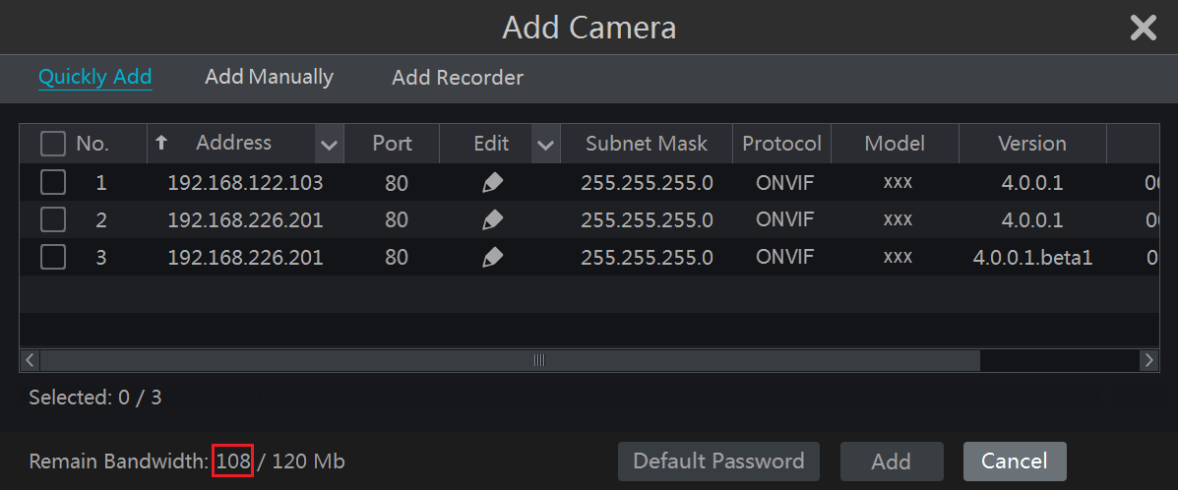

  - The system cannot record, why?
- Make sure the HDD was formatted prior to use.
- The record schedule has not been set in manual record mode. Please refer to 7.3.2 Record Schedule Configuration for details.
- Maybe HDD is full and thus the NVR is not able to record. Check HDD information from Disk Management and if required, please enable the recycle function (please see 7.1.2 Advanced Configuration for details).
- There is no disk but cameras in the disk group, so please add at least one disk to the group. Refer to 7.5.1 Storage Mode Configuration for details.
- The HDD could have gone bad. Please change another one.

  - Fail to access the NVR remotely through IE.
- Please make sure the IE version is IE8 or above.
- Please check whether the PC has enabled the firewall or installed the antivirus software. Please try to access the NVR again after you disable the firewall and stop the antivirus software.
- Allow & block list may have been set in Account and Authority setting. The PC of which the IP address is in the block list or out of the allow list cannot access the NVR remotely.

  - ActiveX control cannot be downloaded. What can I do?
- IE browser blocks ActiveX control. Please do setup as per the steps mentioned below.
- Open IE browser. Click Internet Options.

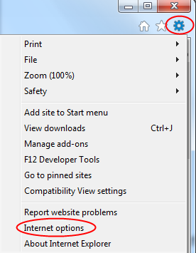

- Select SecurityCustom Level. Refer to Fig 10-1.
- Enable all the sub options under “ActiveX controls and plug-ins”. Refer to Fig 10-2.
- Then click “OK” to finish setup.

- Other plug-ins or anti-virus may block ActiveX. Please disable or do the required settings.

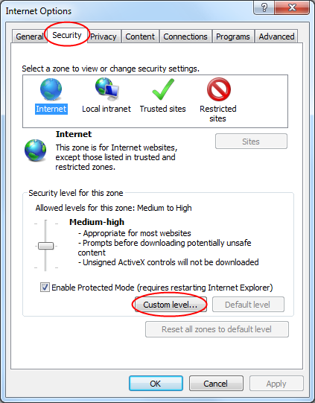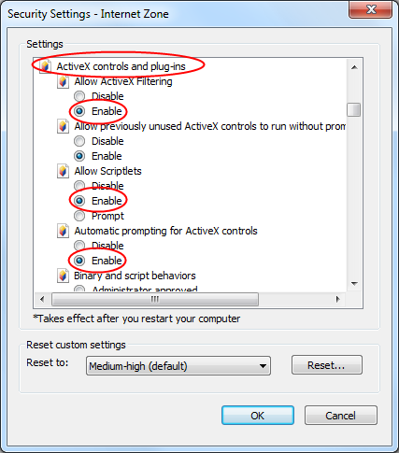
Fig 10-1 Fig 10-2

  - How to play the backup file?
- Record backed up by NVR: insert the USB device in which the record backup files is saved to the USB interface of the PC and then open the USB device path. The record can be backed up in the private format and AVI format by NVR.
- If you select the private format when backing up record by NVR, a RPAS (Recording Player Application Software) compression package will be backed up to the USB device automatically along with the record data. Uncompress the “RPAS.zip” and then click “RPAS.exe” to set up RPAS. After the setup is completed, open RPAS player and then click “Open Folder” button in the middle of the interface to select the record data. Refer to Fig 11-1.

Select camera in the resource tree on the left side of the interface to play the camera record. Click on the tool bar under the camera image to enable audio. Refer to Fig 11-2.
Note: The record will not have audio output if you disable the audio when recording by NVR. Please see 7.1.1 Mode Configuration and 7.2 Encode Parameters Setting for details.

- If you select the AVI format when backing up recorded video by NVR, the recorded video can be played by the video player which supports this format.
- Recorded video backed up through web. The recorded video can only be backed up with AVI format through web. The recorded video can be backed up to PC and played by the video player which supports this format.

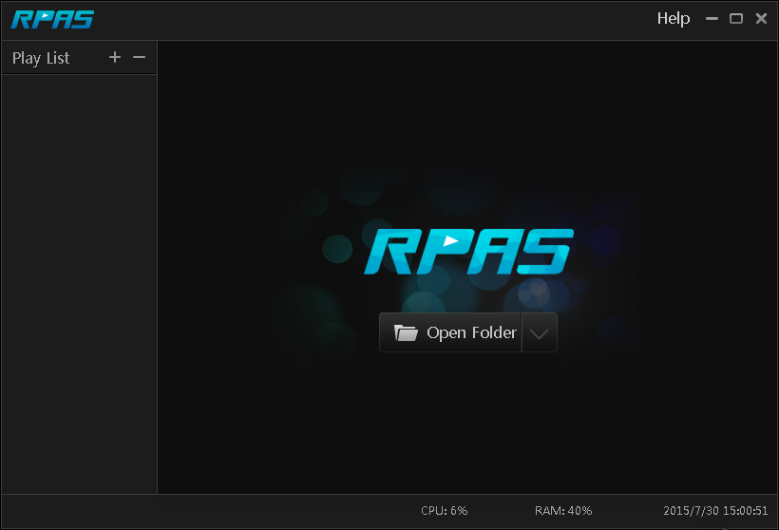

Fig 11-1

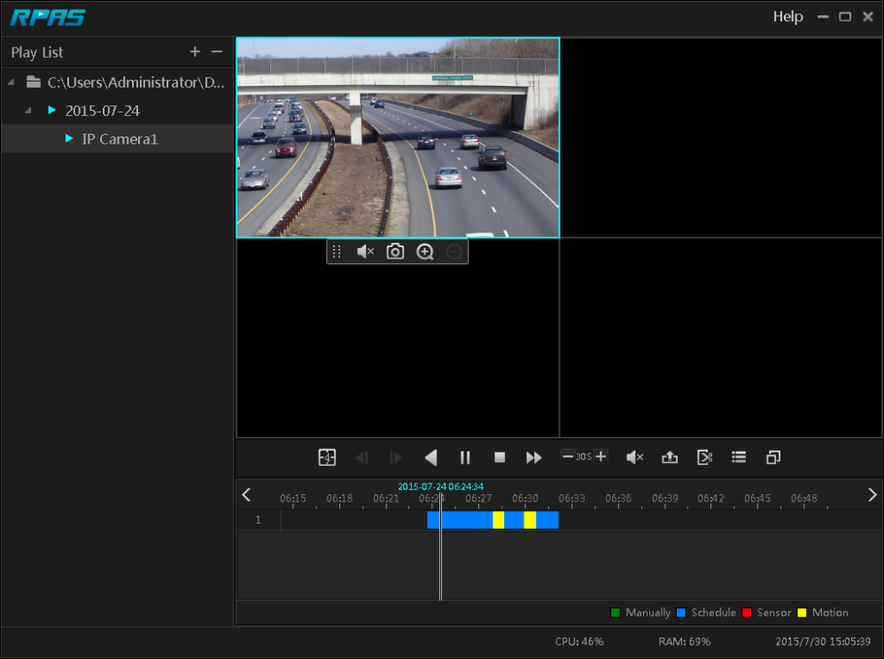

Fig 11-2

Appendix B Calculate Recording Capacity
The recording capacity is mainly up to the record resolution, record stream and bitrate. Different image quality parameters decide different disk capacity occupation in equal times. The bigger the record resolution, record stream and record bitrate is, the more disk capacity is taken up in equal times. The calculation format of recording capacity is shown as below.

Recording Capacity (MB) = Bitrate (Kbps) ÷1024 ÷ 8 × 3600 × Recording hours per day × Record Storage Days × channel numbers
3600 means record for an hour(1TB=1024GB，1GB=1024MB，1MB=1024KB，1Byte=8bit).

Record Bitrate  (Kbps) | Used Space  (MB/H) | Used Space  (MB/D)
10240 | 4500 | 108000
8192 | 3600 | 86400
6144 | 2700 | 64800
4096 | 1800 | 43200
3072 | 1350 | 32400
2048 | 900 | 21600
1024 | 450 | 10800
768 | 337.5 | 8100
512 | 225 | 5400
384 | 168.75 | 4050
256 | 112.5 | 2700

The table below shows the recording capacity requirements for record storage in 30 days.

Record Bitrate (Kbps) | Recording Capacity (TB)
Record Bitrate (Kbps) | 1CH | 4CH | 8CH | 16CH | 32CH | 64CH
10240 | 3.09 | 12.36 | 24.72 | 49.44 | 98.88 | 197.76
8192 | 2.48 | 9.89 | 19.78 | 39.56 | 79.11 | 158.21
6144 | 1.86 | 7.42 | 14.84 | 29.67 | 59.33 | 118.66
4096 | 1.24 | 4.95 | 9.89 | 19.78 | 39.56 | 79.11
3072 | 0.93 | 3.71 | 7.42 | 14.84 | 29.67 | 59.33
2048 | 0.62 | 2.48 | 4.95 | 9.89 | 19.78 | 39.56
1024 | 0.31 | 1.24 | 2.48 | 4.95 | 9.89 | 19.78
768 | 0.24 | 0.93 | 1.86 | 3.71 | 7.42 | 14.84
512 | 0.16 | 0.62 | 1.24 | 2.48 | 4.95 | 9.89
384 | 0.12 | 0.47 | 0.93 | 1.86 | 3.71 | 7.42
256 | 0.08 | 0.31 | 0.62 | 1.24 | 2.48 | 4.95

For instance, there is a 32CH NVR recording 24 hours per day and the record stores for 30 days. The NVR adopts dual stream recording. The main stream is 4096Kbps and the sub stream is 1024Kbps, then the total recording capacity is 49.45TB (39.56TB + 9.89TB).
Considering the format loss of the disk is about 10%, the required disk capacity will be 55TB (49.45TB ÷ (1-10%)).

Appendix C Specifications

Model |  | N64NR
System | Compression | Standard H.265
System | OS | Embedded Linux
Video | IPC Input | 64CH
Video | Network Access Bandwidth | 320Mbps
Video | Network Access Format | 8MP/6MP/5MP/4MP/3MP/1080P/960P/720P@25/30fps
Video | Output | HDMI×1: 4K×2K/1920x1080/1280×1024，  VGA×1：1920x1080/1280×1024
Audio | Network Input | 64CH IPC audio input
Audio | 2-way Audio | RCA×1
Audio | Local Output | RCA×1
Record | Record Stream | Dual stream recording
Record | Resolution | 8MP/6MP/5MP/4MP/3MP/1080P/960P/720P
Record | Mode | Manual, schedule, motion, sensor, intelligence
Playback | Simultaneous Playback | Max 16 CH
Playback | Search Mode | EZ search, museum search, time search, event search, bookmark search, snapshot search
Playback | Smart Search | Highlighted color to display camera records in a certain period of time, different colors refer to different record events
Playback | Function | Play, pause, FF, FB, etc.
Alarm | Mode | Manual, sensor, motion, exception, intelligence
Alarm | Input | 8CH local alarm input; support IPC alarm input
Alarm | Output | 4CH local alarm output; Support IPC alarm output
Alarm | Linkage | Record, snapshot, preset, e-mail, pop-up window, etc.
Network | Interface | RJ45 10M/100M/100Mbps×2
Network | Protocol | TCP/IP，PPPoE，DHCP，DNS，DDNS，UPnP，NTP，SMTP
Network | Web Client | Multiple online users monitoring
Mobile Device | OS | iOS, Android
Storage | HDD | SATA×8，max 14TB per HDD
Storage | E-SATA | E-SATA×2
Export | Local | By U disk，USB mobile HDD
Export | Network | Yes
Interface | USB | USB2.0×2（one in the front panel and the other in the rear panel）
Interface | Remote Controller | Yes
Interface | Power Consumption | ≤15W (without HDD)
Interface | Dimensions (W×D×H) | 16.9” x 17.8” x 3.5” (430mm×453mm×89mm)
Interface | Working Environment | -4~122F (-10~50℃)，10%~90%（humidity）

Android is a trademark of Google LLC.
Model: N64NR
Federal Communications Commission (FCC) Statements
This device complies with Part 15 of the FCC Rules. Operation is subject to the following two conditions: (1) This device may not cause harmful interference, and (2) This device must accept any interference received, including interference that may cause undesired operation.
FCC Responsible Party:
Speco Technologies
200 New Highway
Amityville, NY 11701
www.specotech.com

